Site name: University of Suffolk Wildlife Garden
Grid reference: TM17194420
Area: 179.4 meters²
Date and time of the survey: 21st May 24, 09:00 to 13:00
Weather conditions: 18°C, sunny intervals, isolated cloud. Little wind.
Recorders: Thomas Heathwaite, 6x Foundation year BS(C) Wildlife, Ecology, Conservation Science Students.
Location, description, and geology of site:
The site is located on the University of Suffolk campus which is in the centre of Ipswich. Bordering the wildlife garden, to the east, is Alexander Park. Suffolk new college boarders just to the north of the University of Suffolk campus and the marina and Ipswich wet docks are to the south of the University of Suffolk campus. The centre of Ipswich is about 1km from the site campus.
The geology of the site consists of clay, silt, and sand and this type of geology is known as Thames Group geology.
Statuary and Non-statutory designations:
There are no statutory designations within a radius of 1km of the survey site.
Two non-statutory designations are present within a radius of 1km of the survey site including zone III – total catchment source protection zone and drinking water protected area (surface water) (DEFRA, 2023)
Habitats and species:
The sample site is classified as broadleaved, mixed, and yew woodland under the Living England Habitat Map (DEFRA, 2023). Within the 1km radius of the survey site, there are many areas of Priority Habitat Inventory Deciduous woodland; these areas are present at the border between the survey site and Alexander Park; Bishops Hill, and Hollywell’s Park (DEFRA, 2023). The above areas are also classified as Broadleaf woodland under the National Forest Inventory (DEFRA, 2023).
A Biodiversity Action Plan Priority Habitat is located within 1km of the survey site: namely Hollywell’s park (it is approximately 513 meters from the survey site) (DEFRA, 2023).
Habitats, classified as Open mosaic habitats, are also present within 1km of the survey site (DEFRA, 2023).
For species, a granted European Protected Species Application exists for bats (DEFRA, 2023).
Methodology (pond):
The pond was sampled on the 21st of May.
Ecology:
The pond was sampled using a 30-second sweep using a 1mm pond net. Six samples were taken (as shown in Figure 1), all throughout the pond. Foundation year BS(C) Wildlife, Ecology and Conservation Student identified the plants and taxa present.
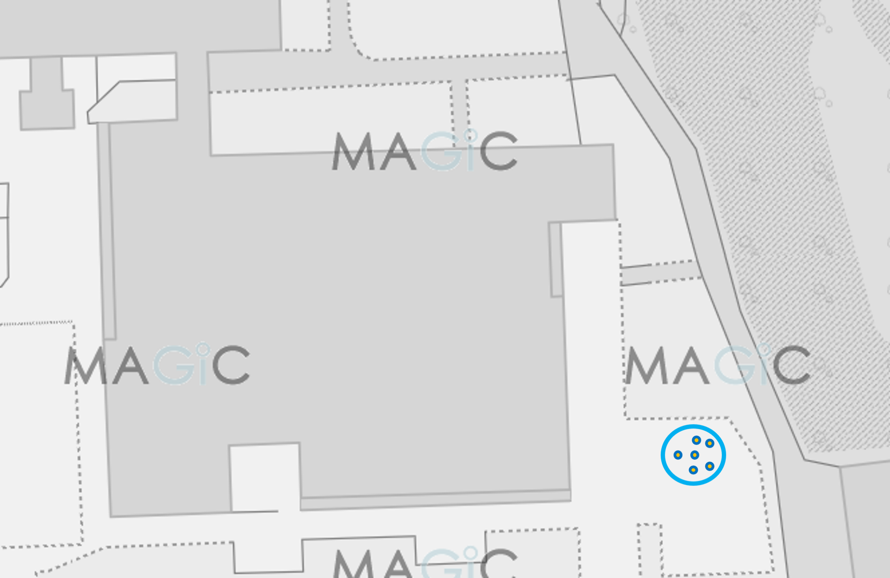
Figure 1, a diagram showing the outline of the pond and where the samples were taken from. The blue outline indicates the Wildlife Garden Pond location, and the blue dots with orange fill indicate where each 30 second sweep pond sample was taken using a 1mm pond net. Image produced using the Magic Map application (DEFRA, 2024)
Water chemistry:
A one-litre sample of pond water was taken from the centre of the pond. pH and temperature of the pond were measured using a Hanna Waterproof tester; nitrate and nitrite using a nitrate nitrogen water test kit; phosphorus using a phosphorus water testing kit; dissolved oxygen used a Lutron Probe; and hardness used a Hanna Titration kit.

Results:
The habitats are described below. Figure 2 shows the habitat present at the site and the relevant code, according to the JNCC’s Phase 1 Habitat survey methodology (JNCC, 2010). Table 1 shows the plant species present, and the estimated number counted or % coverage, and Table 2 shows the animals specie present and the estimated number counted.
Total species richness was recorded at 13 species.
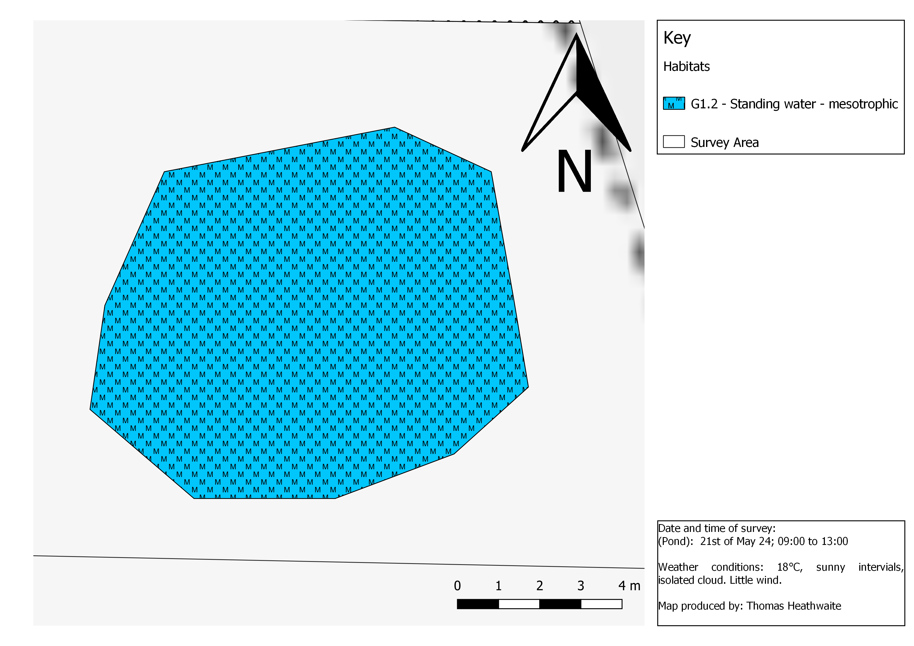
Figure 2, a map showing the results of the Phase 1 Habitat Survey of the University of Suffolk Wildlife Garden Pond. Habitats labelled as per the habitat category standardised phase 1 survey symbols and methodology (JNCC, 2010). Base map and data from OpenStreetMap and OpenStreetMap Foundation (2021).
Table 1 a table describing the plants present and the number counted or % coverage in each sample (estimated)
Species Present | Estimated number/ % cover counted
Water parsnip (Sium suave) | 20%
Iris (Iris pseudacorus) | 1
Carex spp. | 3
Royal fern (Osmunda regalis) | 9
Marsh marigold (Caltha palustris) | 3
Common duckweed (lemna minor) | 98%

Table 2, a table showing the animals present and the estimated number counted in sample.
Species present | Estimated number counted in sample
Water louse (Asellus aquaticus) | 6
Ram’s horn snails (Planorbarius corneus) | 1
Leech (Hirudinea) | 2
Water flea (Daphnia magna) | Varied between <50 and >100 in different samples
Hog louse (Haematopinus suis) | 6
Water scorpion (Nepa cinerea) | 1
Fish leech (piscicola geometra) | 2

Water chemistry:
From the sample, water pH was 6.6, temperature was 18 ºC, phosphorus was 100mg/L dissolved oxygen was 6%, hardness was 930 mg/L CacO3, nitrates were 0 mg/l and nitrides was 10mg/L.
Recommendations:
Disappointedly, the species richness for the pond survey has gone down this year from 19 in 2023 to 13 this year, representing a % change of -31%. However, some of this could be attributed to a change in survey effort.
It is encouraging that C. palustris (one of 2023’s recommendations) is now growing in the pond. C. palustris is attractive to a variety of bumblebees and hoverflies and is known to be visited by up to 39 species (Eiseman, Heller, and Rulik, 2016).
During the last year the pond environment has changed from eutrophic to mesotrophic, based upon the water chemistry data. The pH has declined from 8.1 in 2023 to 6.6, and the dissolved oxygen has also declined from 17.3% to 6%. Additionally, water hardness has increased further supporting this conclusion.
The recommendations from the 2023 report are still valid.

Bibliography:
DEFRA (2024) MAGIC. Available at: https://magic.defra.gov.uk/MagicMap.aspx [accessed 20/06/24].
Eiseman, C.S., Heller, K. and Rulik, B. (2016) A new leaf-mining dark-winged fungus gnat (Diptera: Sciaridae), with notes on other insect associates of marsh marigold (Ranunculaceae: Caltha palustris L.). Proceedings of the entomological Society of Washington, 118(4), pp.519-532.
JNCC (2010) Handbook for Phase 1 habitat survey – a technique for environmental audit. Peterborough: JNCC.
Natural Environment and Rural Communities Act 2006, c. 16. Available at: https://www.legislation.gov.uk/ukpga/2006/16/contents [accessed 20/06/24].
NBN Atlas (2023) Explore your area. Available at: https://records.nbnatlas.org/explore/your-area#52.10412650000001|1.3288216|13|ALL_SPECIES [accessed 20/06/24].
The conservation of habitats and species regulations 2017 (SI 2017/1012). Available at: https://www.legislation.gov.uk/uksi/2017/1012/contents/made [accessed: 20/06/24].
Wildlife and Countryside Act 1981, c. 69. Available at: https://www.legislation.gov.uk/ukpga/1981/69/contents [accessed 20/06/24].

