
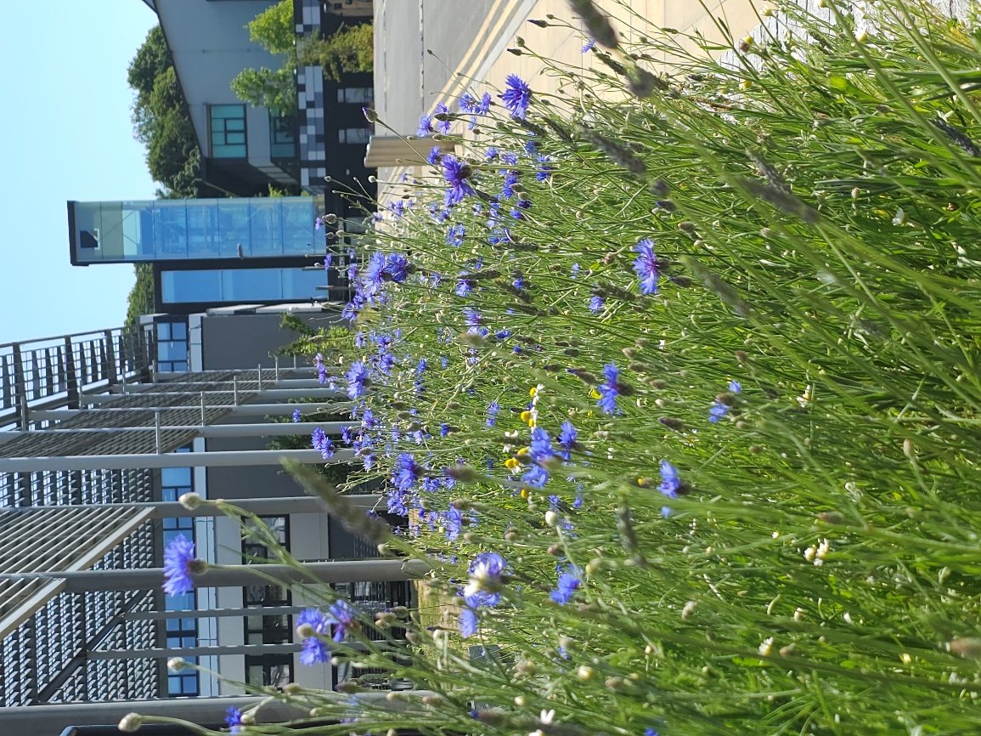
Bumblebee Buffet Area
UK Habitat Classification Survey Report
2025
Physic Garden and Bike shed - UK Habitat Classification Survey:
Site name: University of Suffolk Bumblebee Buffet Area
Grid reference:
Area:
Date and time of the survey: 11th June 2025, 14:00 till 15:00
Weather conditions: sunny, slight wind, 21ºC
Recorders: Thomas Heathwaite, and 2 BS(C) Wildlife, Ecology and Conservation Science Students, Cameron and Daniel.
Location, description, and geology of site:
The site is located on the University of Suffolk campus which is in the centre of Ipswich. Bordering the Bumblebee Buffet Area, to the east, is Alexander Park. Suffolk new college boarders just to the north of the University of Suffolk campus and the marina and Ipswich wet docks are to the south of the University of Suffolk campus. The centre of Ipswich is about 1km from the site campus.
The bedrock geology of the site consists of clay, silt, and sand (the Tharnet Fomation and Lambeth Group) and the superficial deposits consist of sand and gravel (the Lowestoft formation).
Statuary and Non-statutory designations:
There are no statutory designations within a radius of 1km of the survey site.
Three non-statutory designations are present within a radius of 1km of the survey site including Nitrate Vulnerable Zones 2017 Designations (England), total catchment source protection zone and drinking water protected area (surface water) (DEFRA, 2024)
Habitats and species:
Given the Wildlife Garden is only 230.35 meters away, the finding presented within the 2022 Wildlife Garden Phase 1 Habitat Survey report is likely to be valid here too.
Methodology (terrestrial):
Before the site visit, a desktop survey consisting of 1) the geology of the site; 2) statutory and non-statutory designations and 3) a search using the NBN Atlas (2025) of all protected species recorded within a 1km radius of the survey site listed on the UK Wildlife and Countryside Act (1981), section 41 of the Natural Environment and Rural Communities Act (2006), and The Conservation of Habitats and Species Regulations 2017 was conducted.
A visit to site was made on the 23rd of May to survey the terrestrial part of the site, with weather conditions overcast, slight wind, 16ºC
Plants were surveyed using 1 meter squared quadrats, using standardised sampling (see figure 1). Plant species present in these quadrats were recorded, along with their local frequency in each quadrat. From this, dominant species were noted, as well as abundance and local frequencies. The habitats were mapped as per the UK Habs, UK Habitat Classification System, V2.0 methodology (UK Habs, 2025). Where habitats were too small to map, target notes were.
Any species observed throughout the survey period were also noted.
Any species recorded during observations made before the survey in the spring have also been noted; and are indicated as such.

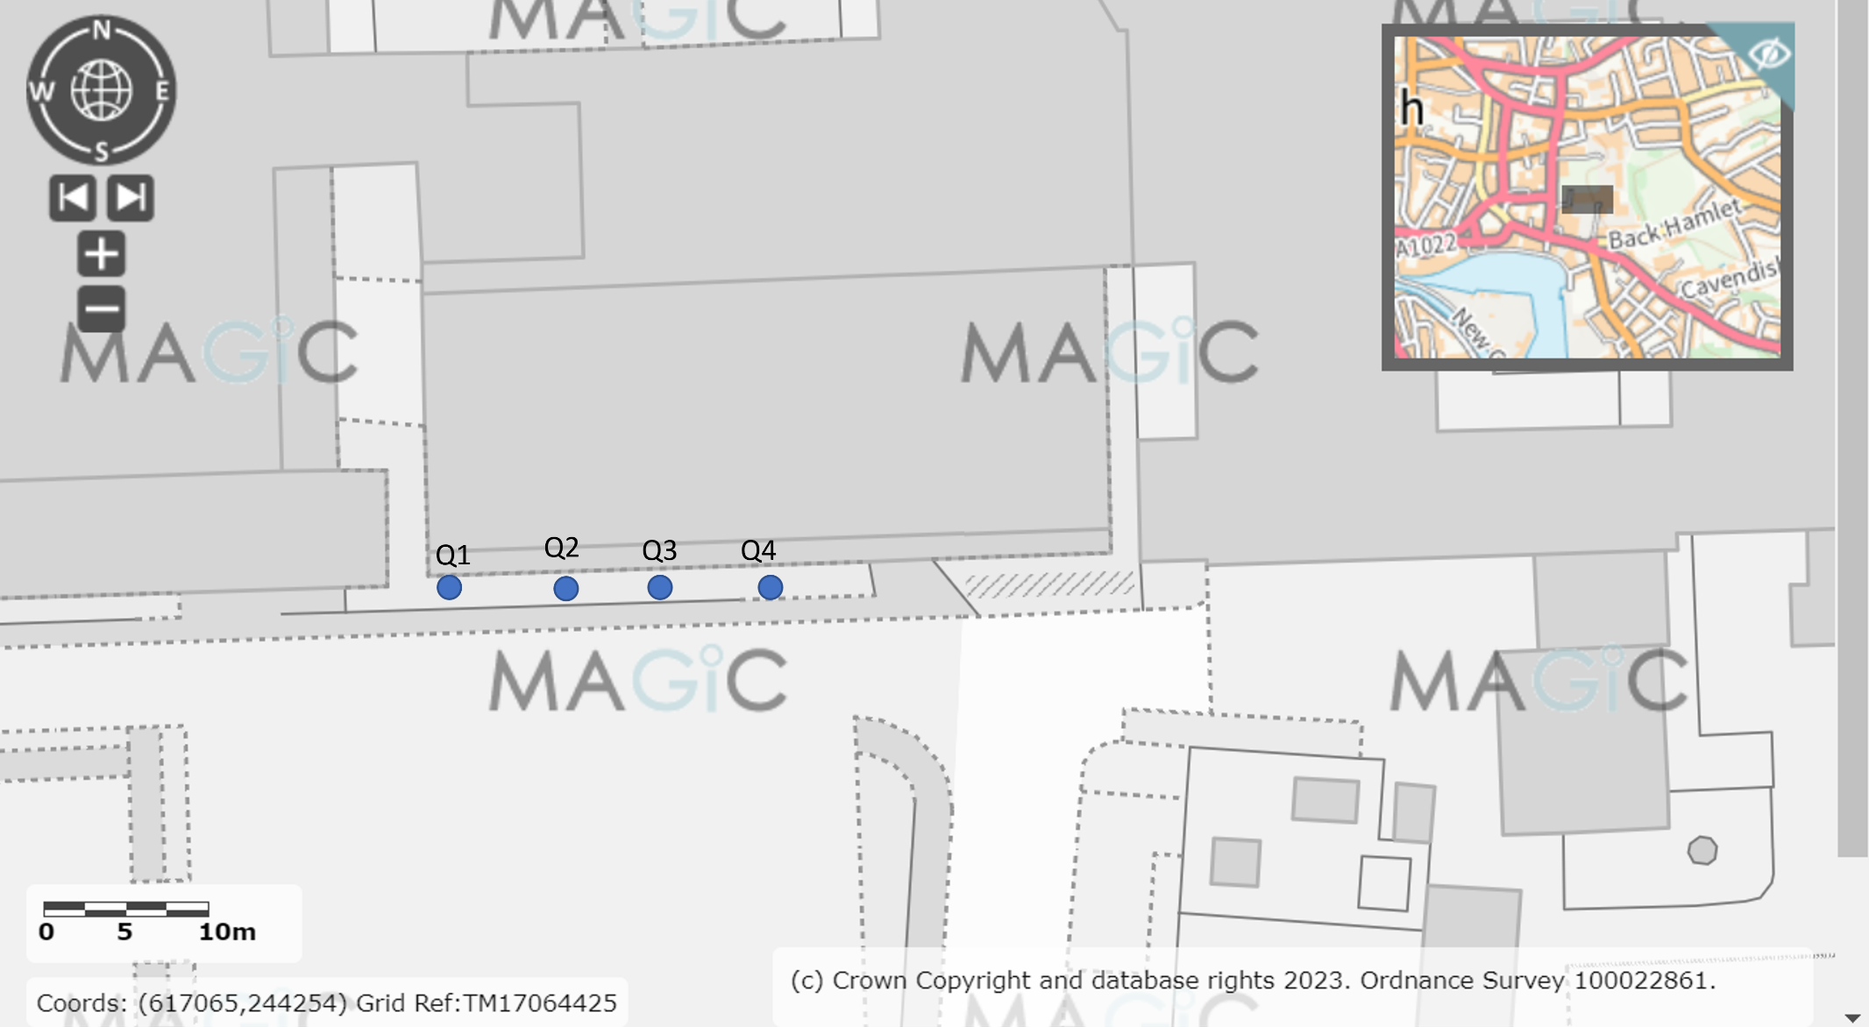
Figure 1, a diagram showing where each quadrat was placed, using systematic sampling. The blue dots indicate where the quadrats were laid. Image produced using the Magic Map application (DEFRA, 2024).

Results:
A map showing the habitats and target notes locations is below (Figure 2). Table 1 describes each target note and Table 2 shows that species were present within the quadrats and their local frequencies.
The total species richness for this site was 28 species, which is an increase of 11 species from the 2024 survey, and an combined increase of 17 species since the inaugural survey of this site in 2023.
Target Notes:
Table 1, a table showing the target note number and description of each target note.
Target Note No. | Target Note description
Q2 | Good distribution of Field thistle (Cirsium discolor) and Rough marsh mallow (Malva setigera), not native. Good abundance of Hoary mustard (Hirschfeldia incana).
Q4 | Bumblebee (genus Bombus) between Q3 & Q4. Also, one Narrow leaf birds foot trefoil, (Lotus tenuis), which is a nitrogen fixing plant (Cralle and Heichel, 1981)

Essential secondary codes applicable to this site are:
- 61 ‘re created habitat’.
Additional secondary codes applicable to this site are:
- 128 ‘Tall of tussocky sward’.
- 201 ‘young trees – planted’.
- 500 ‘dry’.
- 511 ‘compacted substrate’.
- 516 ‘active management’.
- 813 ‘educational building’
- 814 ‘education premises open space’.

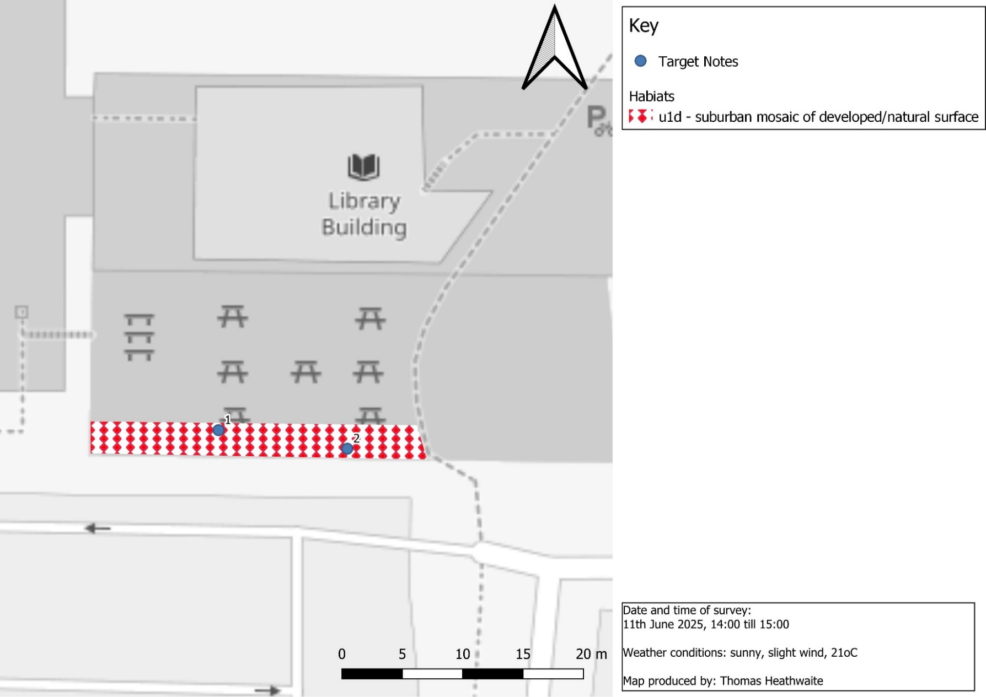
Figure 2, habitat map of the University of Suffolk's Bumblebee Buffet Area, Ipswich, OS Grid Reference: TM1705744239 using the UK Habitat Classification methodology (UKHab Ltd, 2023)
Table 2, showing the plants species present in each quadrat , their local frequency, and a photo if taken.
Quadrat number | Species name and local frequency | Photo taken?
Q1 – right next to fence | Wall barley (Hordeum murinum)
 | Common grass (family Poaceae)
 | Creeping buttercup (Ranunculus repens)
 | Nibwort plantain (Plantago lanceolata)
 | Dandelion (Taraxacum officinale)
 | Cleaver (Galium aparine)
 | Creeping cinquifuel (Potentilla reptans)
Q2 – near 3rd tree along | $\frac{25}{25}=wall barley ($H. murinum) | 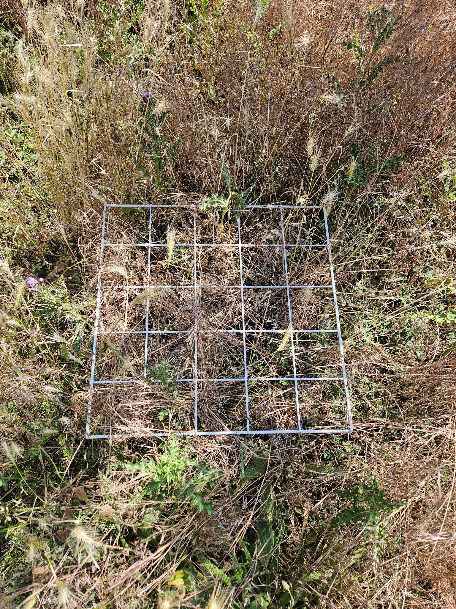  Figure 3, an overview of quadrat 2.
 | $$\frac{5}{25}=field thistle (C. discolor)$$
Q3 | $\frac{17}{25}=wall barley ($H. murinum) | 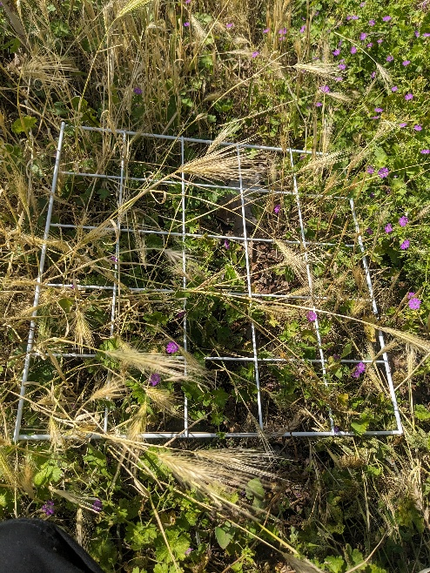  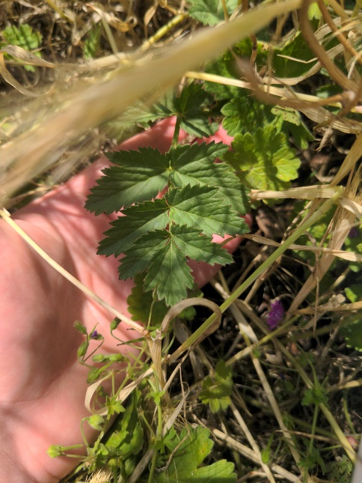  Figure 4, wall barley and dove's foot crane's bill.  Figure 5, greater burnet - saxifrage
 | $$\frac{16}{25}=dove^{'}sfoot crane^{'}s bill (Geranium molle)$$
 | $$\frac{5}{25}=greater burnet saxifrage (Pimpinella major)$$
Q4 | $$\frac{25}{25}=red fescue (Festuca rubra)$$ | 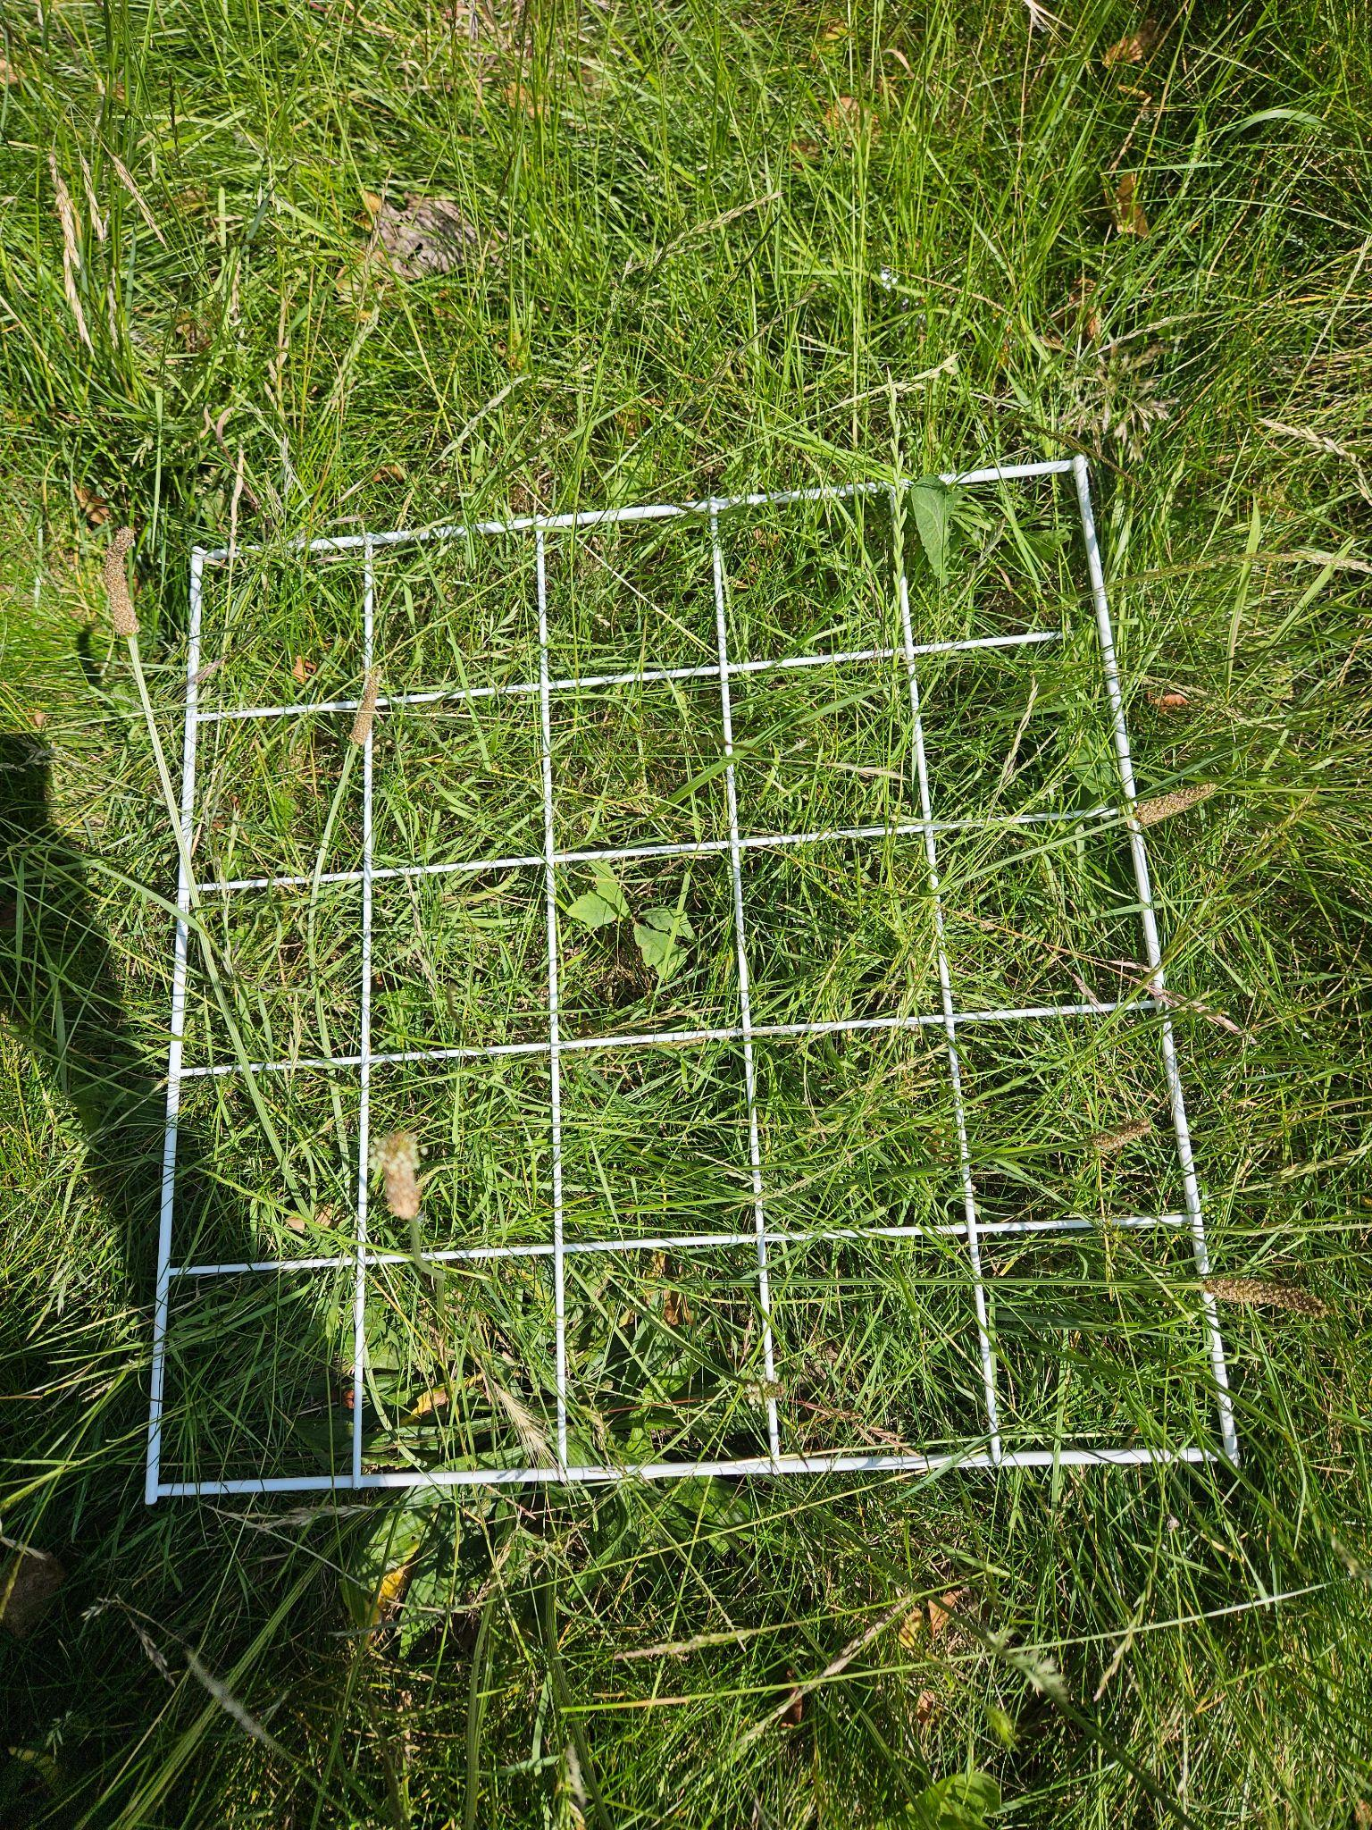  Figure 6, overview of quadrat 4
 | $\frac{6}{26 }=meadow foxtail ($Alopecurus pratensis)
 | $\frac{2}{25}=lamb^{'}tounge ($Plantago lanceolata)
 | $$\frac{2}{25}=field scabious (Knautia arvensis)$$
 | $\frac{1}{25}=english oak ($Quercus robur)
 | $$\frac{1}{25}=stinging nettle (Urtica dioica)$$

Results – Animals:
The following animals were spotted during the survey and during the spring.
- Red tailed bumblebee (Bombus lapidarius)
- Ladybird larve (species unrecorded) viewed.
- Grasshoppers (sub order Caelifera) present in both Q3 and Q4 (species unknown). Good distribution.
- Unidentified wasp species.
- Cricket (order Orthoptera) heard. Good distribution.
- White tailed bumblebee (Bombus lucorum), during spring.
- Buff tailed bumblebee (Bombus terrestris), during spring.
- Large white (Pieris brassicae), during survey
- Small white (Pieris rapae), during survey
Results: Desktop survey:
Please see the 2022 Phase 1 report covering the Wildlife Garden (the sites are so close to each other that the results will differ insignificantly between sites).

Discussion and Recommendations:
Species richness continue to improve year on year which is a positive sign for this area, notwithstanding this, there are several recommendations which can be made to further improve the biodiversity potential for this area.
The habitat classification of this site was u1d, suburban mosaic of developed and natural surfaces. No other category of the UK Habitat Classification methodology (UK Habs Ltd, 2023) met the species present in the survey, however, the aim is to get this habitat to a classification of g3c, other natural grassland, after first getting it back to g4, modified grassland.
Grass species continue to dominate the site, which along with stinging nettles (U. dioica) and cleavers (G. aparine) are out competing the wildflowers, with all species planted as plug plants after undertaking the 2024’s Phase 1 habitat survey of this site (see table 3, page 8 of the 2024 survey) not being identified this year. Whilst it is highly likely that the plug plants were planted to late during the season last year after the grass had already established itself, there was an expectation that yellow rattle (Rhinanthus minor) would be present this year and started to reduce the dominance of grass as it is a parasitic plant to grasses (Rowntree and Craig., 2018). However, yellow rattle (R. minor) is notoriously difficult to establish, due to its unreliability of seedling survival rate and it needs several sessions to establish (Hejduk et al., 2020). Some studies have also suggested that nutrient rich, more productive soils affects yellow rattle’s (R. minor) survival rate, however this is unclear (Hejduk et al., 2020). Notwithstanding this, it is recommended that a thorough planting programme is initialised over the autumn to reduce the dominance of the above species, particularly as Hejduk et al., (2020) showed that R. minor can reduce fescue (genus festuca) biomass.
Additionally, because the plug plant species last year have a range of biodiversity benefits (see table 3, 2024 survey for a summary) it is recommended that these are still integrated into the Bumblebee Buffet Area through establishment from seed, after selected rotovating of the site has happened (where the dominance of grass species is highest). These plants would also help to attract some of the rarer bee species, thus helping this site to continue to establish as a “bumblebee buffet area”.
As with all areas, management of this area should also seek to ensure a “right plant, right area” mantra. Indeed, although English oak (Q. robur) trees can support over 2,300 different species through their lifetime (Woodland Trust, n.d), and stinging nettles (U. dioica) are the food plant of the comma (Polygonia c-album) these should be removed from this site and maybe transplanted in their correct location.
Cow parsley (Anthriscus sylvestris) and groundsel (Senecio vulgaris) were all present in the 2024 and 2023 surveys but were not picked up in this survey. As these species are known to be beneficial to pollinators (Marshall et al., 2003; Lysenkov S.& Galinskaya T. 2017) next year’s planting should seek to reestablish these species.

Bibliography:
Cralle, H.T. and Heichel, G.H. (1981) Nitrogen fixation and vegetative regrowth of alfalfa and birdsfoot trefoil after successive harvests or floral debudding. Plant physiology, 67(5), pp.898-905.
DEFRA (2024) MAGIC. Available at: Magic Map Application [accessed 07/08/25].
Hejduk, S., Bitomský, M., Pornaro, C. and Macolino, S. (2020) Establishment of a hemiparasite Rhinanthus alectorolophus and its density‐dependent suppressing effect on a grass: A case study from golf roughs. Agronomy Journal, 112(5), pp.3619-3628.
Lysenkov S. and Galinskaya T. (2017) Comparison of the Pollen Content on the Body and in the Gut of Hoverflies (Diptera, Syrphidae). Entomological Review. 97:10-16.
Marshall, E.J.P., Brown, V.K., Boatman, N.D., Lutman, P.J.W., Squire, G.R. and Ward, L.K. (2003) The role of weeds in supporting biological diversity within crop fields. Weed research, 43(2), pp.77-89.
Natural Environment and Rural Communities Act 2006, c. 16. Available at: https://www.legislation.gov.uk/ukpga/2006/16/contents [accessed 13/08/25].
NBN Atlas (2025) Explore your area. Available at: https://records.nbnatlas.org/explore/your-area#52.10412650000001|1.3288216|13|ALL_SPECIES [accessed 13/08/25].
The conservation of habitats and species regulations 2017 (SI 2017/1012). Available at: https://www.legislation.gov.uk/uksi/2017/1012/contents/made [accessed: 13/08/25].
UKHab Ltd (2023). UK Habitat Classification Version 2.0. Available at: ukhab – UK Habitat Classification [accessed 07/08/25].
Wildlife and Countryside Act 1981, c. 69. Available at: https://www.legislation.gov.uk/ukpga/1981/69/contents [accessed 13/08/25].
Woodland Trust (n.d) Oak, English. Available at: English Oak (Quercus robur) - British Trees - Woodland Trust [accessed 15/08/25].

