9. Medicines Management

Your student will need to complete a medicines management assessment once during the part (year). Your student will send you an email link to access their medicines management or alternatively using your username and password.
To access the Medicines Management if you have logged in using your username and password, click on the menu at the top left of your screen, select your student and then click the menu again to select Medicines Management.

The Medicines Management is split in to a Formative and Summative section, so that the student has the opportunity to have a “trial run” before the summative. Please note that the Formative is optional and does not have to be completed. Only the Summative Section is Mandatory.

If a decision is made to NOT complete the Formative section, then the Practice Assessor should navigate directly to the Summative. Select Summative and then choose the relevant submission.

If the Formative is blank, the Practice Assessor will be asked to confirm that a Formative was either not offered or was offered and student declined.

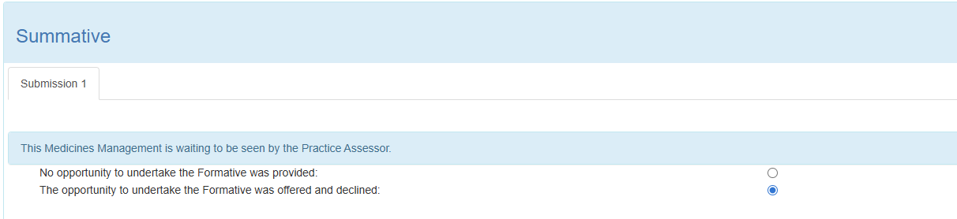

Next, record the Competencies the Student has achieved within Medicine Management, by selecting Yes or No in the achieved column for each competency.

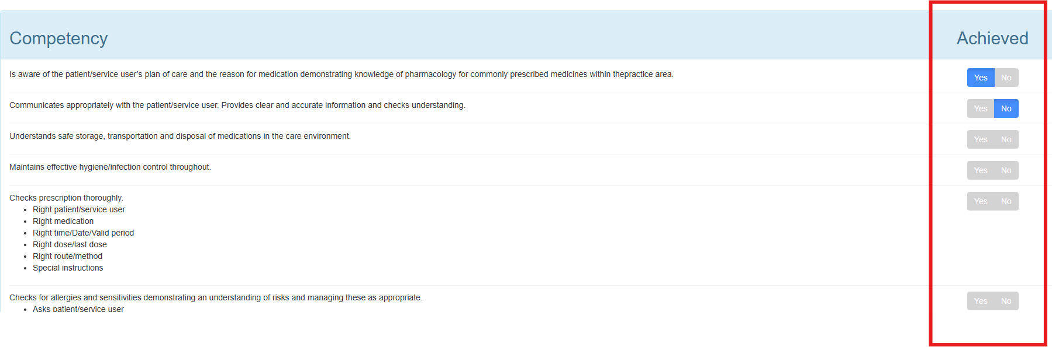
Once you have completed yes or no for each you can add any feedback into the comments box. You can then either save for later or save and submit to complete the Medicines Management review.

