7. Assessment of Proficiencies

Students need to have their Assessment of Proficiencies completed throughout the whole part. It is not essential that all are completed in the first placement however your student should aim to complete as many as possible in each placement. All proficiencies must all be achieved by the end of the part to progress to the next part. Proficiencies can be completed more than once where possible.
If you feel that your student has been unable to maintain a proficiency, you can mark it as ‘not passed’ even if you or another Practice Assessor has previously marked it as ‘passed’.

Your student will ask you to review one or more proficiencies and will tell you the number of each proficiency that they would like you to assess. They will also send you an email link to their ePAD to complete the proficiencies.

You can also login to the ePAD with your username and password. Once you have logged in clicking on the three bars menu button to the top left of the screen, then selecting Assessment of Proficiencies from the menu.

Ensure you select the correct part from the menu

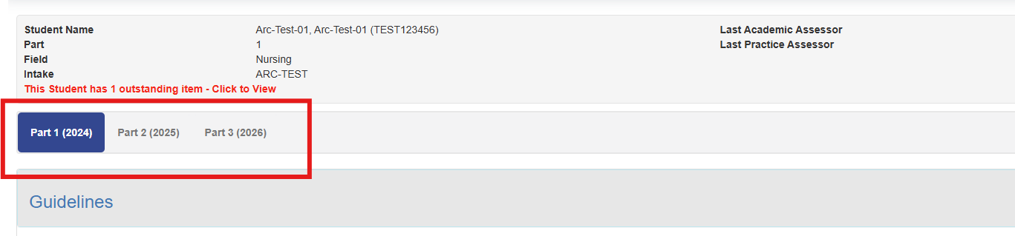

You can then select one of the options below to see a number of proficiencies within that section

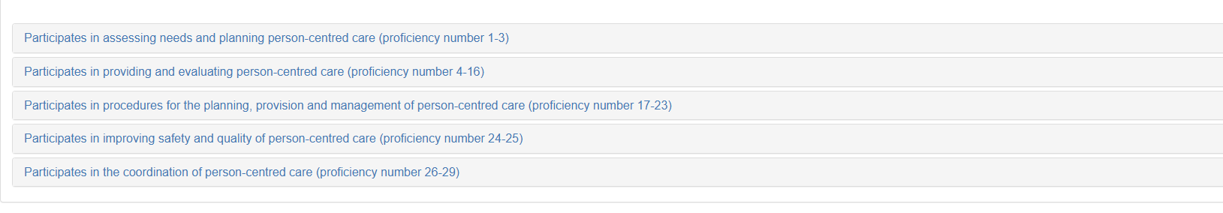

To sign off a proficiency simply add the date that it was achieved and select ‘Yes’ followed by ‘Save’

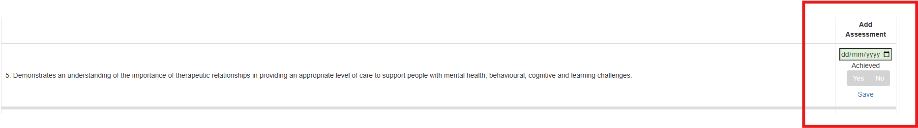

Once completed you will see a green tick. Proficiencies can be marked as completed multiple times, or marked as ‘not passed’ even if you or another Practice Assessor has previously marked it as ‘passed’.

