6. Action Plans

If you have identified any professional values that need to be developed at the Mid-Point Interview, or you have other concerns regarding your student’s practice, you should create an action plan to target those concerns so that your student has the opportunity to address them before their final interview.
To create an action plan for your student, you will need to first log into the ePAD using your username and password. Once you have selected your student, you need to click on the three bars menu at the top left of the screen.

You will then need to click on Action Plan which is towards the bottom half of the menu.

When the action plan screen loads you can create a new action and also review and mark as complete existing actions.

Create New Action
To create a new action, click on the Create New Action button. This will open the New Action form for you to complete as below.

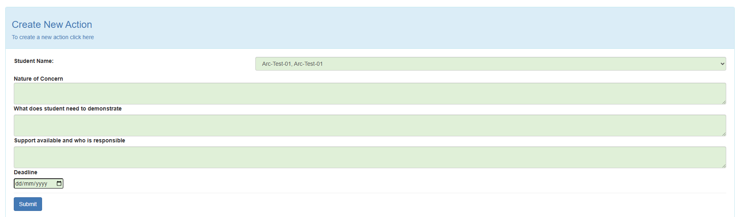

You should first check that the correct student name is displayed at the top of the form and then you can proceed to complete the form by filling out each of the green boxes. Please ensure that all boxes are filled out and that you have entered a deadline date which should be in the format dd/mm/yyyy
Once you have completed the form, you can click the blue submit button to complete the action. If you need to add more actions, you can repeat the process.

Review Actions and Mark as Complete

Here. you can also review the list of existing actions. Actions with a green status have been completed, those with a red status are still outstanding

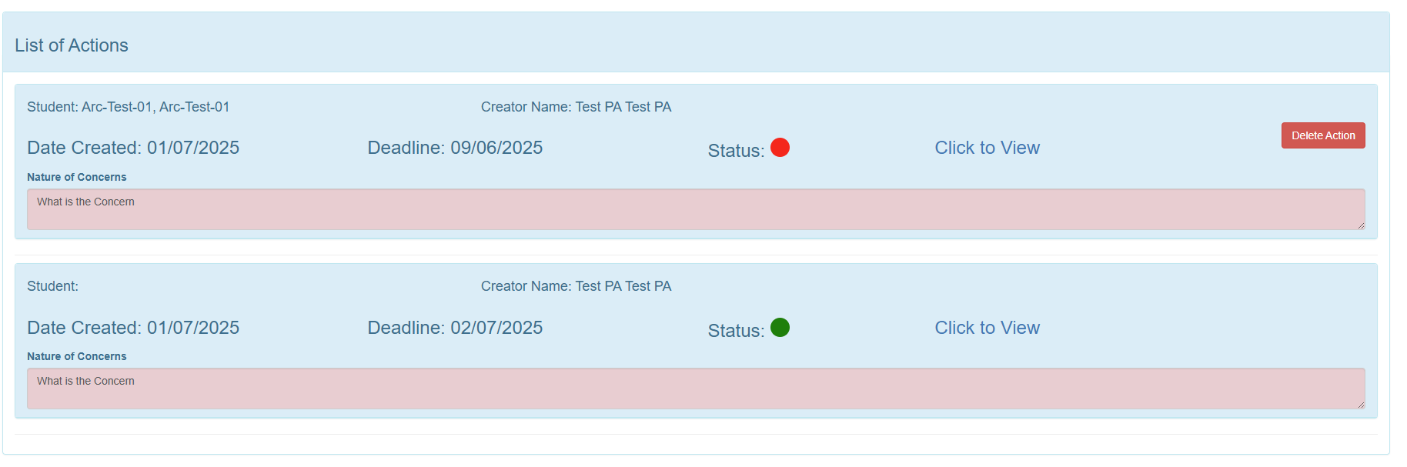

To review an action click ‘Click to View’. You will then be able to view the details against this action. You can then either add new comments or mark the action as complete

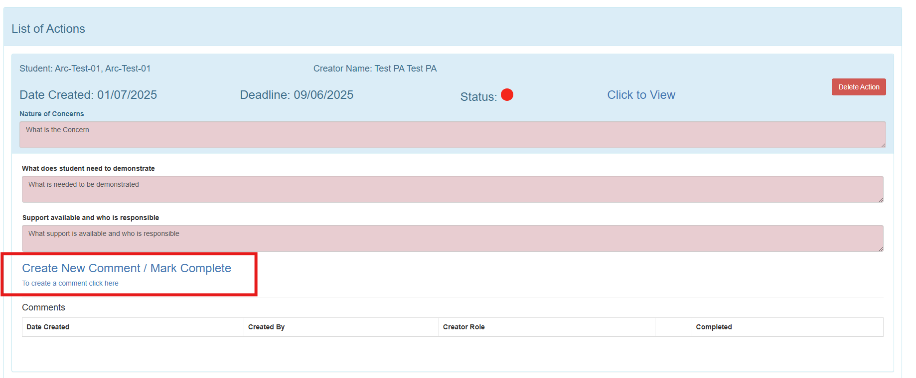

This will open a box for you to add additional comments. You can then leave the status as ‘Red’ if still outstanding, or click the ‘Green’ status button to mark the action as completed. Then press the blue ‘Submit’ button.
