**Completing the Final Interview & OAR**

**Final interview**

When the student has come to the end of their placement, you will need to complete the Final Interview.

The student must complete their section of the final interview before you are able to complete and finalise your section of the ePAD.

Once the student has completed their section of the final interview in the ePAD, you will receive an email link to access the student’s final interview in their ePAD.

If you do not receive the email link, you can [log in using your username and password](https://sites.glos.ac.uk/arcsupport/epad-training-practice-assessor-guide/logging-into-the-epad/). If logging in with your username and password, you will need to first select the student, then click on your placement in the list to be able to access the final interview section.

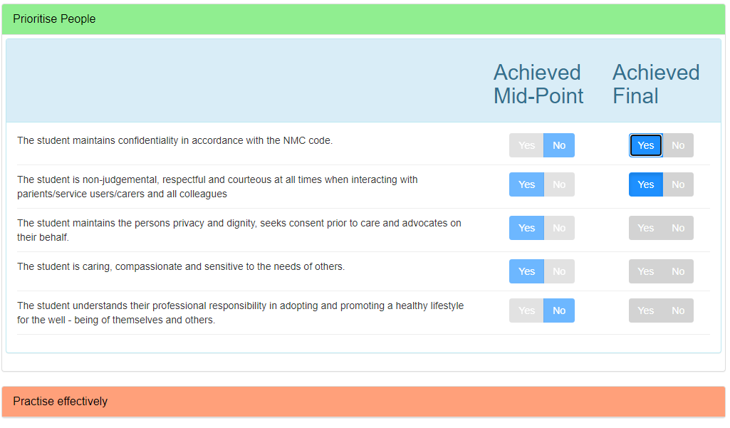Once you have accessed the correct part of the ePAD you need to assess the student’s professional values. This follows the same procedure as in the Mid-Point Interview and you will see the Mid-Point entries to help you with your assessment.

You need to access all four categories of professional values and asses the student as having either achieved or not achieved each value by selecting yes or no at the end of the row.

You will need to add an action plan for any values that have not been achieved, this can be done at the bottom of the screen by clicking on Create New Action. All professional values must be passed to for the student to successfully pass their placement.

Once you have completed your assessment of the student’s professional values, you can scroll down the page and review the student’s comments before adding your own comments.

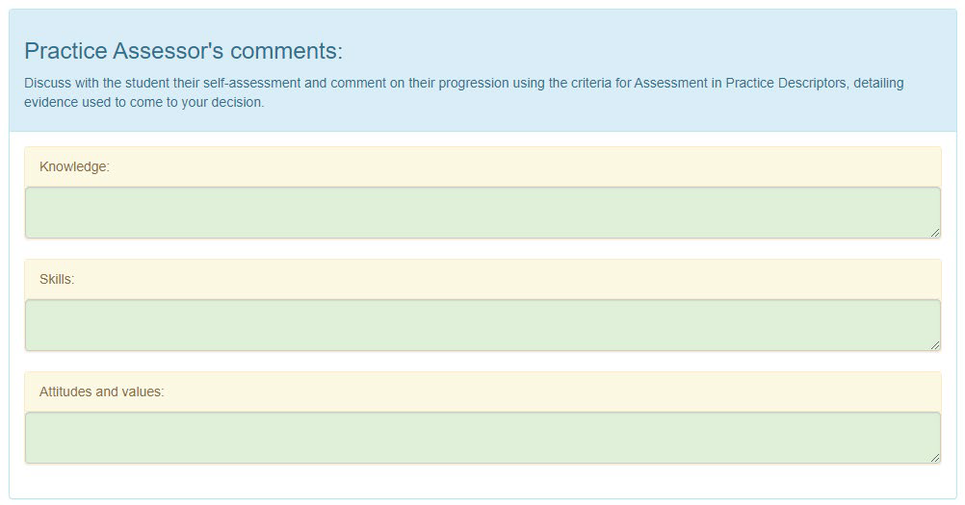

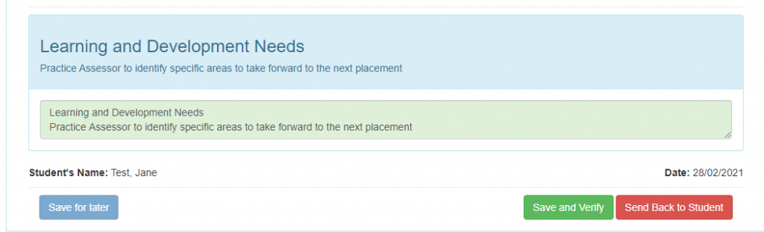You then need to add any learning and development needs and save and verify the final interview. If you want to save your work and come back to it later, you can click “Save for Later” and then log out of the ePAD.

**OAR – Ongoing Achievement Record**

After the final interview is complete, you need to complete the OAR.

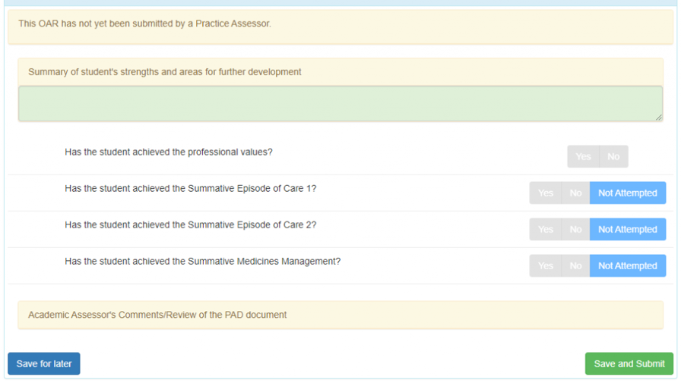Under the placement name you will see a box to add your overall comments on the student’s strengths and areas for development, and several questions to answer. You will need to state if the student has achieved all the professional values and if they have achieved, not achieved or not attempted the Episodes of care and the medicines management tasks.

The students must have achieved all professional value in each placement and must have completed all Episodes of Care and the Medicines Management by the end of the last placement of the part (year) to pass the part. If any of these are missing at the end of the last placement of the part, please ask the student to complete them to avoid failing the part.

Once you have completed this section you can Save & Submit the OAR.

**Final placement**

If you are completing the OAR for the student’s final placement of their course, you need to scroll to the bottom of the page and complete the End of Programme section. Once you have answered the questions, please click Save and Submit.

