**Completing the Midpoint Interview**

**Midpoint Interview:**

After the Mid-Point Interview has been held with your student, this will need to be documented in the ePAD.

The student must first complete their self-assessment/reflection on progress and add any Mid-Point Review Learning & Development needs that you have identified for the remainder of the placement.

Once your student has completed their sections of the Mid-Point Interview in the ePAD, they will submit it to you to review in an email link which will take you to the correct place in the ePad.

Click on the link and add your comments on your student’s knowledge, skills, and attitudes & values.

**Professional values**

The first part of the Mid-Point Interview is the Professional Values section which is subdivided into four categories; Prioritise People, Practice Effectively, Preserve Safety and Promote Professionalism & Trust. Although the categories are the same for all parts of the programme, the individual values differ for each part.

Before you start to fill out your sections, you should review the student’s comments and the learning and development needs that they have identified which should have been discussed as part of the interview process.

When you click on the category titles, the box will expand to show you the values in that domain. You need to select Yes or No to indicate whether your student has achieved and demonstrated each value.

Once you have completed a category you can click on the next category to state whether those professional values have been achieved or not.

Please note – If a Professional Value has NOT been achieved, then an Action Plan should be created – please see the [guide to Action Plans here.](https://www.glos.ac.uk/information/knowledge-base/epad-action-plan/)

Once you have assessed all the professional values, you will be able to scroll down the screen and add your comments into the Practice Assessor’s Comments section. You have the same subheadings as your student and there is no word limit to the Practice Assessor’s comments section.

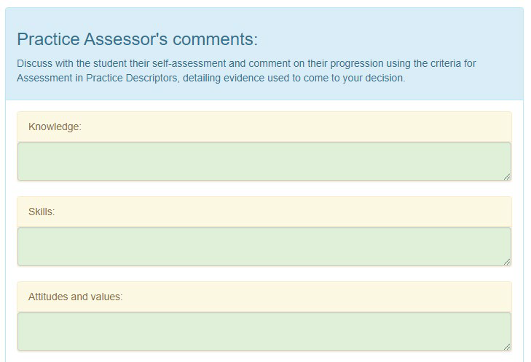

If you wish, you can click the “Save for Later button at the bottom left of the screen to save your progress. You can then log back into the Mid-Point review at another time to continue where you left off.

Once you have completed the review click “Save and Verify, or if you disagree with something the student has entered you can send the review back to the student.

Save and verify button


Click ‘OK, verify the Mid-point Interview’

If the “Save and Verify” buttons are missing, your student has not correctly submitted their section of the Mid-Point Interview and will need to do so before you can finalise your section.