**Navigating the ePad:**

After logging into the ePad, you will arrive at the homepage.

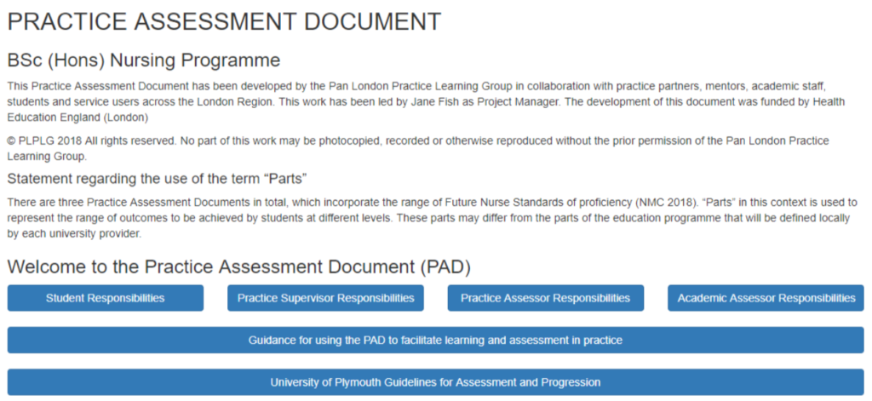

Select any text box in blue heading to expand the section and view the helpful guidance notes.

To return to the home page at any time, just click ‘Home’ in the top right of your screen.



**Accessing the menu**

You can access all sections of ePAD from the main menu – to open the menu, click on the three black bars in the top left of your screen.

**GUIDE TO FINDING A STUDENT RECORD IN EPAd**

To search for a student in ePAD first select the menu (top left of the screen) and select ‘Students’.

On the next screen you will see a search box. Enter the student’s name into the box and click the blue search button. You do not need to fill in all three boxes, you can search just for surname or forename.

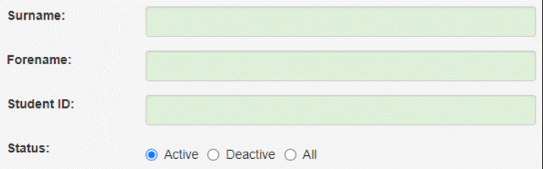

If your student is available in the ePAD, they will appear in a list underneath the search box.

To load your student’s details, click on the student’s name (shown in blue).

