10. Record of Communication

You can add emails and files to the students records to be viewable by Practice Assessors, the student, and Academic Assessors.

Your student cannot send you a link to this section so you will need to log into the ePAD using your username and password. Once logged in you can click on the menu at the top left of the screen, this is the three bars icon, and then select Record of Communications from the list.
Once the record of communications screen has opened, please make sure that the correct part (year) has been automatically selected for your student and change it if needed.

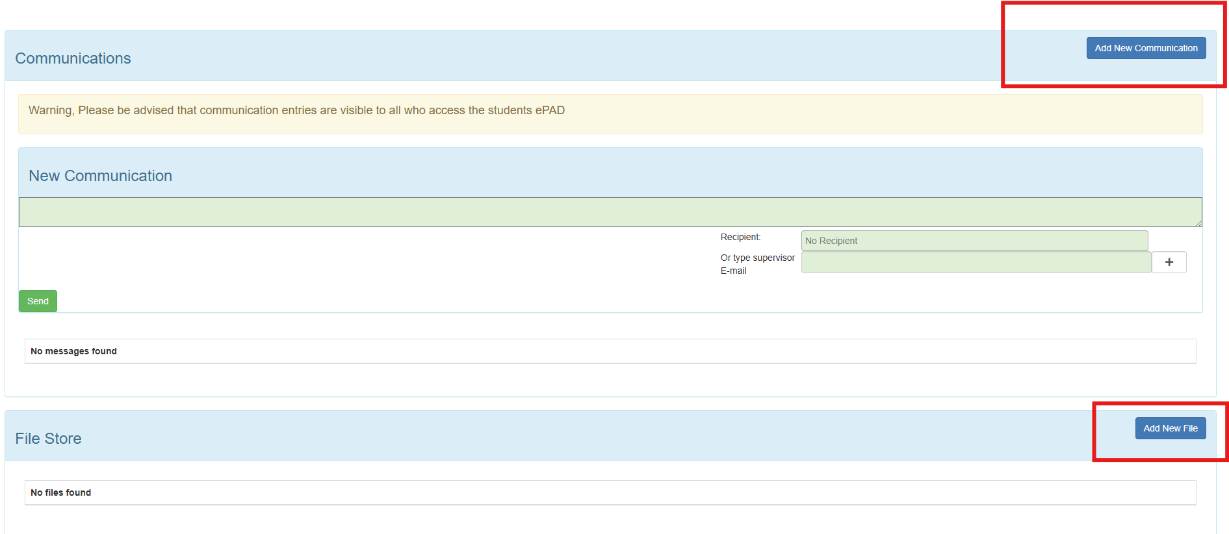

You can add a new communication and ensure you enter the recipient details and press ‘Send’.

You can add files in this section too, such as patient feedback. Click ‘Add New File’ and click to upload a files or drag and drop. Make sure you press ‘Save’

