Supervisor Feedback
Log into the eMORA, select the menu at the top left, and select ‘Students’.
Select the relevant student from the list. You will only be able to see students that have selected you as a Practice Assessor.
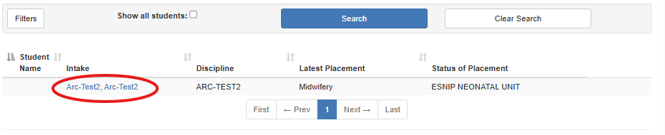
From the menu at the top left, select ‘Supervisor Feedback’.
You may select ‘Guidelines on completing the Supervisor Feedback’ to read information on completing these.
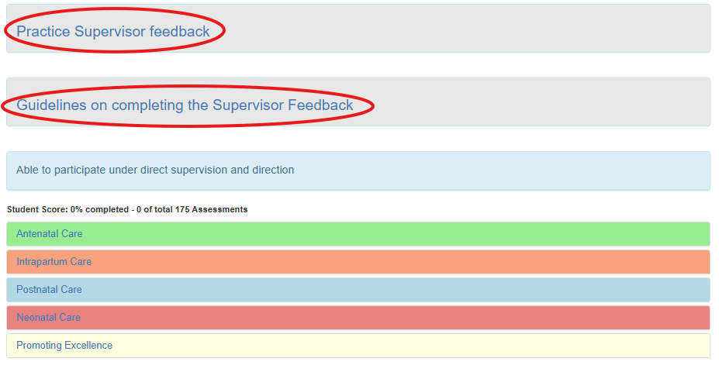
Selecting one of the headings brings up an icon to add supervisor feedback.
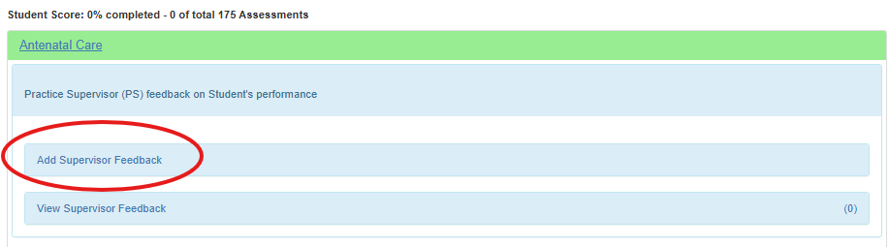
Select ‘Add Supervisor Feedback’.
Fill in the required sections and select ‘Submit’.

