Completing Assessment of Proficiencies
Log into the eMORA, select the menu at the top left, and select ‘Students’.
Select the relevant student from the list. You will only be able to see students that have selected you as a Practice Assessor.
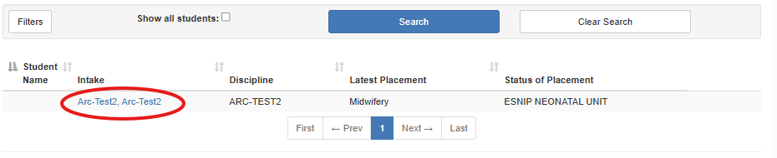
From the menu at the top left, select ‘Proficiencies’.
You may select ‘Guidelines on completing the Proficiencies’ to read information on the completing these.
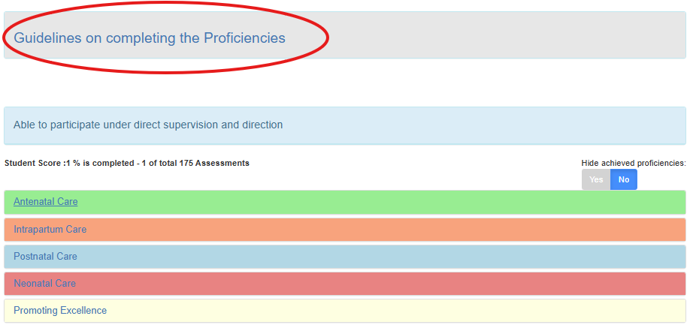
Selecting one of the headers brings up the corresponding proficiencies.
Select the date that the proficiency was met and select ‘Save’.
