Completing a Progression Plan
A progression plan is required when there is a need to address a student’s progress or performance. The Acadmeic Assessor must also be informed.
Log into the eMORA, select the menu at the top left, and select ‘Students’.
Select the relevant student from the list. You will only be able to see students that have selected you as a Practice Assessor.
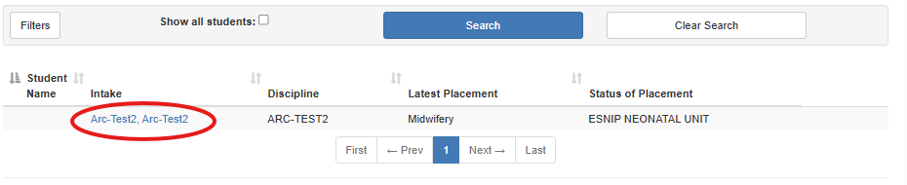
From the menu at the top left, select ‘Progression Plan’.
Select ‘Create New Progression Plan’.
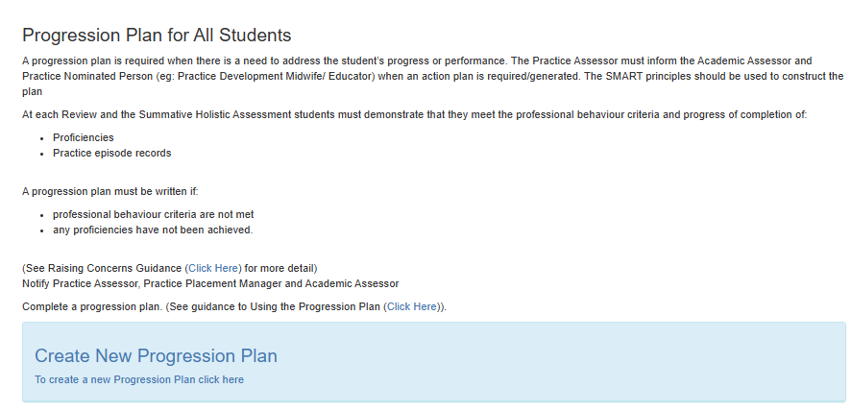
Select ‘Create new Progression Plan’.
Complete the sections within the green boxes and select ‘Submit’.
