Completing Practice Episode Records
When a student completes a Practice Episode Record and records you as the Practice Supervisor, you will receive an email inviting you to verify the record.
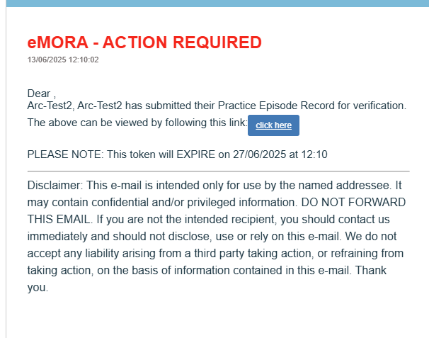

Find the required Practice Episode from the list. Selecting the ‘+’ symbol brings up what the student has recorded.
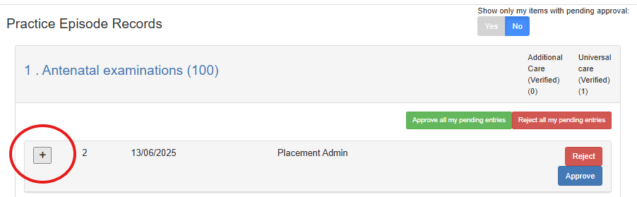
Providing that you agree with what the student has recorded, select the ‘Approve’ icon.

