Completing the Initial Meeting
Log into the eMORA, select the menu at the top left, and select ‘Students’.
Select the relevant student from the list. You will only be able to see students that have selected you as a Practice Assessor.
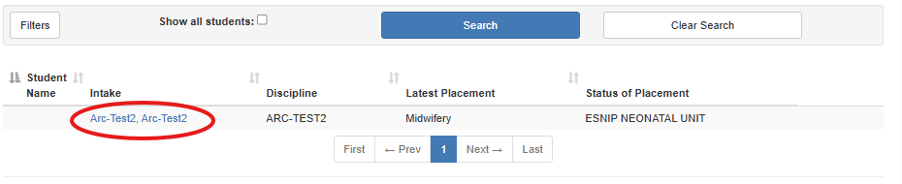
From the menu at the top left, select ‘Initial Meeting’.
The student will have completed the top part.
Please comment the bottom part in the green box and select ‘Save and Submit’.
