Completing the Orientation
You will receive an invitation by email.
Select the relevant ‘click here’ icon to be taken to the entry on eMORA.
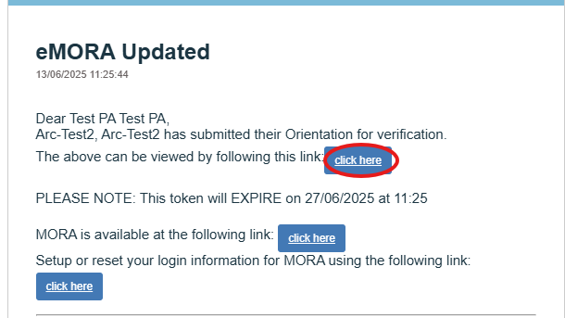

Alternatively, log into eMORA and, using the menu, navigate to the student and then to ‘Orientation and Timesheets’.
Under ‘Electronic Orientations’, select the relevant area.
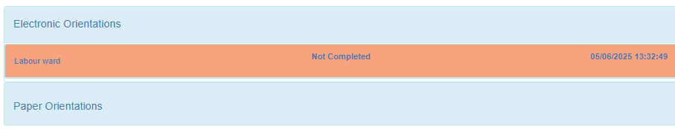
The first part is to be completed with the student on the first day.
Select ‘Mark as See’.
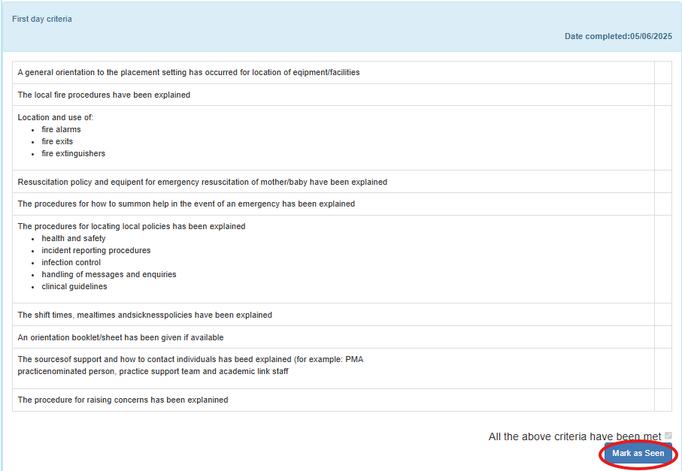
Then select ‘OK, Verify the Orientation’.
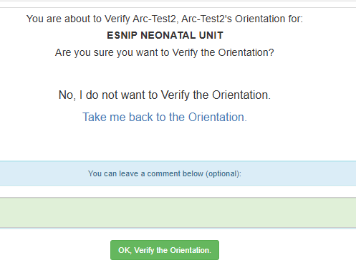
The second part of the orientation is to be completed with the student during the first week.
The same steps as above can be followed.
Once the first week criteria has been completed, select the check box and then select ‘Mark as Seen’ followed by ‘OK, Verify the Orientation’.
