Completing the Learning Contract
Log into the eMORA, select the menu at the top left, and select ‘Students’.
Select the relevant student from the list. You will only be able to see students that have selected you as a Practice Assessor.
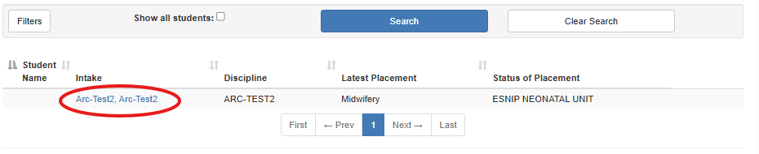
From the menu at the top left, select ‘Learning Contract’.
The student will have completed the Student Declaration.
Please complete the Practice Assessor Declaration by selecting the tick box and selecting ‘Submit’.
