Navigating the eMORA
When you first log in to eMORA, you will arrive at the homepage.
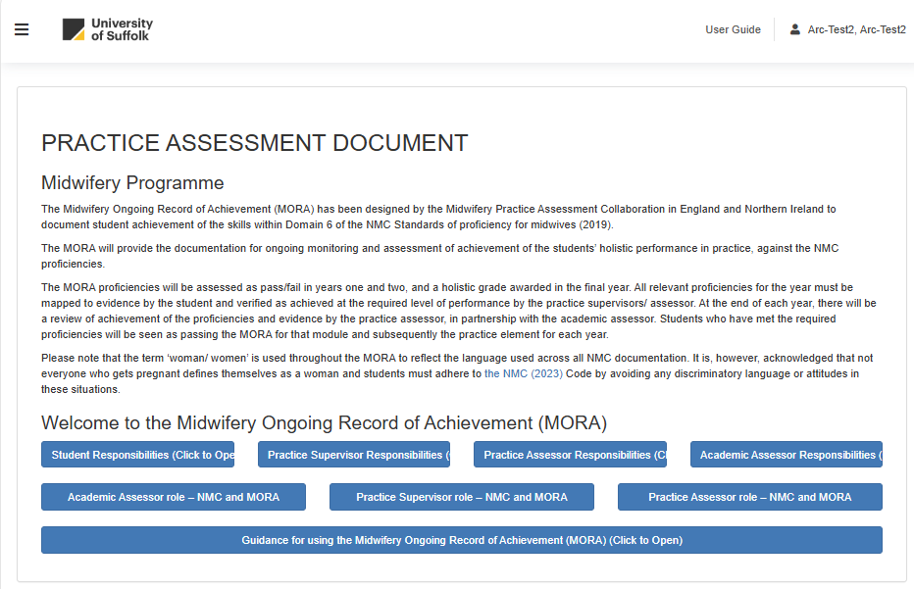

You can access all sections of eMORA from the main menu. To open the menu, select the three horizontal bars at the top left of the screen.


