Summative Holistic Assessment
Log into the eMORA.
Select the relevant student from the list. You will only be able to see students that have selected you as a Practice Assessor.
Select the menu at the top left and select ‘Summative Holistic Assessment’.
The student should have completed the Student reflection section.
The Practice Assessor Summative Holistic Assessment section is to be completed with the student.
Select the link highlighted in red below to bring up the green text boxed to be completed.
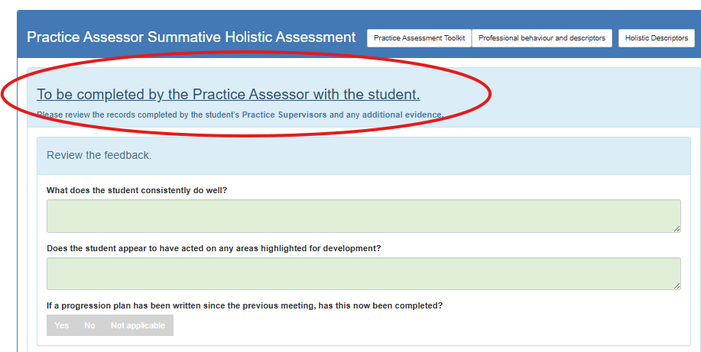
Select ‘Save and Submit’ once completed.
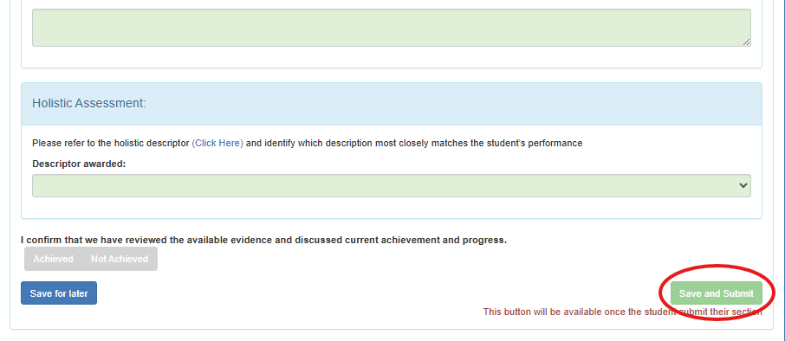
Complete the Academic Assessor Summary of Progress section and select ‘Save and Submit’.

