Record of meetings/ periodic observations
This section is to be used to record notes from any meetings between the student and Practice Supervisors, Practice Assessors, Academic representative, Academic Assessor or Practice Nominated Person
Log into the eMORA.
Select the relevant student from the list. You will only be able to see students that have selected you as a Practice Assessor.
Select the menu at the top left and select ‘Record of meetings/ periodic observations’.
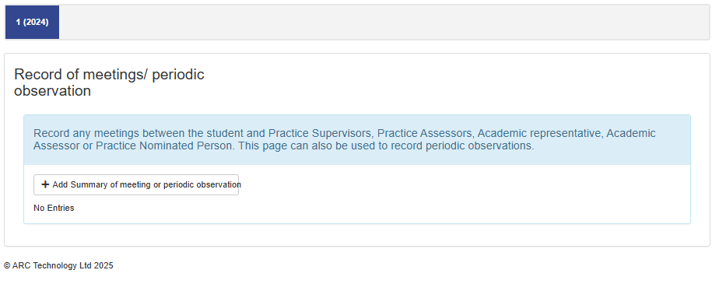
Select ‘Add summary of meeting or periodic observation’.
Enter the meeting notes into the green box.
