Practice Assessor Review 1 and 2
When a student completes this section and submits it you, you will receive an email link:
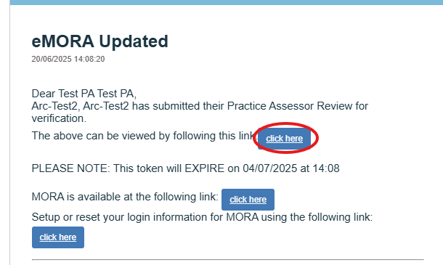
Alternatively, log into the eMORA, select the menu at the top left, and select ‘Practice Assessor Review 1/ 2’.
Select the relevant student from the list. You will only be able to see students that have selected you as a Practice Assessor.
The student should have completed the Student reflection.
Please complete the Assessor reflection and then select ‘Save and submit’.
