Logging in to eMORA
You will be able to access eMORA upon receiving an email invitation from a student.
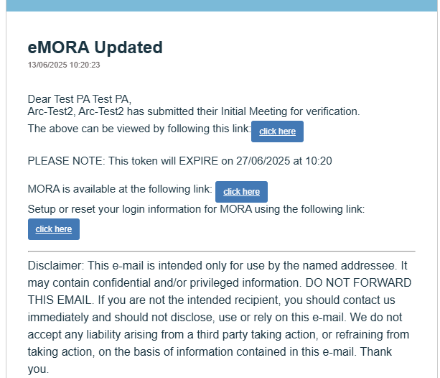
To access the section that the student has invited you to, select the relevant ‘click here’ icon.
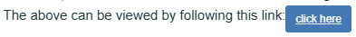

You can also set up your account using the relevant icon.
