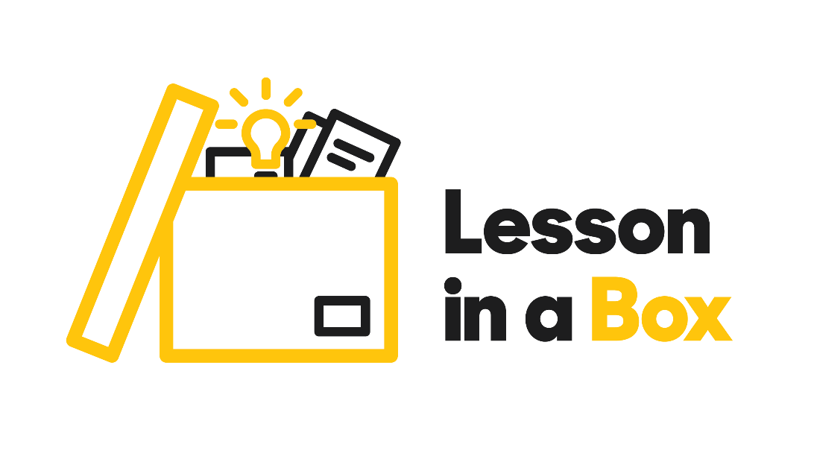

BA Childhood and Education with QTS / How do Children Learn. Lesson 1.

|  |  |
| --- | --- |
| Lesson title | How do Children Learn. |
| Session format | * Video Lecture and Video activity instructions. * Group discussion. * Activity with materials. |
| Aim of the session | * To introduce the topic of children’s learning. Highlighting how much children learn from their environment and everyday items. |
| Session overview | * Video lecture Part 1 Welcome and Introduction. * Activity 1 with resources and discussion. * Two additional activities. * Video lecture Part 2 Review of activity   and Employability and course information video. |
| Materials | * Digital Video lecture with activity instructions. * Online PowerPoint presentation of the session. * Employability and course overview video. * Physical Materials: Play-Doh (8), tissue boxes (3), plastic cups (9), plastic containers (7). * PowerPoint slides with images of physical materials if using online resources only. * Handout for Additional activities available online.   . |

|  |  |  |
| --- | --- | --- |
| Activity | Instructions | Resources |
| **Watch Video** | **Play Video**   * Welcome and introduction to the session. * How do children learn? * What can a child learn from specific items? * The video includes instructions for the resources and discussion activity.   **Pause Video** | * Physical box of resources. |
| **Interactive** | **Activity 1**   * Ask the students to work in groups of 4 or 5. * Once each group has a box resource, ask the students to look at the item and encourage them to think about what a child could do with the item and how and what they could learn. * Circulate around the groups to listen to some of the ideas that students are coming up with. * Ask the students to swap resources. * Bring the class back together as a whole group to share their ideas (for example use of Play Doh for creativity, learning about colours, squish it to make shapes etc). | * Distribute Play-Doh tissue boxes, plastic cups, plastic container, and the tissue boxes. So, one group of students has one item/ resource each. If using online material only use Power point of physical materials. |
| **Play Video**  **Length 10 minutes** | * Review of Activity 1 and summary of what a child could learn from each resource. * Information about BA (Hons) Childhood and BA (Hons) Childhood: Primary Education with QTS. * Employability and UOS course information video. * End of 45-minute session. Please see additional activities below depending on the length of your session. These activities could be spread over a half-term/term or multiple terms depending on the interests of your students and your aims in terms of the focus on this topic.) | * Use Employability and course info Power Point if required. |
| **Interactive** | **Additional Activity 1 (Depending on length of session)**   * Students to work individually starting from Page 1 to write in each text box what they think ‘learning’ and ‘education’ are in their own words. * Students do not have to think of a complex definition, encourage them to think about each term and write what they think it involves. Students can then share what they have written with other students in their small group or the whole group. * Then on Page 2, students can choose 3 words from the list of key words which they think fits best with each term (‘learning’, ‘education’) * Students can then share and discuss their choices and why they chose these words. | * Hand out the ‘Lesson 1 Children and Learning Worksheets’ to each student. |
| **Interactive** | **Additional Activity 2 (Depending on length of session)**   * Students can be shown this video and then discuss what they think the infants in the video could be learning/which skills they are developing during this interaction. | * Watch Video link below on YouTube: <https://www.youtube.com/watch?v=_JmA2ClUvUY>   (Twin babies ‘talking’ to each other). |
| **Interactive** | * Ask students to complete lesson feedback forms. * End of Lesson in a Box. | * Hand out student feedback forms from box. |