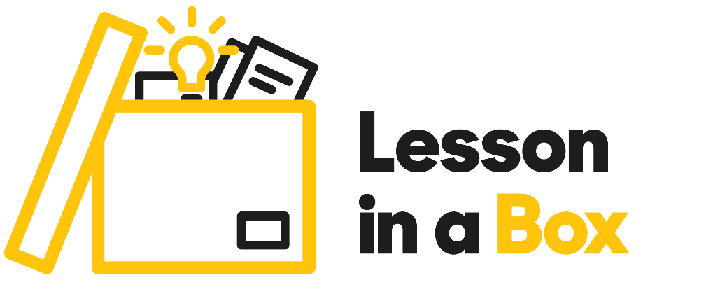

BA (HONS) Architecture/ Light and Experience. The hidden materials of Architecture.

Lesson title | Light and Experience. The hidden materials of Architecture.
Session Overview | First part of the session.  - Session should start with students making card models using the Brutal Britain books provided in the box to create a model city.  Second part of the session.  - Play the guided digital footage which includes the following.  - Introduction into studying Architecture and how light is used as a material within the design of structures.  - Introduction to Key Architects Tadao Ando, and Frank Gehry.  - Guided two-minute and seven- minute student model making activity.  - End of Digital footage.  - Remaining time left for developing students 7-minute model or use the time to create another model (Depending on lesson length).
Materials | - Online PowerPoint.  - Online Lesson Plan.  - Digital video footage led by Academic Marco Spada.  - Box Materials - Brutal Britain Model making books, plastic human figures, A4 paper in different colours.  - Box includes, Pritt Stick, green cutting mat, ruler, tape measure, protractor, adjustable set squares, (Equipment can be shared by students working in pairs).
Materials not included but required for session. | - Scissors or cutting Scalpel blade.

Activity | Instruction | Resources
Interactive  10/15 minutes | Start the session.  - Ask students to work in small groups depending on class size.  - Hand out individual lesson in a box resource kit to each student or between two if students wish to work together.  - Hand out the Brutal Britain books to students. Each book has 8 press out models that can be folded and glued together.  - Ask students to work in small groups depending on class size.  - If students are sharing a book resource, ask them to press out the model and take a picture of the instructions so the model making is shared between the class  - Once the students have created their model city play the lesson in a box digital content. | - Brutal Britain books.  - Students will also need the Pritt Stick glue.
Video  24 Minutes | Play video  - Introduction to Architecture as encompassing imagination, sustainability and being a collective art form (6 minutes).  - Explanation of how light is used in the Architecture process.  - Short film of light and shadow – highlighting work by Architecture Tadao Ando - (2.37 minutes).  - Introduction to the work of Architecture Frank Gehry – (8 minutes).  - Why study Architecture at the University of Suffolk.
 | Pause video  - Ensure students have all the resources needed and are prepared to start the model making activity. | Students will need  - One sheet of paper.  - Scissors or Scalpel blade (not included in kit).  - Pritt stick.  - Sandpaper.  - Plastic figures /blue tact.
Video | Play Video  - Watch Marco create a model in 2 minutes.
Interactive | Pause Video  - Set a timer and give students 2 minutes to create their first model.
Watch Video/ Interactive | - Give students a few minutes to prepare their materials for the next model making activity.  - For the next part of the session. Encourage students to watch the footage and work alongside Marco to create their second model in 7 minutes. | - Each student/pair will need two different colour pieces of paper.  - Scissors or Scapel blade (not included in kit).  - Pritt stick.  - Sandpaper.  - Plastic figures/blue tact.
Watch Video/Interactive Activity. | - Play Video  - Students to create second model in 7 minutes.  - End of Digital Content.
Interactive | - Any additional time for students to extend their 7-minute model or to create an additional structure in 15 minutes depending on session time constraints.  - Encourage students to use light (using the torches provided or their phones) and their created structures. | - Encourage students to use all resources and equipment in the packs.
 | - Ask students to complete lesson feedback forms.  - Place forms and any unused resources back in the box.  - End of Lesson in a Box. | - Handout student feedback forms.

