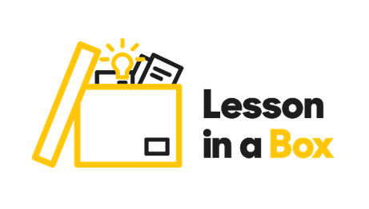

**Lesson 2 Diversity and Inclusion: Additional activities worksheet**

**Additional activity 1 Mind maps Feeling included vs not included**

Think of a place **where you feel included**? What makes it feel that way? Write some ideas down.

Think of some possible situations **when people might not feel included.** How could they feel? What do you think prevents them from being included? Write down some of your ideas.



**Additional activity 2 Cooking inclusion**

Write down your own recipe for inclusion. List the ingredients, their quantity and describe the cooking process.

Quantity: Ingredients:

____________________ __________________________

____________________ __________________________

____________________ __________________________

____________________ __________________________

____________________ __________________________

____________________ __________________________

____________________ __________________________

Cooking instructions:

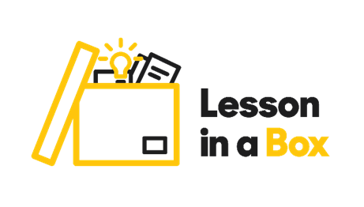

**Additional activity 3 Strengths for each finger**

Trace around your hand.

Then think of your skills and your strengths and write one for each finger.



**Additional activity 4 Diversity acrostic**

Think about what defines diversity. Come up with an association for each letter of the word.

D ___________________

I ___________________

V ___________________

E ___________________

R ___________________

S ___________________

I ___________________

T ___________________

Y ___________________



**Additional activity 5 Song lyrics**

Creative task: Based on the ideas that you collected, write song lyrics about diversity and inclusion.