
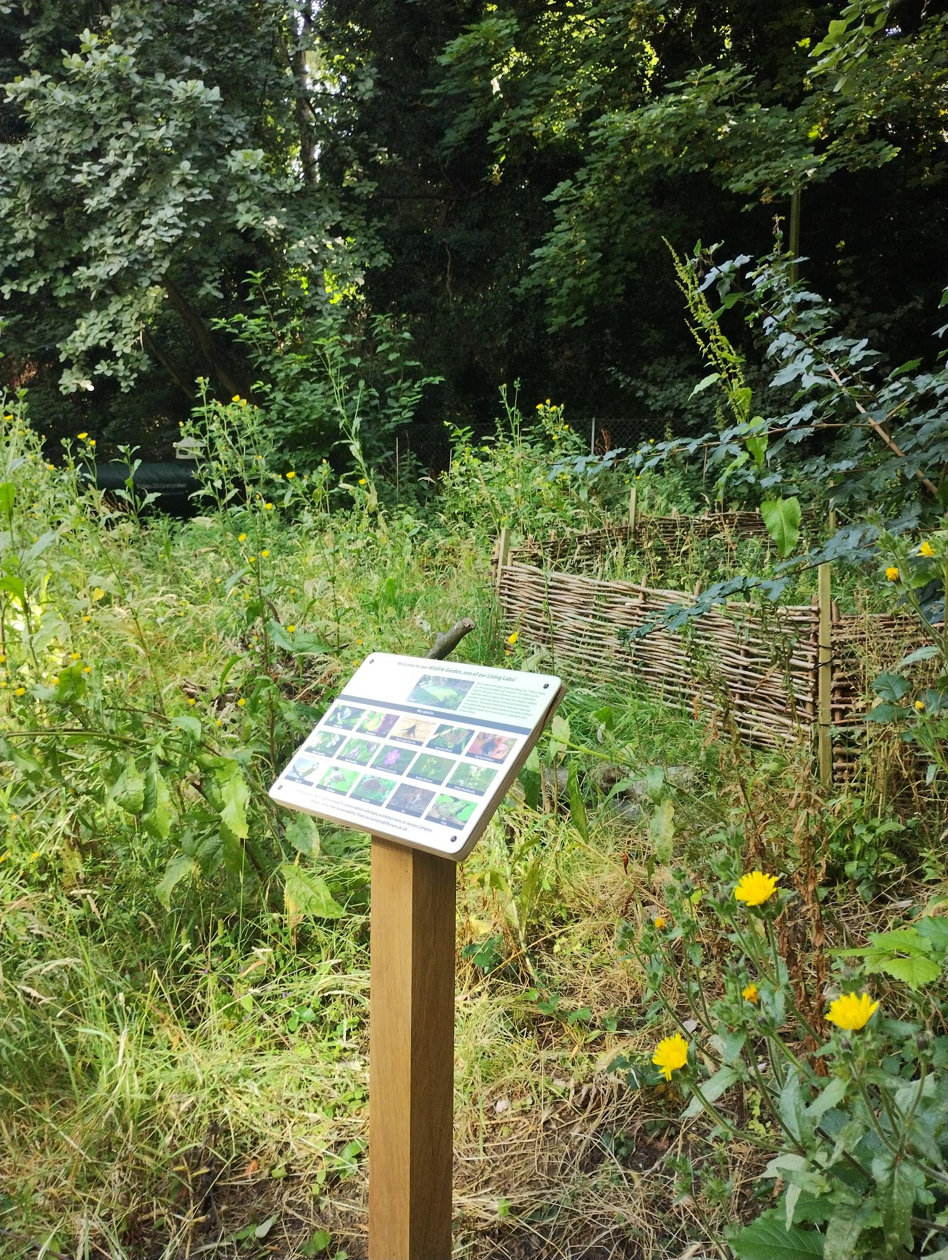
Wildlife Garden
UK Habitat Classification Survey Report
2025
Site name: University of Suffolk Wildlife Garden
Grid reference: TM17194420
Area: 179.4 meters²
Date and time of the survey:
Terrestrial: 21st May 25, between 12:45 and 14:00
Weather conditions:
Terrestrial: overcast, limited sun, no wind, 18°C
Recorders:
Terrestrial: Thomas Heathwaite (staff) and two WECS students: Daniel and Cameron
Location, description, and geology of site:
The site is located on the University of Suffolk campus which is in the centre of Ipswich. Bordering the wildlife garden, to the east, is Alexander Park. Suffolk new college boarders just to the north of the University of Suffolk campus and the marina and Ipswich wet docks are to the south of the University of Suffolk campus. The centre of Ipswich is about 1km from the site campus.
The geology of the site consists of clay, silt, and sand and this type of geology is known as Thames Group geology
Statuary and Non-statutory designations:
There are no statutory designations within a radius of 1km of the survey site.
Two non-statutory designations are present within a radius of 1km of the survey site including zone III – total catchment source protection zone and drinking water protected area (surface water) (DEFRA, 2024)
Habitats and species:
The sample site is classified as broadleaved, mixed, and yew woodland under the Living England Habitat Map (DEFRA, 2024). Within the 1km radius of the survey site, there are many areas of Priority Habitat Inventory Deciduous woodland; these areas are present at the border between the survey site and Alexander Park; Bishops Hill, and Hollywell’s Park (DEFRA, 2024). The above areas are also classified as Broadleaf woodland under the National Forest Inventory (DEFRA, 2024).
A Biodiversity Action Plan Priority Habitat is located within 1km of the survey site: namely Hollywell’s park (it is approximately 513 meters from the survey site) (DEFRA, 2024).
Habitats, classified as Open mosaic habitats, are also present within 1km of the survey site (DEFRA, 2024).
For species, a granted European Protected Species Application exists for bats (DEFRA, 2024).
Methodology (terrestrial):
Before the site visit, a desktop survey consisting of 1) the geology of the site; 2) statutory and non-statutory designations and 3) a search using the NBN Atlas (2025) of all protected species recorded within a 1km radius of the survey site listed on the UK Wildlife and Countryside Act (1981), section 41 of the Natural Environment and Rural Communities Act (2006), and The Conservation of Habitats and Species Regulations 2017 was conducted.
A visit to site was made on the 21st of May to survey the terrestrial part of the site, with weather conditions overcast, no wind, and 18°C.
Plants were surveyed using 1 meter squared quadrats, using standardised sampling (see figure 1). Plant species present in these quadrats were recorded, along with their local frequency in each quadrat. From this, dominant species were noted, as well as abundance and local frequencies. The habitats were mapped as per the UK Habs, UK Habitat Classification System, V2.0 methodology (UKHab Ltd, 2023). Where habitats were too small to map, target notes were.
Any species observed throughout the survey period were also noted.
Any species recorded during observations made before the survey in the spring have also been noted; and are indicated as such.
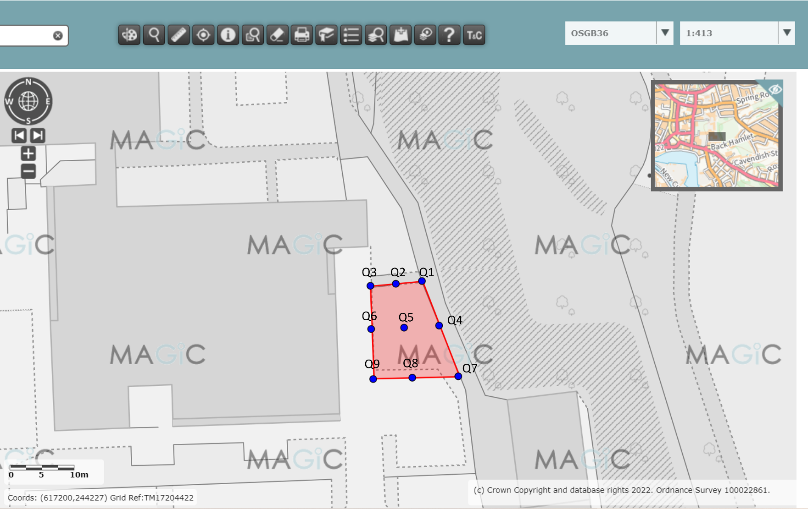

Figure 1, a diagram showing where each quadrat was placed, using systematic sampling. Red indicates the whole sampling site (terrestrial) boundary, and the blue dots indicate where the quadrats were laid. Image produced using the Magic Map application (DEFRA, 2024)

Results:
The habitats are described below. Figure 2 shows the habitats and boundaries present at the survey site, their codes, and the location of the target notes. Table 1 describes each target note. Table 2 shows that species were present within the quadrats, their local frequencies, and a photo where relevant (figures 3 to 17).
Total species richness (plants and animals combined) is estimated at 48 species, including those found in the spring before survey.
The UK Habitat Classification (UKHab Ltd, 2023) essential secondary codes of relevance for this site are:
- 80: ‘open mosaic habitat on previously developed land’ (applies to whole site as it has different habitats, and was previously developed upon).
- 61: ‘re created habitat’ (applies to whole site as this site is a re created habitat from previously being developed upon)
The Uk Habitat Classification (UKHab Ltd, 2023) additional secondary codes of relevance for this site are:
- 500: ‘dry’ (applies to whole site as the land was very dry during the survey).
- 827: ‘garden’ (applies to whole site as it is a wildlife garden).

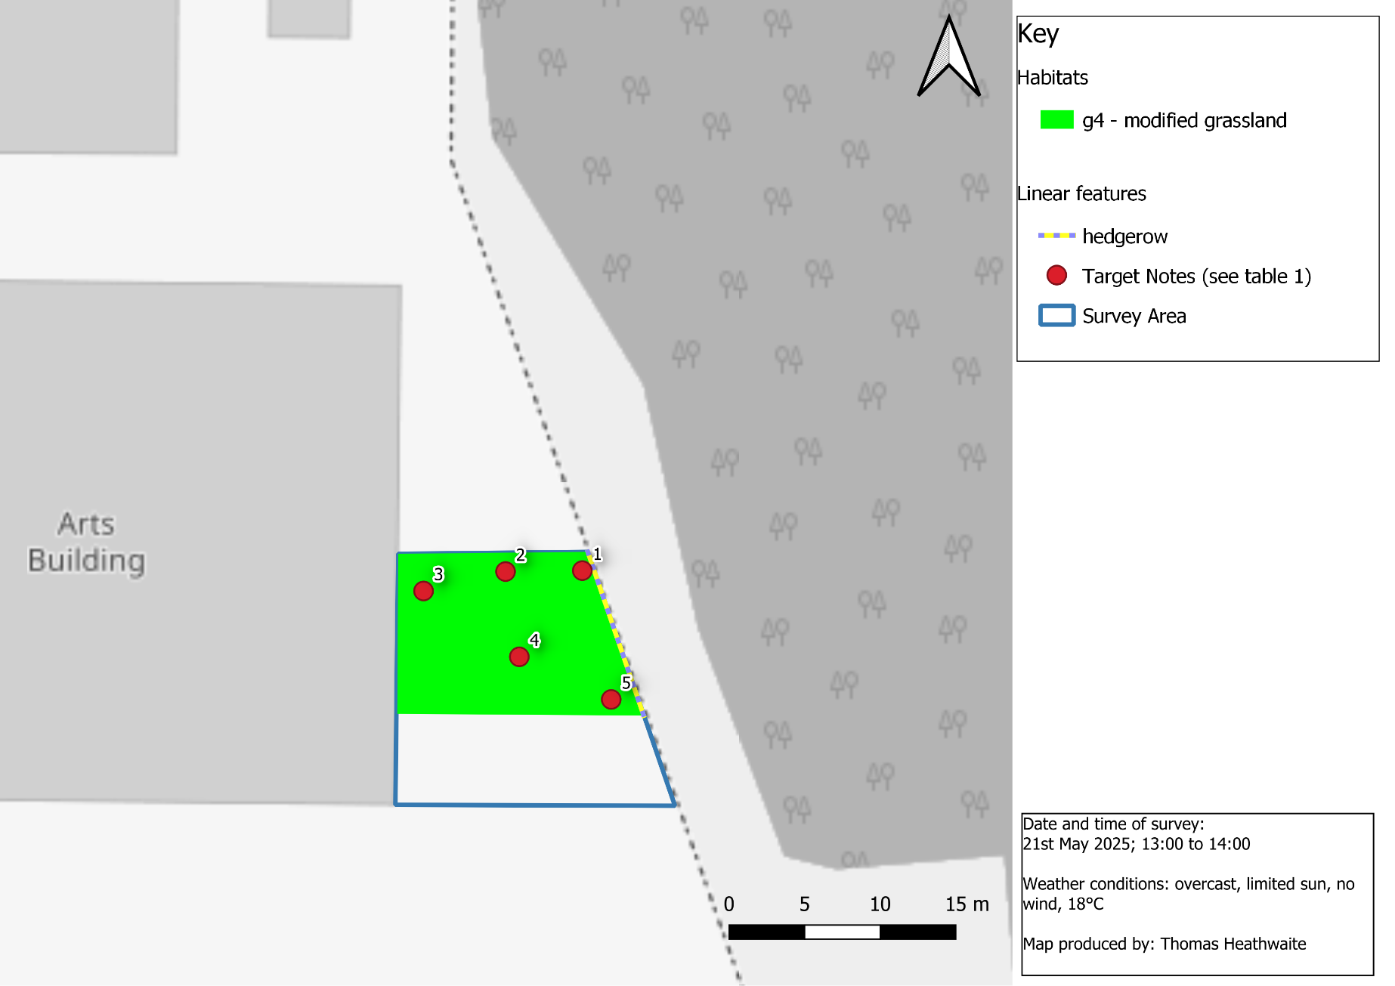
Figure 2, habitat map of the University of Suffolk's Wildlife Garden, Ipswich, OS Grid Reference: TM1718744205 using the UK Habitat Classification methodology (UKHab Ltd, 2023)
Table 1, a table showing the target note number and description of each target note.
Target Note number | Quadrat related to | Target note description
T1 | Q1 | high quantity of ivy present (Hedera helix). White comfrey (Symphytum orientale) appeared, as well as small amounts of Garlic mustard (Alliaria petiolate).
T2 | Q2 | Sparsely vegetated due to tree fall, only live plant was a young stinging nettle (Urtica dioica).
T3 | Q3 | Three species of bird cherry present (genus Prunus). Flowering white deadnettle (Lamium album).
T4 | Q5 | Dense grass, mainly velvet grass (genus Albovariegatus) and cleaver (Galium aparine). Spiders (species unknown) present.  There is also a very high abundance of stinging nettles (U. dioica), which is an indicator of the soil being nutrient rich in this area. Ensuring this area does not become dominated by stinging nettles is a key priority and something that’s managed every year.  2 bird cherry trees (genus Prunus) also present.
T5 | Q7 | Oxeye daisy (Leucanthemum vulgare) showing particularly strong growth. Creeping thistle (Cirsium arvense), red vein dock (Rumex sanguineus) and egg leaf spurge (Euphorbia oblongata) all present around this quadrat but outside quadrat as well as ash (Fraxinus excelsior).

Table 2, a table showing the plants found in each quadrat, their local frequency, and a photo where relevant.
Quadrat Number | Species name and local frequencies | Photo?
1 | $\frac{14}{25}=ivy$(H. helix)  $\frac{19}{25}=white comfrey$ (S. orientale)  $\frac{2}{25}=garlic mustard$(A. petiolate) | 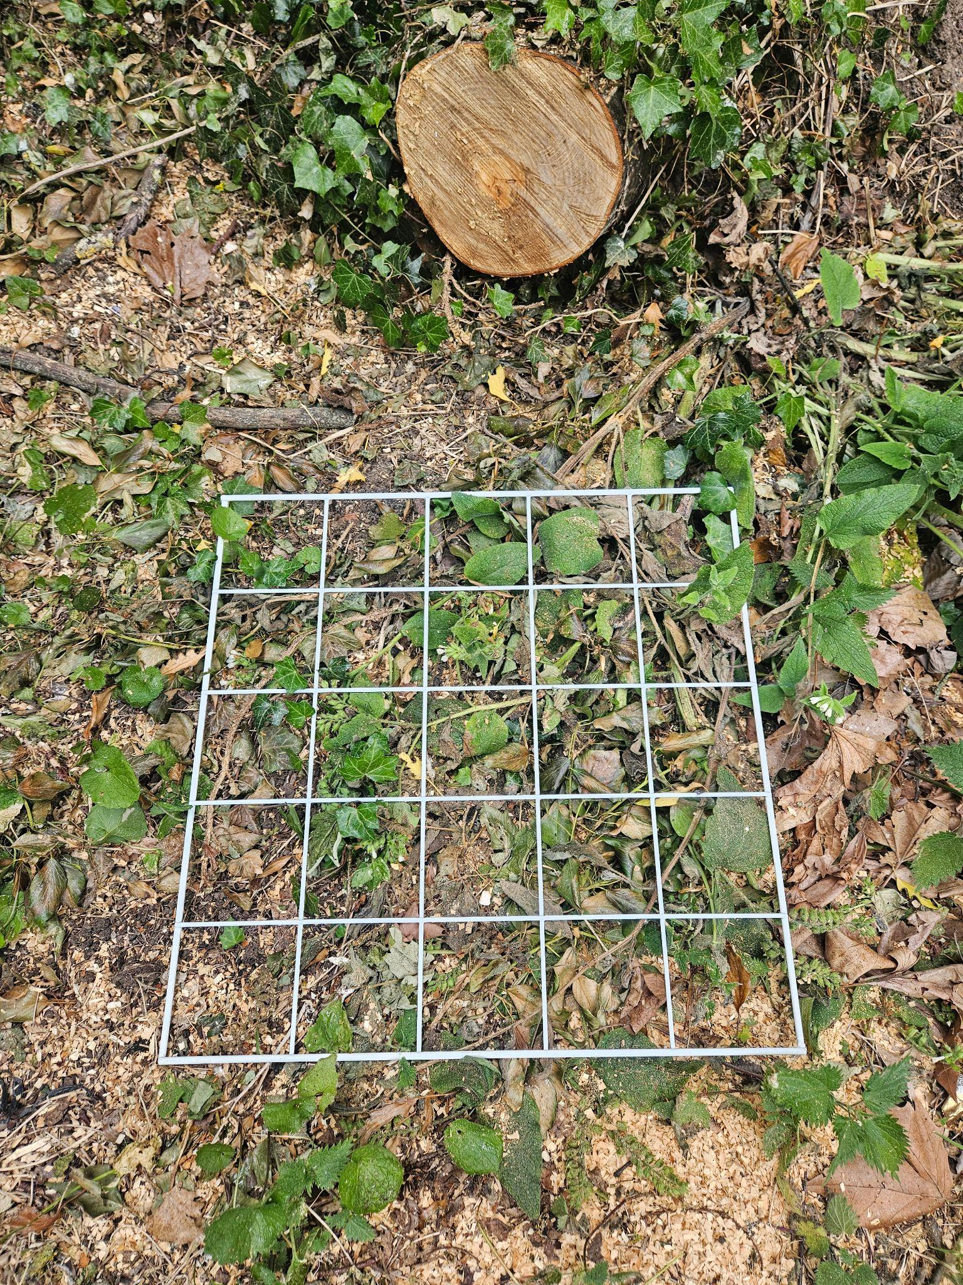  Figure 3, an overview of quadrat 1.
2 | $\frac{1}{25}=stinging nettle$(U. dioica) | 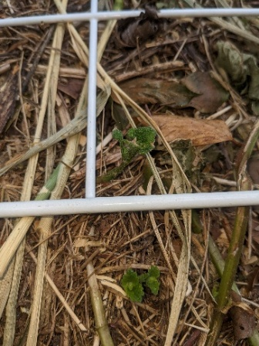  Figure 4, stinging nettle present in Quadrat 2.
Q3 | $\frac{1}{25}=common selfheal$ (Prunella vulgaris)  $\frac{7}{25}=rubwort plantain ($Plantago lanceolata)  $\frac{25}{25}=perennial ryegrass$(Lolium perenne)  $\frac{1}{25}=creeping buttercup$ (Ranunculus repens)  $\frac{1}{25}=sycamore$ (Acer pseudoplatanu) | 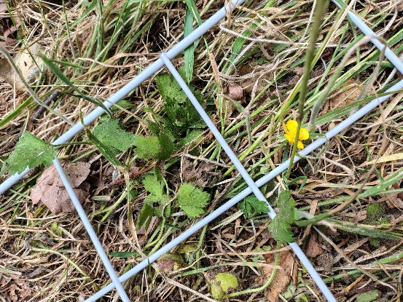  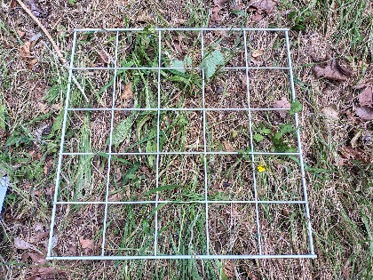  Figure 5, creeping buttercup, quadrat 3  Figure 4, an overview of quadrat 3  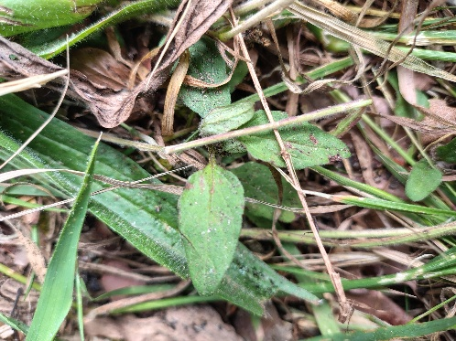  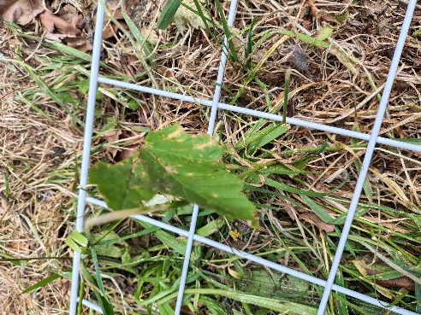  Figure 7, common selfheal, quadrat 3  Figure 5, sycamore, quadrat 3
Q4 | $$\frac{25}{25}=black horehound (Ballota nigra)$$  $\frac{6}{25}=cleavers$ (G. aparine)  $$\frac{1}{25}=low mallow (Malva pusilla)$$ | 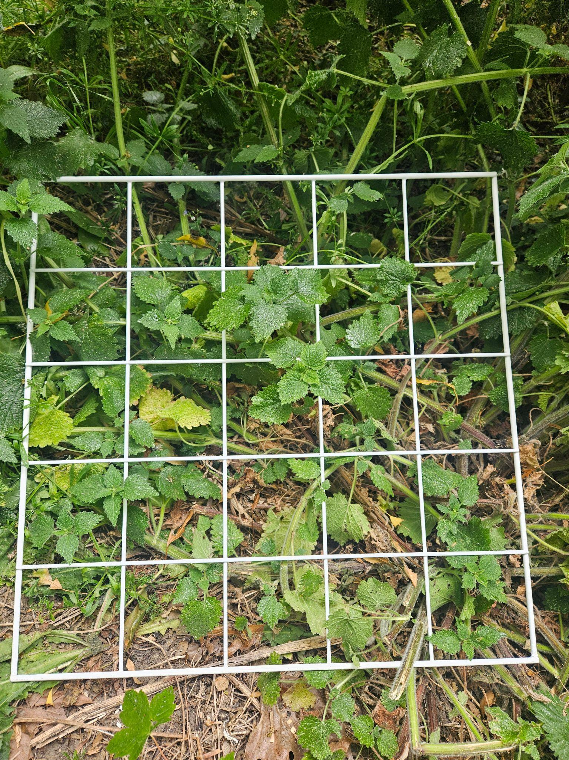  Figure 8, an overview of quadrat 4
Q5 | $\frac{1}{25}=stinging nettle$ (U. dioica)  $\frac{7}{25}=cleavers$ (G. aparine)  $\frac{1}{25}=madwort$ (Alyssum oxycarpum)  $\frac{1}{25}=hedgerow cranes-bill$(Geranium pyrenaicum)  $$\frac{1}{25}=bitterdock (Rumex obtusifolius)$$  $$\frac{25}{25}=creeping velvet grass$$  $$\left(Holcus mollis\right)$$ | 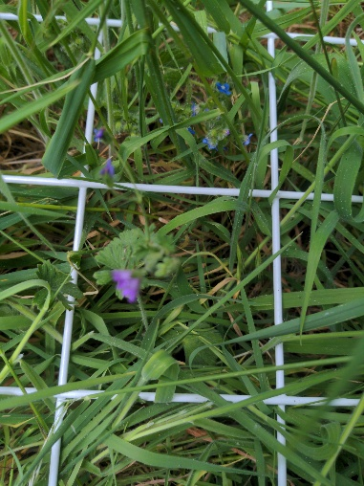  Figure 9, Madwort (foreground) and Hedgerow Crane's Bill (Background)
Q6 | $\frac{4}{25}=white campion ($Silene latifolia)  $\frac{3}{25}=red clover$ (Trifolium pratense)  $\frac{9}{25}=creeping buttercup$ (R. repens)  $\frac{1}{25}=sycamore$ (A. pseudoplatanu)  $\frac{1}{25}=elmleaf blackbery$ (Rubus ulmifolius) | 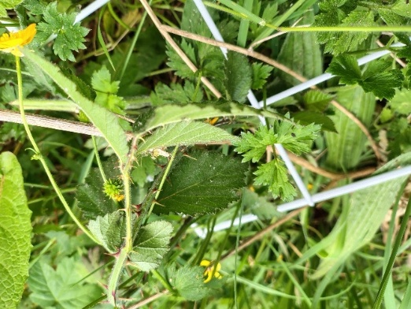  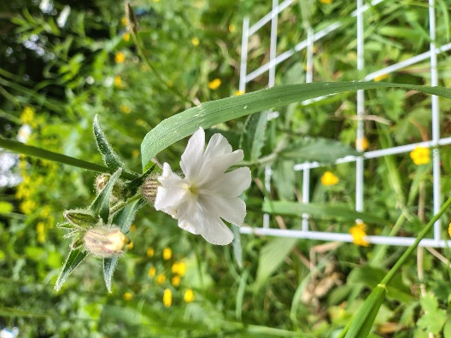  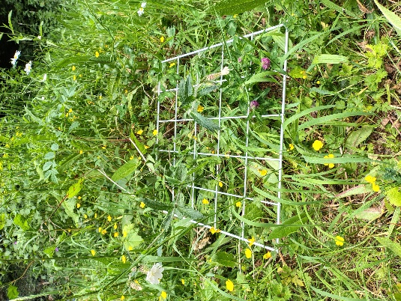  Figure 10, elm leaf blackberry - quadrat 6  Figure 6, white clover - quadrat 6  Figure 7, an overview of quadrat 6  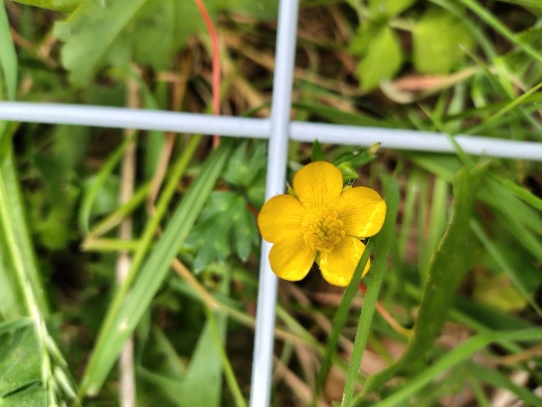  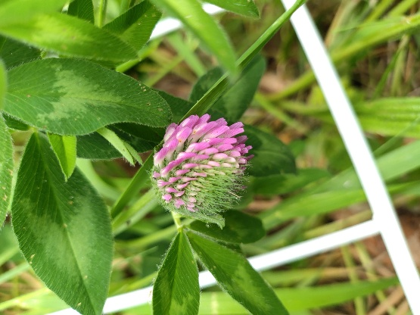  Figure 8, creeping buttercup - quadrat 6  Figure 9, red clover - quadrat 6,
Q7 | $\frac{1}{25}=field speedwell$ (Veronica persica)  $$\frac{6}{25}=redvein dock \left(Rumex sanguineus\right)$$  $\frac{8}{25}=cleavers$ (G. aparine)  $\frac{3}{25}=ivy$(H. helix)  $$\frac{2}{25}=black horehound (B. nigra)$$ | 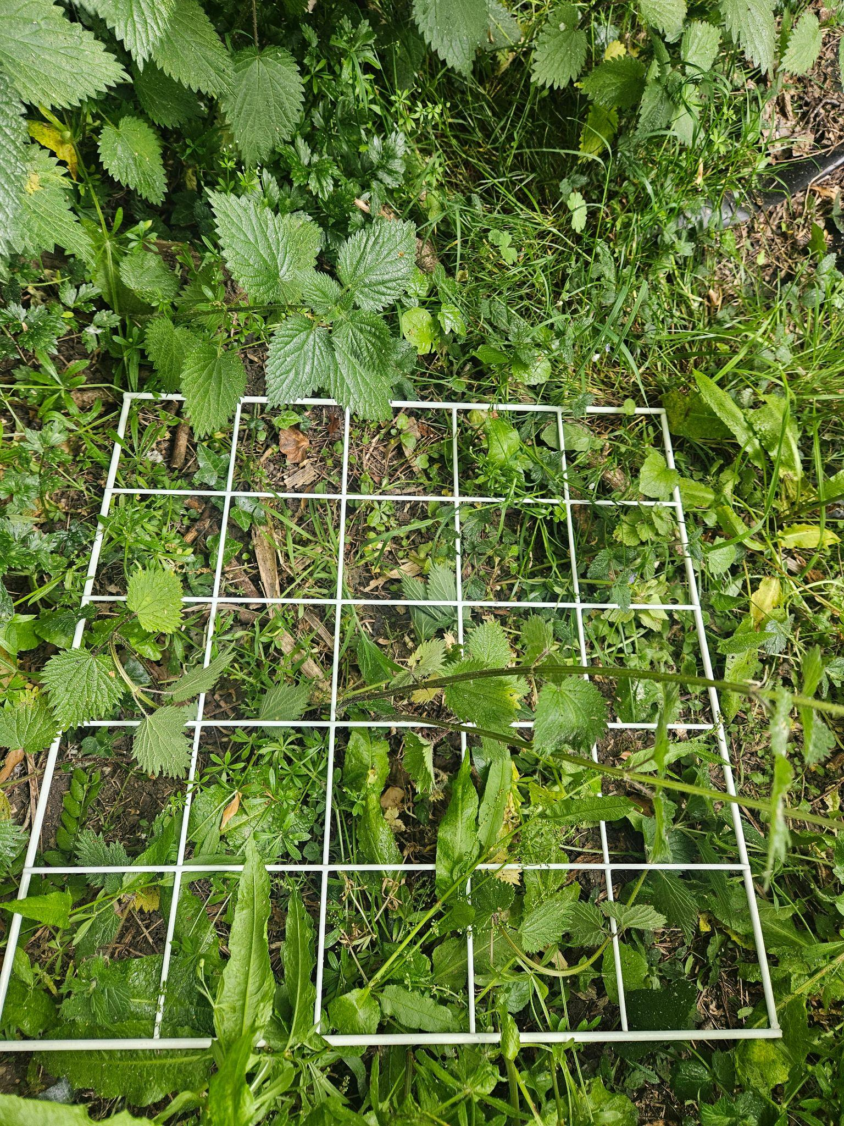  Figure 11, an overview of quadrat 7
Q8 | $$\frac{2}{25}=broad leaved dock$$  $$\frac{25}{25}=creeping velvet grass$$  $$\left(H. mollis\right)$$  $\frac{3}{25}=cleavers$ (G. aparine)  $\frac{1}{25}=hedgerow cranes bill$ (G. pyrenaicum)  $\frac{1}{25}=white campion$(Silene latifolia)  $\frac{2}{25}=common yarrow$ (Achillea  millefolium) | 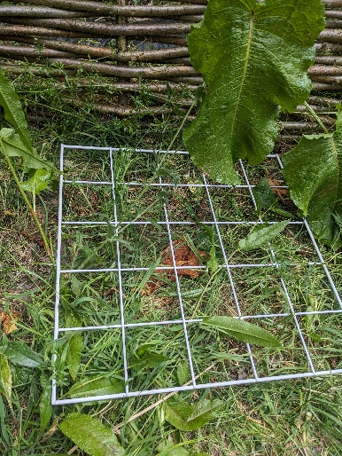  Figure 12, an overview of quadrat 8
Q9 | $\frac{2}{25}=green alkanet$ (Pentaglottis sempervirens)  $\frac{10}{25}=creeping buttercup$ (R. repens)  $\frac{3}{25}=oat grass$ (Arrhenatherum elatius)  $\frac{1}{25}=sycamore$ (A. pseudoplatanu)  $\frac{2}{25}=common dandelion ($Taraxacum  officinale) | 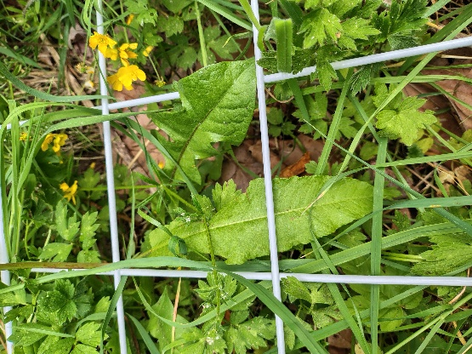  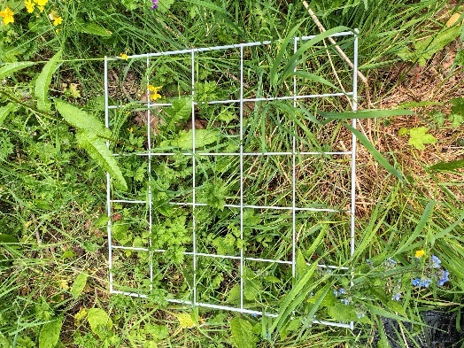  Figure 13, common dandelion - quadrat 9  Figure 14, an overview of quadrat 9  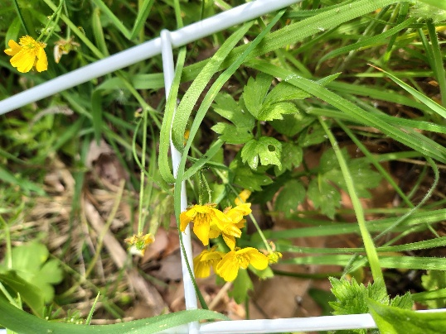  Figure 15, creeping buttercup - quadrat 9  Figure 16, green alkanet - quadrat 9  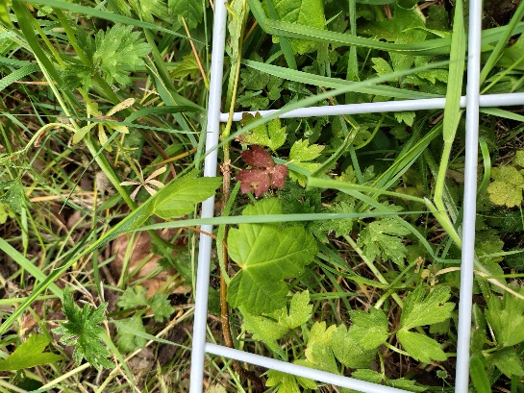  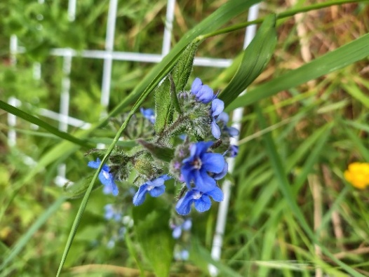  Figure 17, sycamore - quadrat 9

Results – Animals:
During the survey, the following species were recorded:
- Blackbird (Turdus merula) singing
- Red tailed bumblebee (Bombus lapidaries)
- Blue tit (Cyanistes caeruleus)
- Great tit (Parus major) in nest box
- Chaffinch (Fringilla coelebs)
- Robin (Erithacus rubecula)
- Fox (Vulpes vulpes)
- Muntjac (Muntiacus reevesi)
- Black garden ant (species unidentified)
- Aphid sp. (species unidentified)
- Black bean aphid (Aphis fabae)
- Green aphid (family Aphidoidea)
- Harlequin ladybird (larvae)
- Common candy striped spider (Enoplognatha ovata)
- Long jawed orb weaver (family Tetragnathidae)
Throughout the spring up until the time of this survey, the following species have also been recorded:
- Brimstone (Gonepteryx rhamni)
- Buff tailed bumblebee (B. terrestris)
Results: desktop survey:
For these result, please see the 2022 Phase 1 report covering the Wildlife Garden.
Discussion and Recommendations:
This is the first year of using the UK Habitat Classification system (UKHab Ltd, 2023) for reporting, the results show a change in habitat type reflective of how the habitat has change over the last two years as the space has matured.
Species richness has decreased by 8 species, from 56 in 2023 to 48 in 2025 for the terrestrial part. The biggest reason for this decrease is natural processes. The species that thrive in more nutrient rich soil (which is present in the wildlife garden) and are naturally stronger, more resilient and dominating plants, such as stinging nettles (U. dioica), perennial ryegrass (L. perenne), creeping velvet grass (genus Albovariegatus) and goosegrass (G. aparine) have out competed the more delicate wildflower species which also prefer nutrient poor soils, such as corncockle (Agrostemma githago), hedge mustard (Sisymbrium officinale), blue field madder (Sherardia arvensis), black medick (Medicago lupulina), borage (Borago officinalis) and common bird foot trefoil (Lotus corniculatus) which were all found in the 2023 survey.
As yellow rattle (Rhinanthus minor) is parasitic to grasses (Rowntree and Craig., 2018), it is recommended that a thorough planting programme is initialised over the autumn to reduce the dominance of the above species, noting that goosegrass (G. aparine), in small amounts, can, however, provide good shelter to deer such as muntjac (M. reevesi) so a balance should be sought.
Stinging nettles, U. dioica, requires careful intervention to simultaneously provide benefits as it provides good cover for deer species such as muntjac (M. reevesi) which have been seen as well as being the foodplant of the comma (Polygonia c-album) whilst preventing it from spreading beyond the hedgerow area and thus inhibiting other wildflowers from thriving.
Species such as red clover (T. pratense), creeping buttercup (R. repens), field speedwell (V. persica), white clover (T. repens), common selfheal (P. vulgaris), are all excellent for pollinators (The Wildlife Trust, n.da;; Phillips et al., 2019; Windsor et al., 2021; Harris and Ratnieks, 2024; Ferrante, Kirsch, and Westphal 2025) and with the implementation of the above recommendations, these species should continue to increase in abundance and occupancy.
Furthermore, to promote species richness, planting/ sowing of species that have been lost in the last two year is recommended including corncockle (A. githago), borage (B. officinalis) common bird foot trefoil (L. corniculatus) and hedge mustard (S. officinale), as these are especially good for pollinators such as bumblebees, butterflies and moths (The Wildlife Trust., ndb; The Wildlife Trust., ndc; The Wildlife Turst n.dd) Both garlic mustard (Alliaria petiolata) and hedge mustard (S. officinale) are the food plant of the orange tips (Anthocharis cardamines), which colonises grassland and woodland edges (Agerbirk et al., 2010).
Sycamore (Acer pseudoplatanus) seedlings continue to inhabit the wildlife garden. Although sycamore trees seeds can be beneficial to a range of birds including greenfinch (Chloris chloris) goldfinch (Carduelis carduelis), and can provide nesting locations for blackbirds (T. merula), blue tit (C. caeruleus) and robins (E. rubecula), and can benefit moths such as the maple prominent (Ptilodon cucullina), and insects such as lacewings (family Chrysopidae) and sycamore aphid (Drepanosiphum platanoidis), and some fungi (Woodland Trust, n.d) they can also be very dominant and invasive as seedlings (Morecroft et al., 2008). Thus, keeping a couple of mature sycamores is important but in this sized space (179.4m²), all others should be removed.
To improve the classification of this site according to the UK Habitat Classification methodology:
Since this site inauguration 4 years ago, and based upon the data, the most appropriate management from G4 modified grassland would be to G3C5, arrhenatherum grassland, a much more biodiversity beneficial habitat. This is because, false oat grass (A. elatius), ribwort plantain (P. lanceolata), sorrel (Rumex acetosa), self heal (P. vulgaris), and yarrow (A. millefolium) are all key features of this habitat which are already present, and further recommendations such as Common Couch (Elymus repens), Cock’s foot (Dactylus glomerata), would further enrich this habitat. Indeed, Common Couch (E. repens) is the foodplant of the ringlet (Aphantopus hyperantus) and gatekeeper (P. Tithonus) and both common couch (E. repens) and Cock’s foot (Dactylus glomerata) are beneficial to the speckled wood (P. aegeria).

Bibliography:
Agerbirk, N., Chew, F.S., Olsen, C.E. and Jørgensen, K. (2010) Leaf and floral parts feeding by orange tip butterfly larvae depends on larval position but not on glucosinolate profile or nitrogen level. Journal of Chemical Ecology, 36(12), pp.1335-1345.
DEFRA (2024) MAGIC. Available at: Magic Map Application [accessed 07/08/25].
Ferrante, M., Kirsch, F. and Westphal, C. (2025) Stable pollinator communities in different white clover populations suggest potential win-win scenarios for crop yield and biodiversity. Agriculture, Ecosystems & Environment, 378, p.109295.
Harris, C. and Ratnieks, F.L. (2024) Improving pollen and nectar supply by identifying the red clover (Trifolium pratense) cultivars that attract most pollinators. Agricultural and Forest Entomology, 26(2), pp.273-283.
Morecroft, M.D., Stokes, V.J., Taylor, M.E. and Morison, J.I. (2008) Effects of climate and management history on the distribution and growth of sycamore (Acer pseudoplatanus L.) in a southern British woodland in comparison to native competitors. Forestry, 81(1), pp.59-74.
Natural Environment and Rural Communities Act 2006, c. 16. Available at: https://www.legislation.gov.uk/ukpga/2006/16/contents [accessed 13/08/25].
NBN Atlas (2025) Explore your area. Available at: https://records.nbnatlas.org/explore/your-area#52.10412650000001|1.3288216|13|ALL_SPECIES [accessed 13/08/25].
Phillips, B.B., Gaston, K.J., Bullock, J.M. and Osborne, J.L. (2019) Road verges support pollinators in agricultural landscapes, but are diminished by heavy traffic and summer cutting. Journal of Applied Ecology, 56(10), pp.2316-2327.
Rowntree JK and Craig H. (2018) The contrasting roles of host species diversity and parasite population genetic diversity in the infection dynamics of a keystone parasitic plant. Journal of Ecol. 2019;107:23–33. https://doi.org/10.1111/1365‐2745.13050
The conservation of habitats and species regulations 2017 (SI 2017/1012). Available at: https://www.legislation.gov.uk/uksi/2017/1012/contents/made [accessed: 13/08/25].
The Wildlife Trust, (n.da) Selfheal. Available at: Selfheal | The Wildlife Trusts [accessed 07/08/25].
The Wildlife Trust, (n.db) Common Bird Foot Trefoil. Available at: Common bird's-foot-trefoil | The Wildlife Trusts [accessed 07/08/25].
The Wildlife Trust (n.dc) Hedge mustard. Available at: Common bird's-foot-trefoil | The Wildlife Trusts [accessed 07/08/25].
The Wildlife Trust (n.dd) Garlic Mustard. Available at: Garlic mustard | The Wildlife Trusts [accessed 07/08/25].
UKHab Ltd (2023). UK Habitat Classification Version 2.0. Available at: ukhab – UK Habitat Classification [accessed 07/08/25].
Wildlife and Countryside Act 1981, c. 69. Available at: https://www.legislation.gov.uk/ukpga/1981/69/contents [accessed 13/08/25].
Windsor, F.M., Tavella, J., Rother, D.C., Raimundo, R.L., Devoto, M., Guimarães Jr, P.R. and Evans, D.M. (2021) Identifying plant mixes for multiple ecosystem service provision in agricultural systems using ecological networks. Journal of Applied Ecology, 58(12), pp.2770-2782.
Woodland Trust, (n.d) Sycamore. Available at: Sycamore (Acer pseudoplatanus) - Woodland Trust [accessed 07/08/25].

