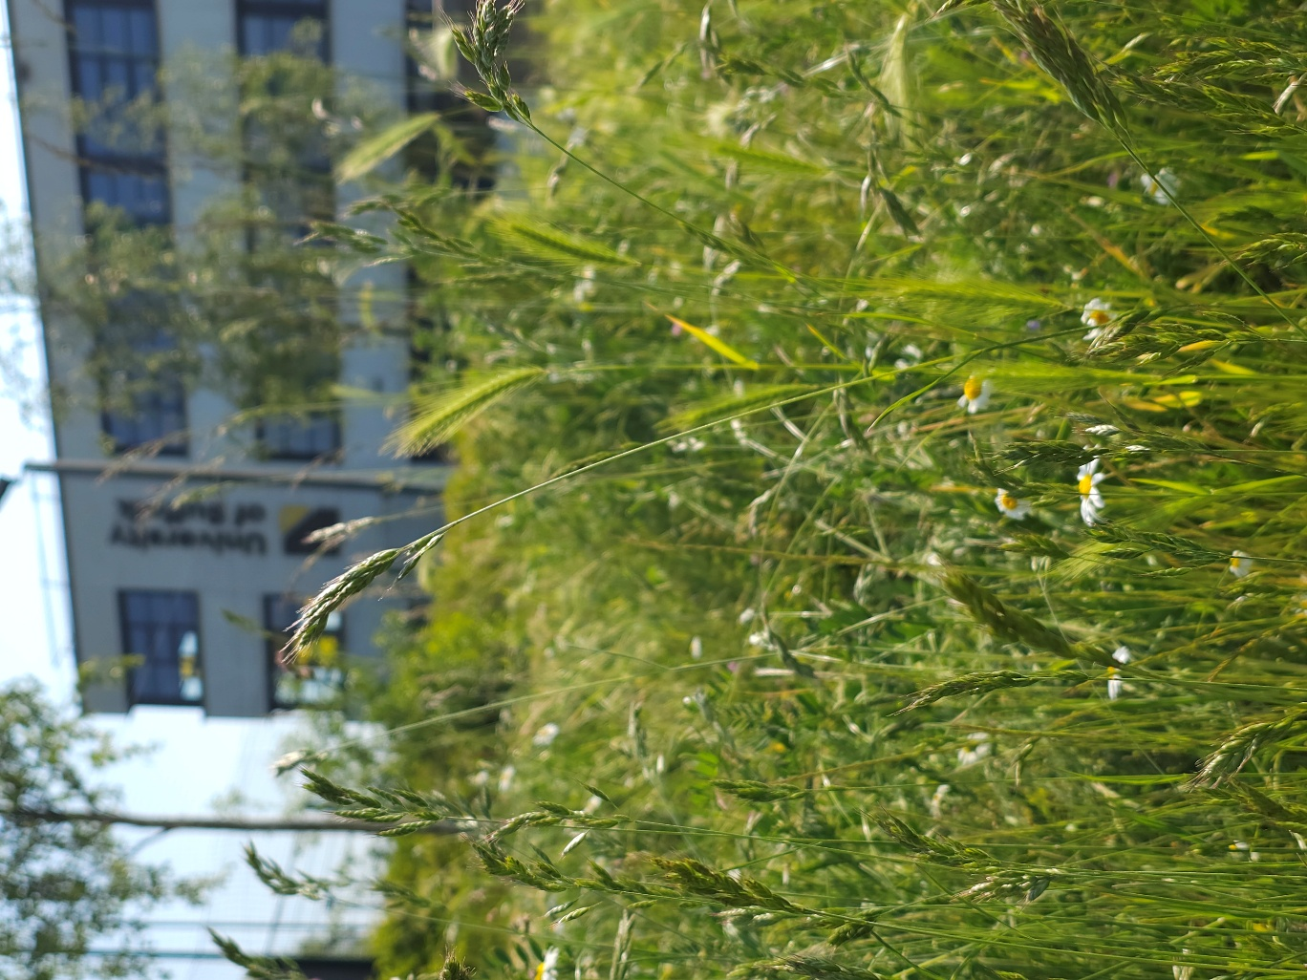

Wildflower Meadow
UK Habitat Classification Survey Report
2025

Site name: University of Suffolk Wildflower Meadow
Grid reference: TM696044240
Area: 1,131 M²
Date and time of the survey: 23rd May 25, 12:45 to 13:30
Weather conditions: overcast, slight wind, 16ºC
Recorders: Thomas Heathwaite, and 2 BS(C) Wildlife, Ecology and Conservation Science Students, Cameron and Daniel.
Location, description, and geology of site:
The site is located on the University of Suffolk campus which is in the centre of Ipswich. Bordering the Bumblebee Buffet Area, to the east, is Alexander Park. Suffolk new college boarders just to the north of the University of Suffolk campus and the marina and Ipswich wet docks are to the south of the University of Suffolk campus. The centre of Ipswich is about 1km from the site campus.
The bedrock geology of the site consists of clay, silt, and sand (the Tharnet Fomation and Lambeth Group) and the superficial deposits consist of sand and gravel (the Lowestoft formation).
Statuary and Non-statutory designations:
There are no statutory designations within a radius of 1km of the survey site.
Three non-statutory designations are present within a radius of 1km of the survey site including Nitrate Vulnerable Zones 2017 Designations (England), total catchment source protection zone and drinking water protected area (surface water) (DEFRA, 2024)
Habitats and species:
Given the Wildlife Garden is only 230.35 meters away, the finding presented within the 2022 Wildlife Garden Phase 1 Habitat Survey report is likely to be valid here too.
Methodology (terrestrial):
Before the site visit, a desktop survey consisting of 1) the geology of the site; 2) statutory and non-statutory designations and 3) a search using the NBN Atlas (2025) of all protected species recorded within a 1km radius of the survey site listed on the UK Wildlife and Countryside Act (1981), section 41 of the Natural Environment and Rural Communities Act (2006), and The Conservation of Habitats and Species Regulations 2017 was conducted.
A visit to site was made on the 23rd of May to survey the terrestrial part of the site, with weather conditions overcast, slight wind, 16ºC
Plants were surveyed using 1 meter squared quadrats, using standardised sampling (see figure 1). Plant species present in these quadrats were recorded, along with their local frequency in each quadrat. From this, dominant species were noted, as well as abundance and local frequencies. The habitats were mapped as per the UK Habs, UK Habitat Classification System, V2.0 methodology (UK Habs, 2025). Where habitats were too small to map, target notes were.
Any species observed throughout the survey period were also noted.
Any species recorded during observations made before the survey in the spring have also been noted; and are indicated as such.

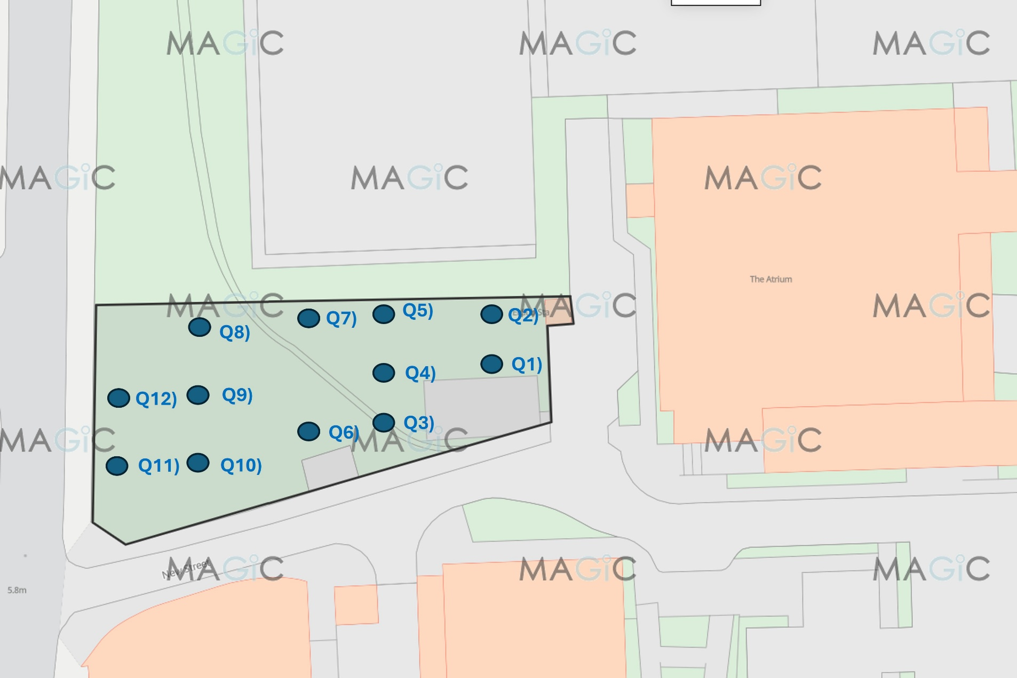
Figure 1, a diagram showing where each quadrat was placed, using systematic sampling. The brown outline indicates the whole sampling site boundary, and the blue dots indicate where the quadrats were laid. Image produced using the Magic Map application (DEFRA, 2024)

Results:
A map showing the habitats and target notes locations is below (Figure 2). Table 1 shows that species were present within the quadrats, their local frequencies and a photo if taken (figures 3 to 22).
The total species richness of this site is 22 species, of which 13 are plant species.
No target notes were recorded.
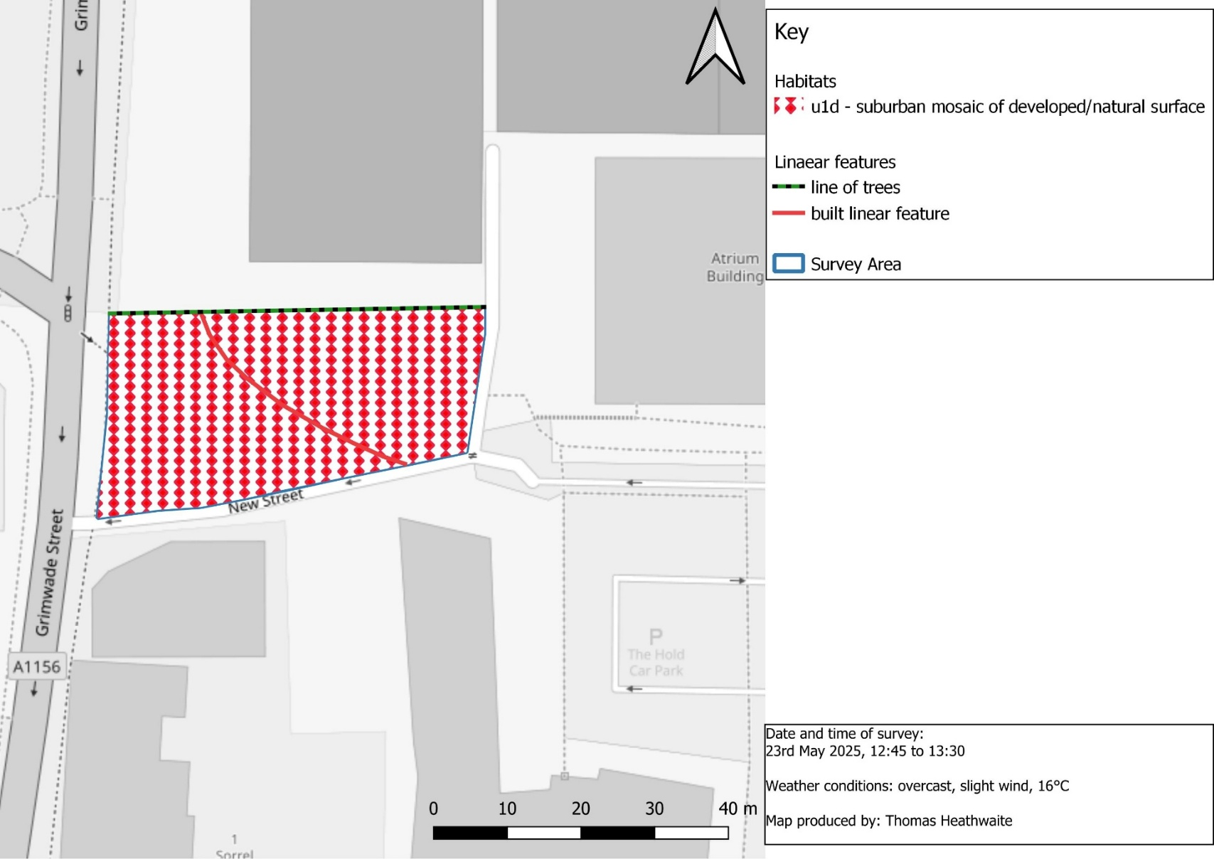

Figure 2, habitat map of the University of Suffolk's Wildflower Meadow, Ipswich, OS Grid Reference: TM696044240 using the UK Habitat Classification methodology (UKHab Ltd., 2023)
Table 1, a table describing the species found in each quadrat, the local frequency, essential and additional secondary codes (UKHab Ltd, 2023) and a photo if taken. Habitat classification and secondary codes based upon the UK Habitat Classification Methodology (UKHab Ltd, 2023).
Quadrat number | Species name and local frequency | Essential secondary code | Additional secondary code | Photo?
Q1 | $$\frac{10}{25}=oxeye daisy (Leucanthemum vulgare)$$  $\frac{5}{25}=cornflower$ (Centaurea cyanus)  $\frac{12}{25}=corn poppy ($Papaver rhoeas) | 60,81 | 500 | 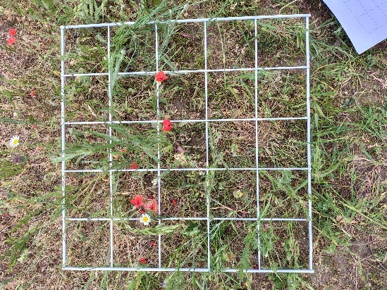  Figure 3, an overview of quadrat 1
Q2 | $\frac{7}{25}=oxeye daisy$ ($L. vulgare)$  $$\frac{11}{25}=long prickly head poppy (Roemeria argemone)$$  $\frac{20}{25}=soft brome$ (Bromus hordeaceus) | 528 | 512 | 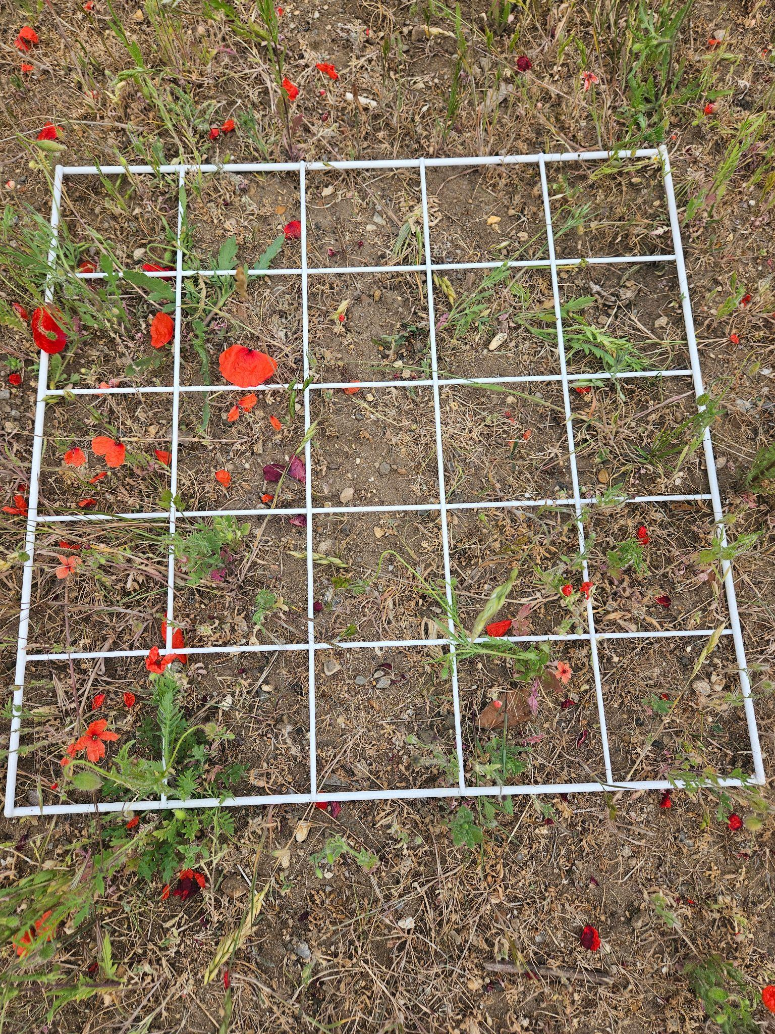  Figure 4, an overview of quadrat 2
Q3 | $$\frac{4}{25}=lawn daisy (Bellis perennis)$$  $\frac{19}{25}=common poppy$ (P. rhoeas)  $\frac{4}{25}=cornflower$ (C. cyanus)  $\frac{5}{25}=soft brome ($B. hordeaceus)  $$\frac{1}{25}=ribwort plantain (Plantago lanceolata)$$ | 80 | 827 | 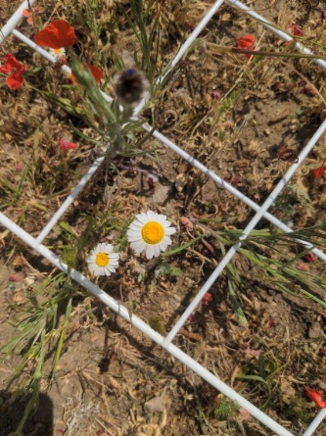  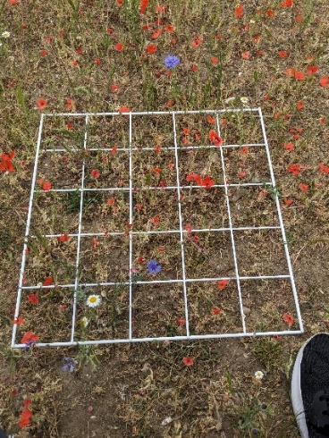  Figure 5, an overview of quadrat 3  Figure 6, lawn daisy  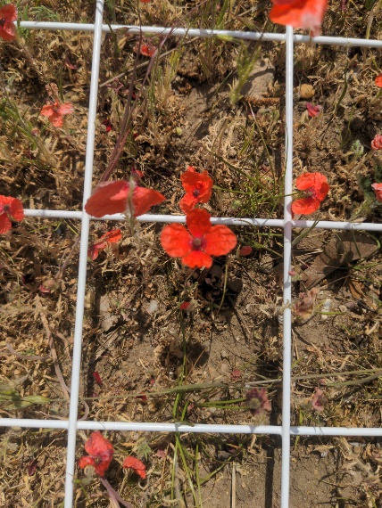  Figure 7, common poppy.
Q4 | $\frac{6}{25}=soft brome ($B. hordeaceus)  $$\frac{10}{25}=corn poppy (P. rhoeas)$$  $\frac{2}{25}=oxeye daisy$ ($L. vulgare)$  $$\frac{4}{25}=cornflower (C. cyanus)$$ | 60,81 | 500 | 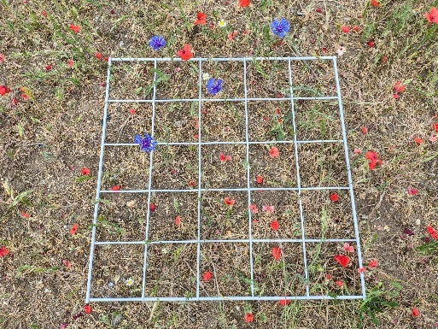  Figure 8, an overview of quadrat 4
Q5 | $$\frac{24}{25}=common poppy (P. rhoeas)$$  $$\frac{1}{25}=lawn daisy (B. perennis)$$  $\frac{6}{25}=soft brome$ (B. hordeaceus)  $\frac{1}{25}=barren brome ($Bromus sterilis) | 80 | 827 | 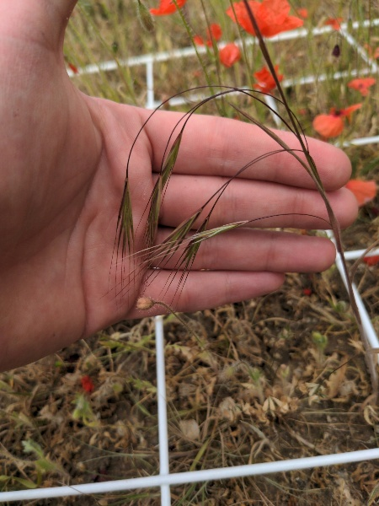  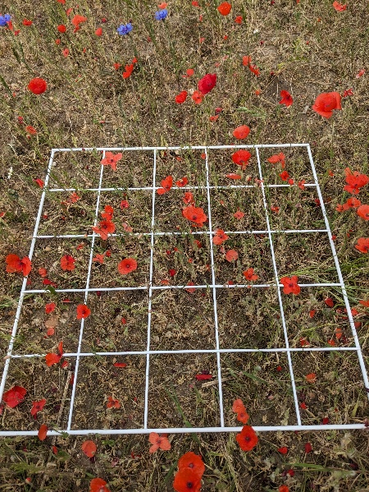  Figure 10, barren brome.  Figure 9, an overview of quadrat 5 showing an abundance of common poppies.
Q6 | $$\frac{9}{25}=long prickly head poppy (R. argemone)$$  $\frac{1}{25}=long smooth head poppy$(Papaver dubium)  $\frac{1}{25}=soft brome$(B. hordeaceus) | 526 | 512 | Figure 11, an overview of quadrat 6
Q7 | $\frac{5}{25}=cornflower$(C. cyanus)  $\frac{15}{25}=oxeye daisy$ ($L. vulgare)$  $\frac{15}{25}=barron brome ($B. sterilis) | 60,81 | 500 | 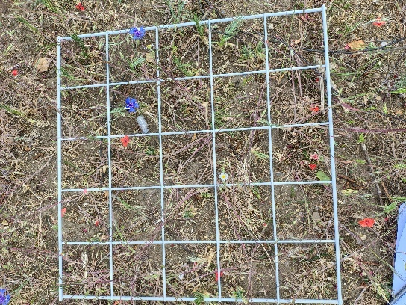  Figure 12, an overview of quadrat 7
Q8 | $\frac{25}{25}=barron brome$ (B. sterilis)  $$\frac{7}{25}=common poppy (P. rhoeas)$$  $\frac{2}{25}=lawn daisy$ (B. perennis)  $\frac{4}{25}=soft brome ($B. hordeaceus) | 80 | 827 | 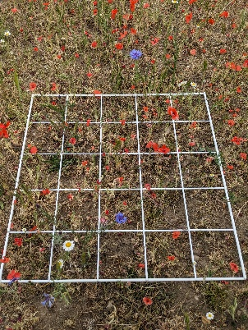  Figure 13, an overview of quadrat 8
Q9 | $$\frac{17}{25}=long prickly head poppy (R. argemone)$$  $\frac{12}{25}=soft brome$(B. hordeaceus) | 526 | 512 | 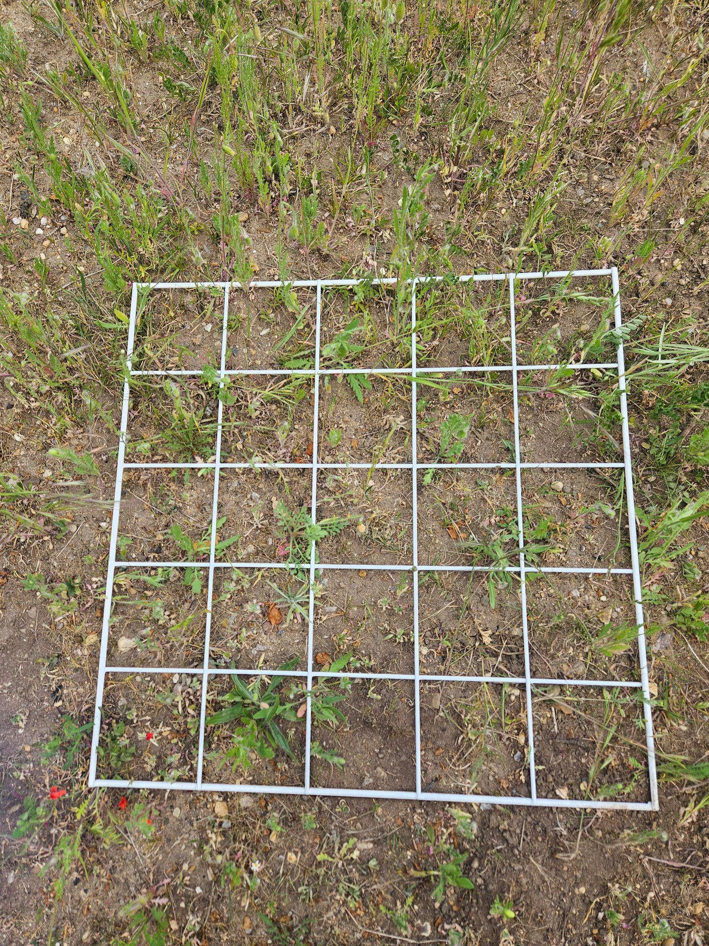  Figure 14, an overview of quadrat 9
Q10 | $$\frac{10}{25}=corn poppy (P. rhoeas)$$  $$\frac{2}{25}=soft fennel (Foeniculum vulgare)$$  $$\frac{1}{25}=common stock bill (Erodium cicutarium)$$  $\frac{1}{25}=long smooth headed poppy ($P. dubium)  $\frac{3}{25}=soft brome$ (B. hordeaceus) | 60,81 | 500 | 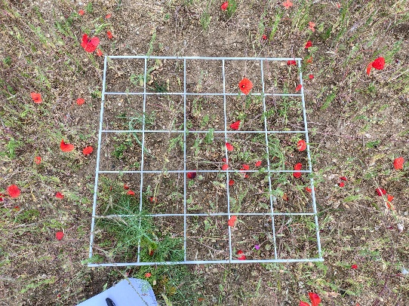  Figure 15, an overview of quadrat 10  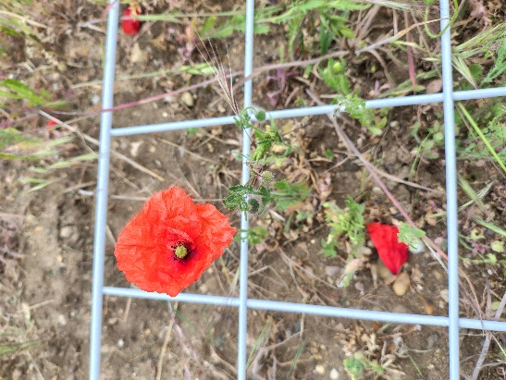  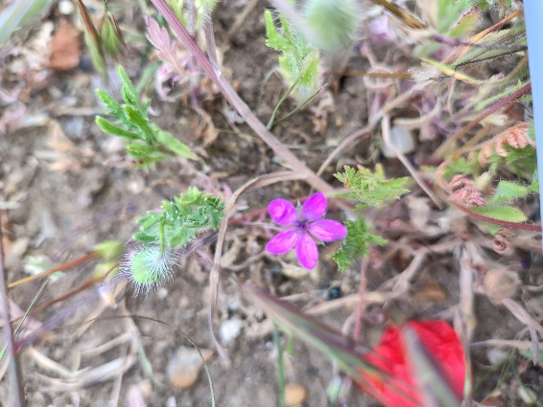  Figure 16, common poppy  Figure 17, common stock bill  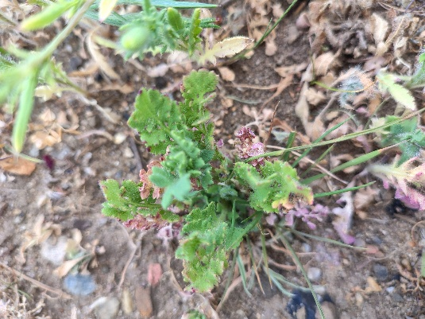  Figure 18, long haired poppy
Q11 | $\frac{7}{25}=soft brome$ (B. hordeaceus)  $\frac{12}{25}=creeping cinquefoil ($Potentilla reptans)  $$\frac{1}{25}=common sorrel (Rumex acetosa)$$  $\frac{2}{25}=common poppy$ (P. rhoeas)  $$\frac{1}{25}=lesser hop trefoil (Trifolium dubium)$$  $\frac{1}{25}=corn cockle$ (Agrostemma githago) | 80 | 827 | 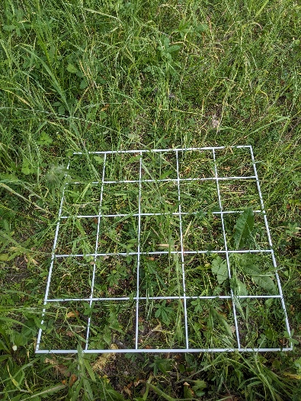  Figure 19, an overview of quadrat 11  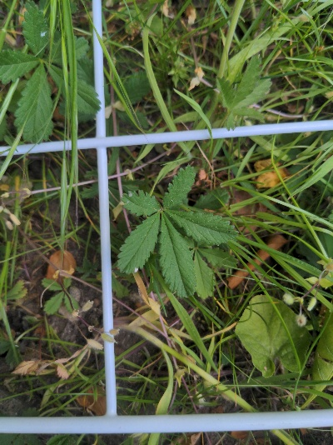  Figure 20, creeping cinquefoil  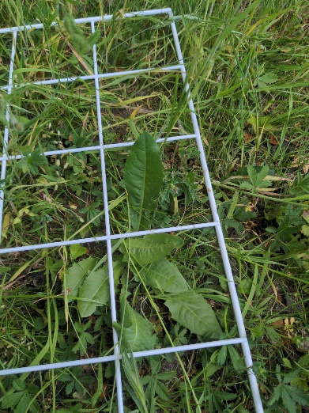  Figure 21, common sorrel
Q12 | $$\begin{aligned}\frac{1}{25}=oxeye daisy (L. vulgare)\#\end{aligned}$$  $$\frac{2}{25}=common poppy (P. rhoeas)$$  $\frac{25}{25}=barron brome ($B. sterilis)  $$\frac{7}{25}=long prickly head poppy (R. argemone)$$ | 526 | 512 | 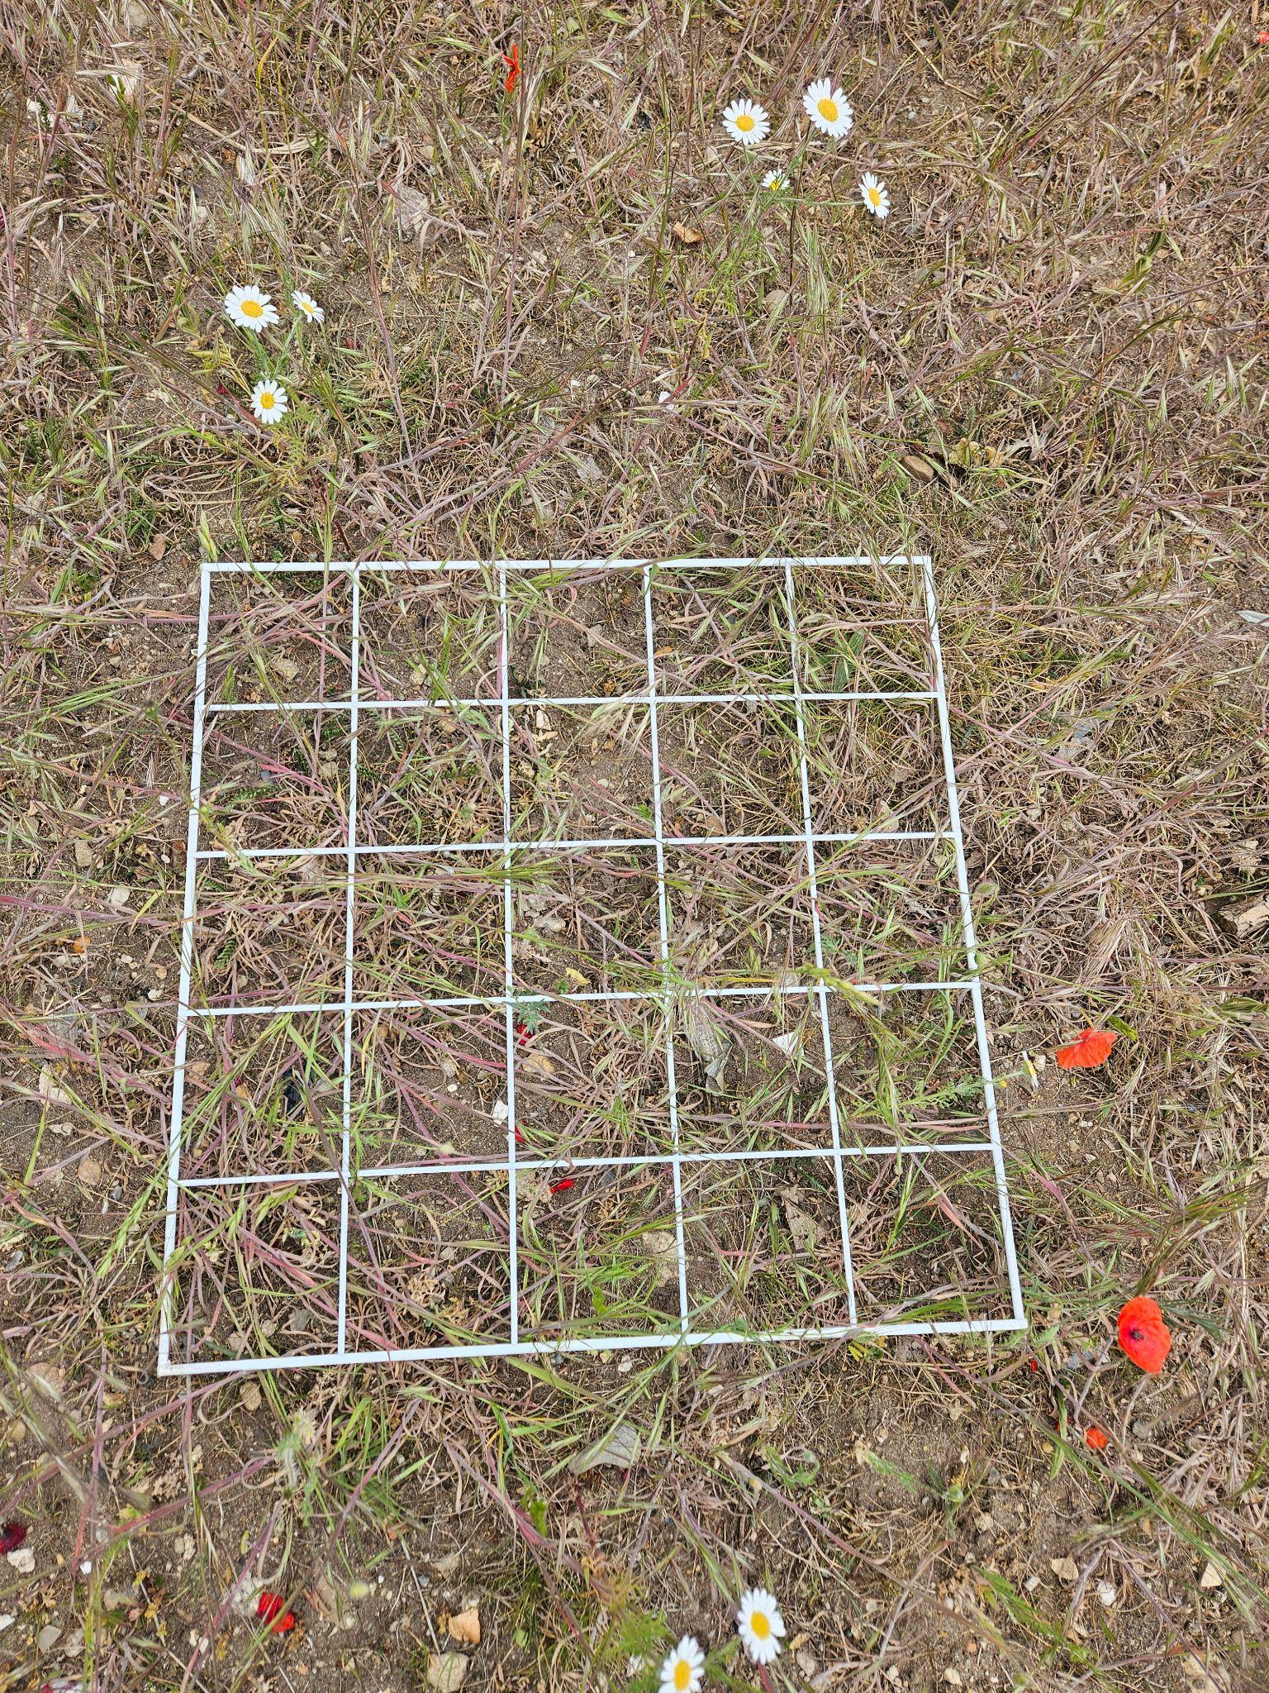  Figure 22, an overview of quadrat 12

Results – animals:
During the survey, the following species were recorded:
- Black garden ant (Lasius niger)
- Black bean aphid (Aphis fabae)
- Bumblebee (genus Bombus sp).
- Grasshoppers (suborder Caelifera)
- Blow fly (genus Calliphora sp).
- Western honey bee (Apis melifera).
Throughout the spring up until the time of this survey, the following species have also been recorded:
- Red tailed bumblebee (Bombus lapidarius)
- Buff tailed bumblebee (Bombus terrestris)
- Brimstone (Gonepteryx rhamni)
Results: desktop survey:
For these result, please see the 2022 Phase 1 report covering the Wildlife Garden.
Recommendations:
Despite the extremely dry spring conditions (the dryest spring and warmest spring in more than 50 years, Met Office (2025), it is good to see a variety of different plant species and a total species richness of 22 species have occupied this area. However, this is much reduced from the variety and number of species that have inhabited this area in previous years and the plants found during this survey were very delicate and small in nature showing the struggles endured through these conditions. Notwithstanding, also, the previous land use of this space which has seen building occupying this land, most recently as a nursery and there thus the ground is extremely compact, has very limited water retention and is also likely full of contaminants further exacerbating the challenging that the plants inhabiting this area face.
The Sustainability Team has, with student support, over the last three years tried to create a wildflower meadow and whilst we have seen successes notably creating a visible biodiversity uplift. Nonetheless, with the warmer summers, weeds ingress, habitat fatigue and climate change intensifying, it is clear through the results of this survey and what the ground is telling us that change in an approach is needed to make this a climate resilient habitat. To this end, management of this area is now focused on creating an urban heathland and bringing this area back to what it used to be: heathland, when it was part of The Sandlings. The Sandlings was a heathland that at one time occupied large expanses of Suffolk, up to 7,700 ha in 1889 according to some estimates (Armstrong, 1973).

Bibliography:
Armstrong, P.H. (1973) Changes in the land use of the Suffolk Sandlings: A study of the disintegration of an ecosystem. Geography, pp.1-8.
DEFRA (2024) MAGIC. Available at: Magic Map Application [accessed 07/08/25].
Met Office (2025) Seasonal Assessment – Spring 2025. Available at: seasonal-assessment---spring-2025.pdf [accessed 15/08/28].
Natural Environment and Rural Communities Act 2006, c. 16. Available at: https://www.legislation.gov.uk/ukpga/2006/16/contents [accessed 13/08/25].
NBN Atlas (2025) Explore your area. Available at: https://records.nbnatlas.org/explore/your-area#52.10412650000001|1.3288216|13|ALL_SPECIES [accessed 13/08/25].
The conservation of habitats and species regulations 2017 (SI 2017/1012). Available at: https://www.legislation.gov.uk/uksi/2017/1012/contents/made [accessed: 13/08/25].
UKHab Ltd (2023). UK Habitat Classification Version 2.0. Available at: ukhab – UK Habitat Classification [accessed 07/08/25].
Wildlife and Countryside Act 1981, c. 69. Available at: https://www.legislation.gov.uk/ukpga/1981/69/contents [accessed 13/08/25].

