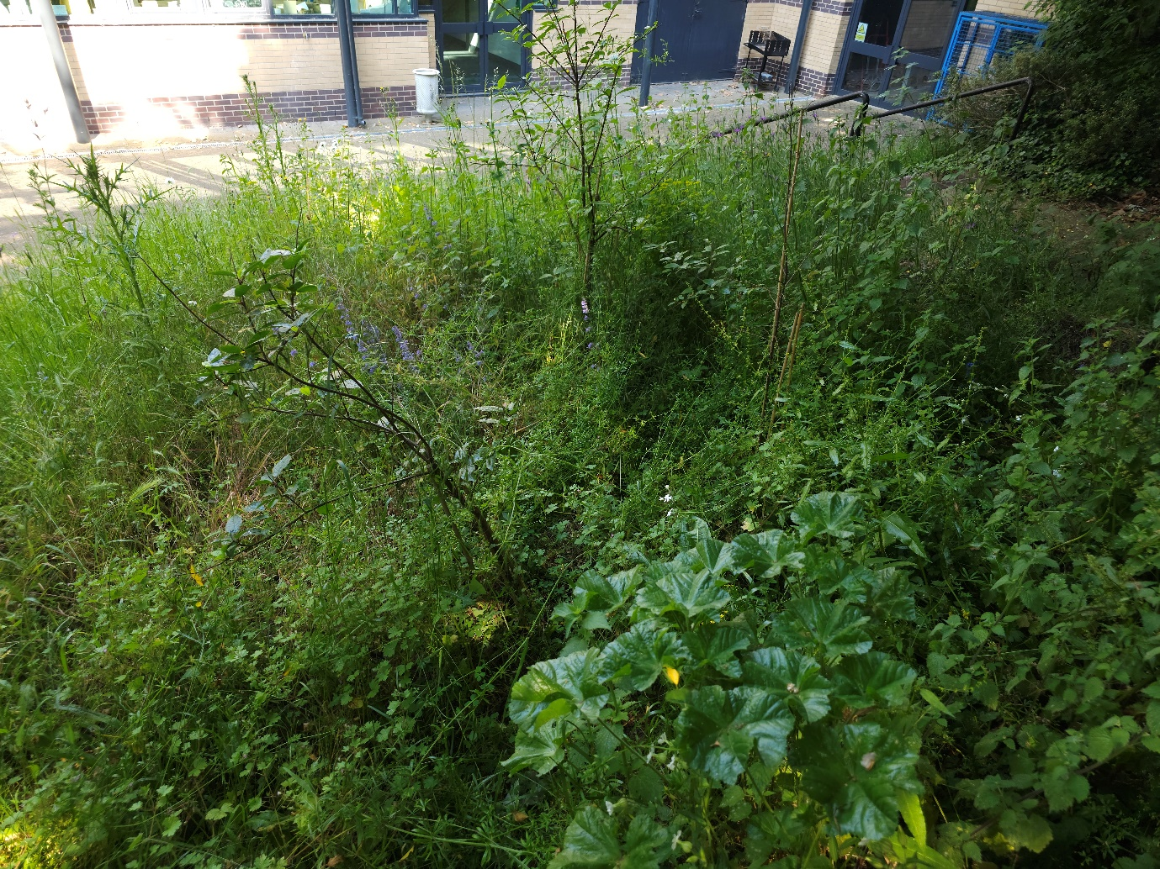

Wildlife Garden Report
Phase 1 Habitat survey report
2023

Site name: University of Suffolk Wildlife Garden
Grid reference: TM17194420
Area: 179.4 meters²
Date and time of the survey:
Terrestrial: 17th May 2023, 14:30 to 16:00;
Pond: 23rd May 2023 14:00 to 15:00
Weather conditions:
Terrestrial: overcast, limited sun, 13°C
Pond: Partly cloudy with limited sun 16°C
Recorders:
Terrestrial: Thomas Heathwaite (staff) and three WECS students: Skye, Natasha, Josie.
Pond: Thomas Heathwaite, Daniel Mills (staff); and 12 2nd year BS(C) Wildlife, Ecology and Conservations Science Students.
Location, description, and geology of site:
The site is located on the University of Suffolk campus which is in the centre of Ipswich. Bordering the wildlife garden, to the east, is Alexander Park. Suffolk new college boarders just to the north of the University of Suffolk campus and the marina and Ipswich wet docks are to the south of the University of Suffolk campus. The centre of Ipswich is about 1km from the site campus.
The geology of the site consists of clay, silt, and sand and this type of geology is known as Thames Group geology
Statuary and Non-statutory designations:
There are no statutory designations within a radius of 1km of the survey site.
Two non-statutory designations are present within a radius of 1km of the survey site including zone III – total catchment source protection zone and drinking water protected area (surface water) (DEFRA, 2023)
Habitats and species:
The sample site is classified as broadleaved, mixed, and yew woodland under the Living England Habitat Map (DEFRA, 2023). Within the 1km radius of the survey site, there are many areas of Priority Habitat Inventory Deciduous woodland; these areas are present at the border between the survey site and Alexander Park; Bishops Hill, and Hollywell’s Park (DEFRA, 2023). The above areas are also classified as Broadleaf woodland under the National Forest Inventory (DEFRA, 2023).
A Biodiversity Action Plan Priority Habitat is located within 1km of the survey site: namely Hollywell’s park (it is approximately 513 meters from the survey site) (DEFRA, 2023).
Habitats, classified as Open mosaic habitats, are also present within 1km of the survey site (DEFRA, 2023).
For species, a granted European Protected Species Application exists for bats (DEFRA, 2023).
Methodology (terrestrial):
Before the site visit, a desktop survey consisting of 1) the geology of the site; 2) statutory and non-statutory designations and 3) a search using the NBN Atlas (2023) of all protected species recorded within a 1km radius of the survey site listed on the UK Wildlife and Countryside Act (1981), section 41 of the Natural Environment and Rural Communities Act (2006), and The Conservation of Habitats and Species Regulations 2017 was conducted.
A visit to site was made on the 17th of May to survey the terrestrial part of the site, with weather conditions overcast, and 13°C.
Plants were surveyed using 1 meter squared quadrats, using standardised sampling (see figure 1). Plant species present in these quadrats were recorded , along with their local frequency in each quadrat. From this, dominant species were noted and the habitats were mapped as per JNCC Phase 1 Habitat Survey methodology (JNCC, 2010). Where habitats were too small to map, target notes were used as per JNCC recommendations (JNCC, 2010).
Any species observed throughout the survey period were also noted.
Any species recorded during observations made before the survey in the spring have also been noted; and are indicated as such.
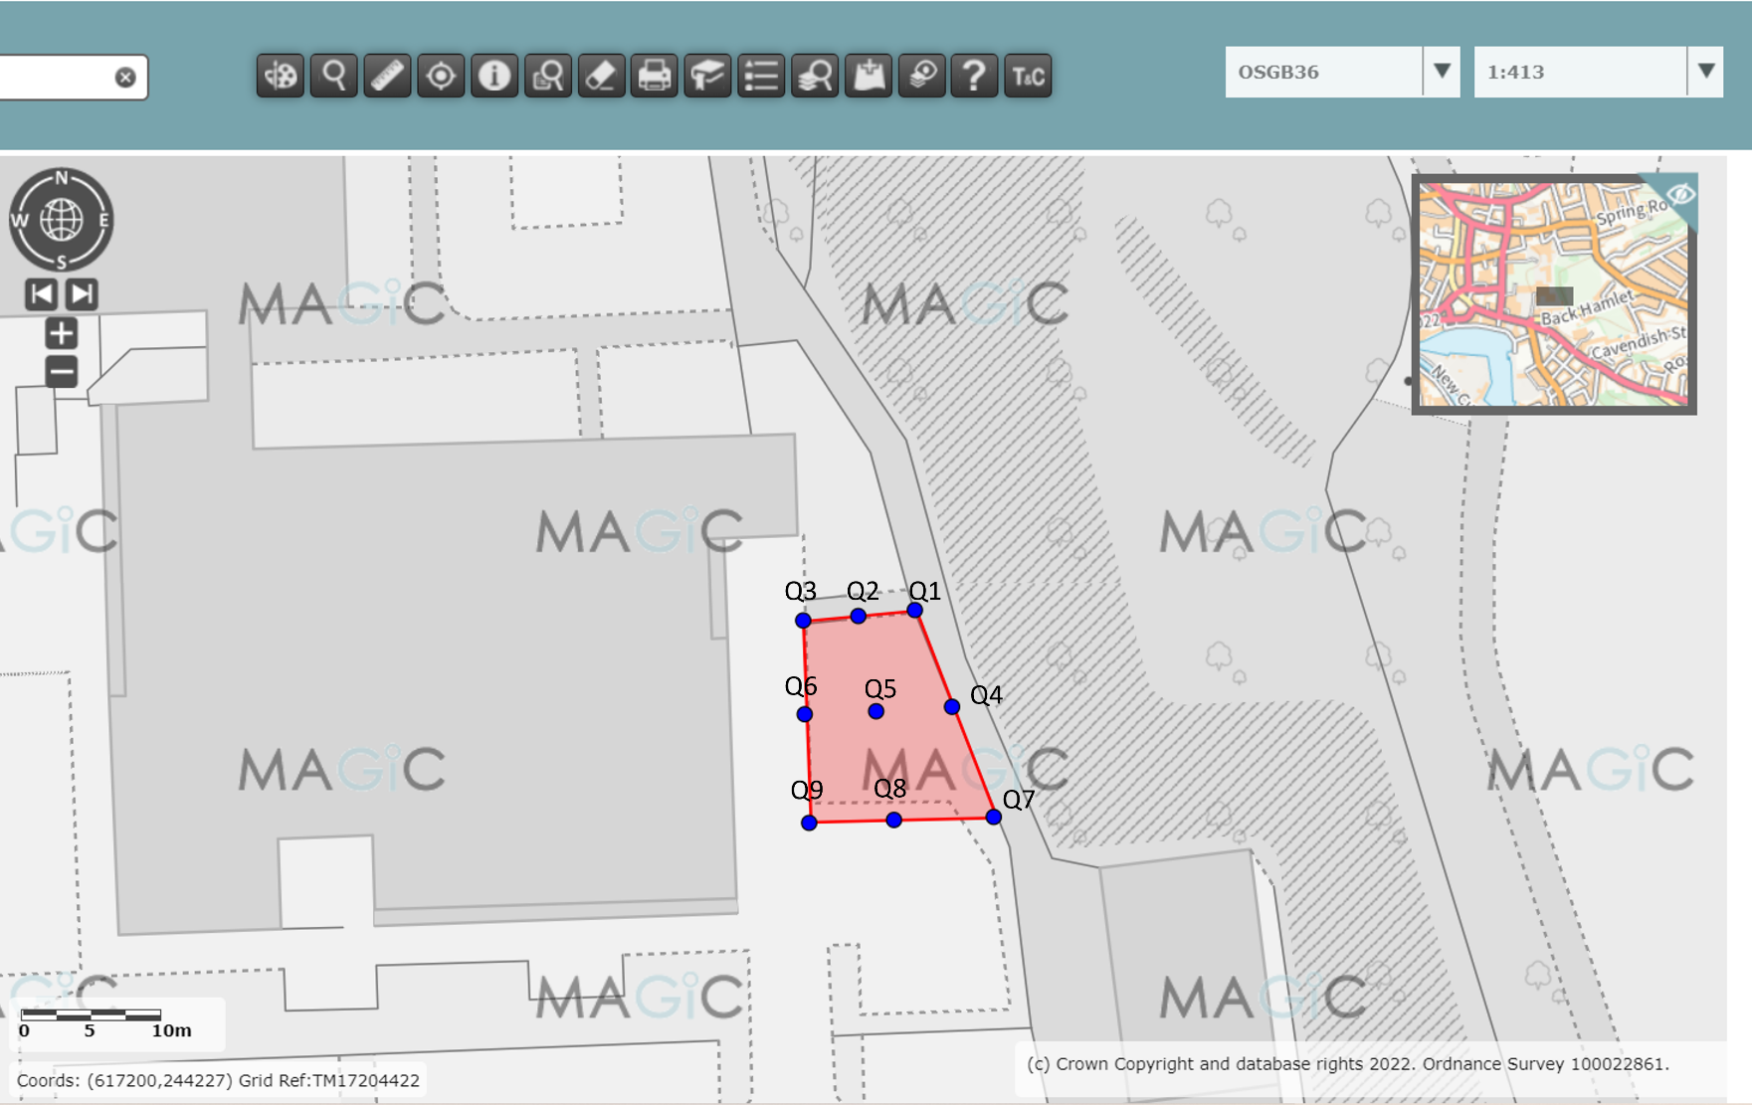

Figure 1, a diagram showing where each quadrat was placed, using systematic sampling. Red indicates the whole sampling site (terrestrial) boundary, and the blue dots indicate where the quadrats were laid. Image produced using the Magic Map application (DEFRA, 2023)

Methodology (pond):
The pond was sampled on the 23rd of May.
Ecology:
The pond was sampled using a 30-second sweep using a 1mm pond net. Three samples were taken, all from the middle of the pond. Second year BS(C) Wildlife, Ecology and Conservation Student identified the plants and taxa present.
Water chemistry:
A one-litre sample of pond water was taken from the centre of the pond. pH, temperature, and conductivity of the pond were measured using a Hanna Waterproof tester; dissolved oxygen used a Lutron Probe, and hardness used a Hanna Titration kit.
Results:
The habitats are described below. Figure 2 shows the habitats and boundaries present at the survey site, their codes, and the location of the target notes. Table 1 describes each target note. Table 2 shows that species were present within the quadrats, their local frequencies, and a photo where relevant (figures 3 to 17).
Total species richness (terrestrial and pond, plants and animals combined) is estimated at 75 species for this site; 19 for the pond.
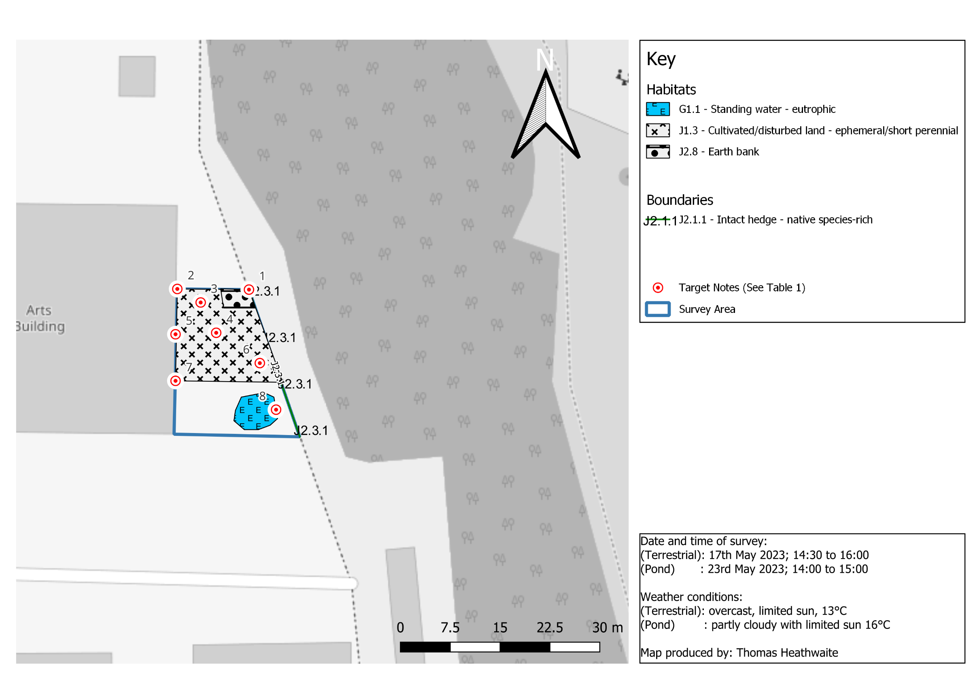
Figure 2, a phase 1 habitat survey map for the University of Suffolk Wildlife Garden. The blue outline shows where the survey boundary is, with each habitat and boundary categories within the site’s boundary according to the standardised phase 1 survey symbols and methodology (JNCC, 2010). Base map and data from OpenStreetMap and OpenStreetMap Foundation (2021).
Table 1, a table showing the target note number and description of each target note.
Target note number | Target note description
T1 | Comfrey (Symphytum orientale) surrounding space of quadrat 1. Many bumblebees and butterflies were attracted. Comfrey (S. orientale) whilst an excellent plant for pollinators, can take over quickly so management may be needed to ensure it doesn’t engulf the entire site.
T2 | Near quadrat 3, around 7 buttercups (likely to be creeping buttercups, Ranunculus repens), and marigolds (Genus Tagetes) were present.
T3 | Wildflowers, such as cornflower (Centaurea cyanus) is present in high numbers here, and 8 cow parsley (Anthriscus sylvestris) were also counted. This is from the seed from the wildflower meadow collected during scything in 2021, which has germinated and created this habitat.
T4 | Near quadrat 5, a large patch of geranium is present, there is also four buttercups (likely to be creeping buttercups, R. repens) also in this area.
T5 | Oxeye daisy (Leucanthemum vulgare), close to quadrat 6, but with a low frequency. 14 buttercups, likely to be creeping buttercups, R. repens were also present.
T6 | Next to quadrat 7, a large amount of white comfrey (S. orientale) was present. As stated in T1, the same information applies here.
T7 | Purple comfrey (S. orientale) is present which is fantastic for pollinators, such as bees.
T8 | Iris pseudacorus present, just one plant which is great for pollinators and is a marginal pond plant, and is situated at the margin of our pond. This plants is good for pollinators, and a range including bumblebees (Bombus. lucorum agg, Bombus. terrestris, Bombus. Hortorum, and Bombus. pratorum), 5 noctuid moths, syrphid flies have all been recorded to visit I. pseudacorus (Good, 1986).

Results – plants:
Table 2, a table showing the plants found in each quadrat, their local frequency, and a photo where relevant.
Quadrat number | Species Present and local frequency | Photo and captions
Q1 | $$\frac{15}{25}=stinging nettle$$  $$\frac{2}{25}=white comfrey$$  $$\frac{6}{25}=stinky mouse ear chickweed$$  $$\frac{17}{25}=common corncockle$$ | 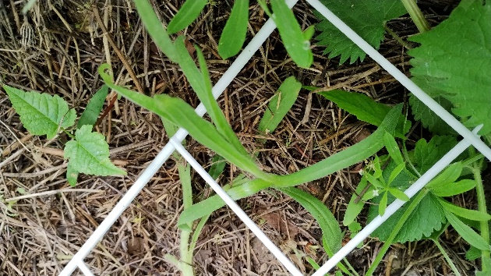  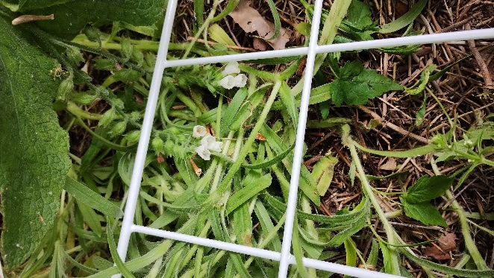  Figure 4, stinky mouse ear chickweed (Galium aparine) and common corncockle (Agrostemma githago)  Figure 3, white comfrey (S. orientale)
Q2 | $$\frac{19}{25}=corncockle$$  $$\frac{6}{25}=round leaf cranesbill$$  White campion  Stinging nettle  $$stinky mouse ear chickweed$$ | 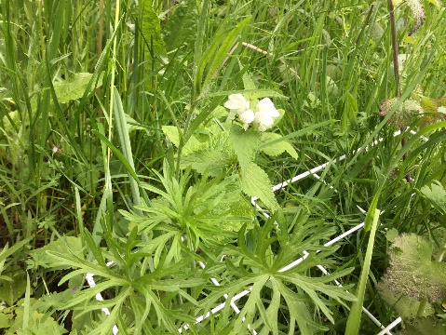  Figure 5, quadrat 2 including sticky weed (Galium aparine).
Q3 | $$\frac{15}{25}=grases \left(species unkown\right)$$  $$\frac{8}{25}=sycomore maple$$  $$\frac{7}{25}=round leaf cranes bill$$  $$\frac{3}{25}=stinky mouse ear chickweed$$  $\frac{1}{25}=spotted medick$ (less than 50% confidence) | 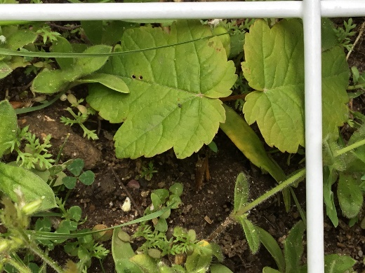  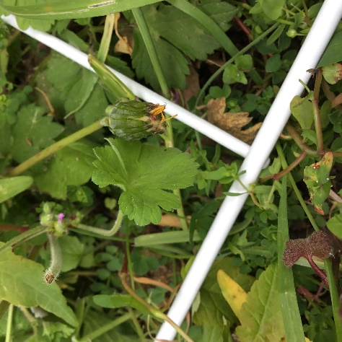  Figure 6, round leaved cranes-bill (Geranium rotundifolium)  Figure 7, sycamore maple (Acer pseudoplatanus)  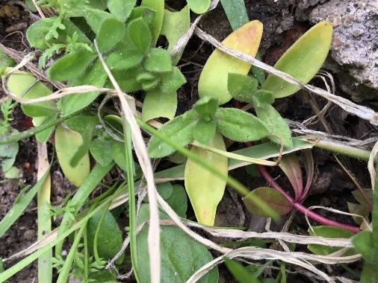  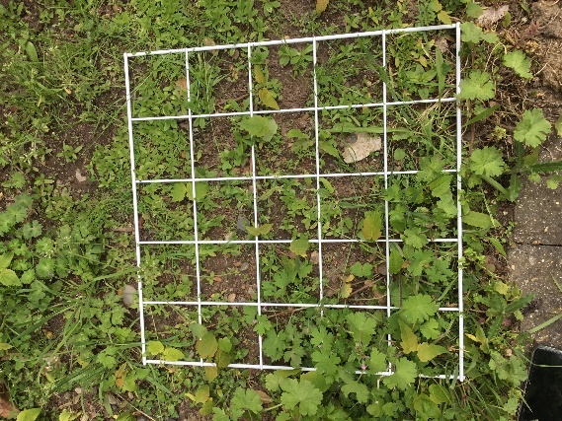  Figure 9, sticky mouse ear chickweed (C. glomeratum)  Figure 8, overview of quadrat 3 including sticky mouse-ear chickweed (Cerastium glomeratum) and round leaved cranes-bill (G. rotundifolium) present.
Q4 | $$\frac{12}{25}=grasses \left(species unknwon\right)$$  $$\frac{11}{25}=green alkanet$$  $$\frac{10}{25}=stinky mouse ear chickweed$$  $$\frac{7}{25}=geranium (species unknown)$$ | 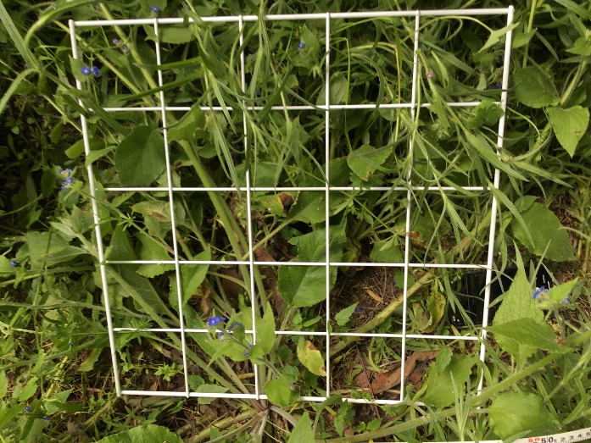  Figure 10, overview of quadrat 4 including green alkanet (Pentaglottis sempervirens) and grasses present.
Q5 | $$\frac{10}{25}=stinging nettle.$$  Hedge mustard  Hedgerow cranesbill  White deadnettle  Blue field-madder  Black medick  Cutleaf geranium | 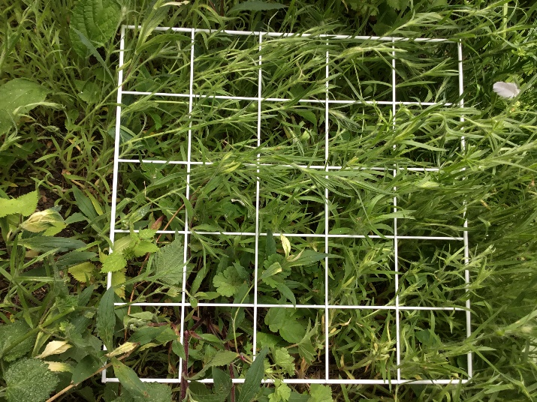  Figure 11, overview of quadrat 5
Q6 | $$\frac{18}{25}=hedge mustard$$  $$\frac{17}{25}=borage$$  $$\frac{7}{25}=little robin$$  $$\frac{6}{25}=crane^{'}sbill$$  $$\frac{5}{25}=thistle \left(species unknown\right)$$  $$\frac{1}{25}=pansy$$ | 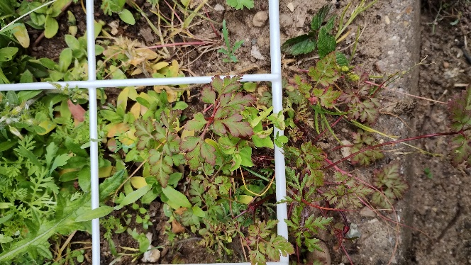  Figure 12, little robin (Erithacus rubecula) and borage (Borago officinalis) present.
Q7 | $$\frac{15}{25}=grasses \left(species unknown\right)$$  $$\frac{5}{25}=dandelion$$  $$\frac{1}{25}=red deadnettle$$ | 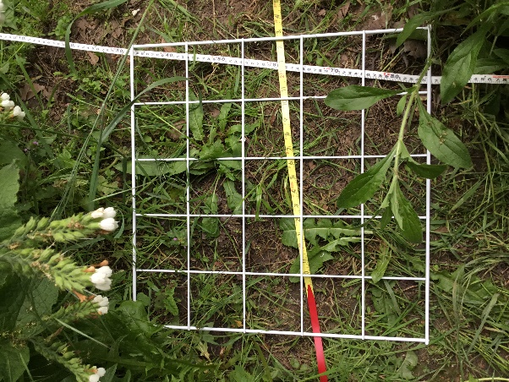  Figure 13, overview of quadrat 7 including red deadnettle’s (Lamium purpureum), grasses (unknown species) and dandelions (Taraxacum officinale).
Q8 | $$\frac{11}{25}=grasses \left(species unknown\right)$$  Common bird foot Trefoil  Cranes bil (species unknown)  Birdeye speedwell  Sticky chickweed  Common corncockle  Ribwort plantain  Rough hawkbit  Clover (species unknown). | 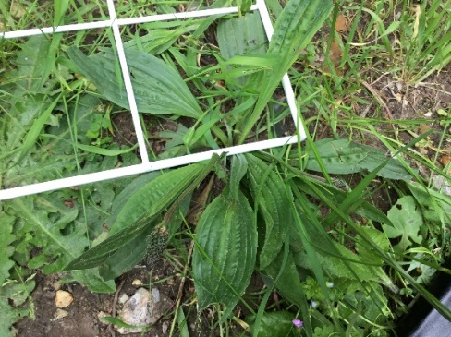  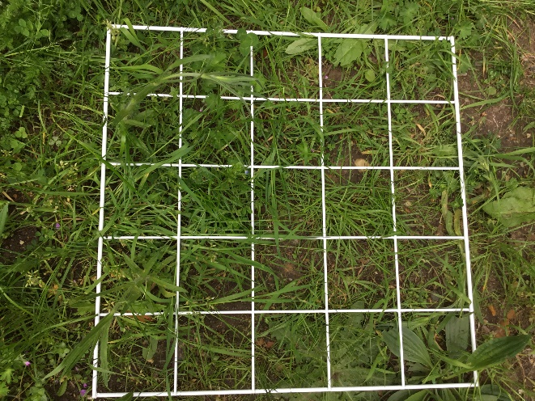  Figure 15, ribwort plantain (Plantago lanceolata)  Figure 14, overview of quadrat 8
Q9 | $$\frac{6}{25}=crane^{'}s bill$$  $$\frac{4}{25}=stinging nettles$$  $$\frac{4}{25}=stinky mouse ear chickweed$$  $$\frac{3}{25}=purple confrey$$ | 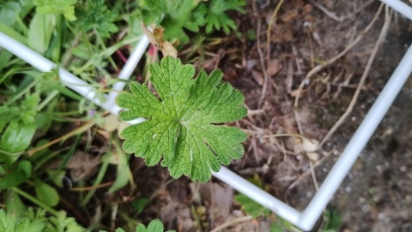  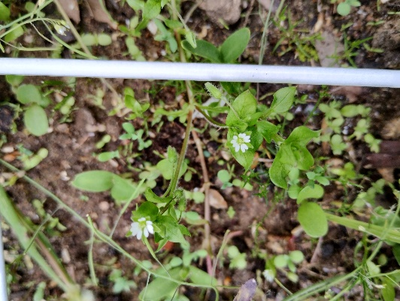  Figure 17, a species of cranesbill (genus Geranium)  Figure 16, common chickweed (Stellaria media)

Results – Animals:
During the survey, the following species were recorded:
- Snail (unknown species).
- Bumblebee (genus Bombus)
- Robin (Erithacus rubecula)
- Wren (Troglodytes troglodytes)
- Blackcap (Sylvia atricapilla)
- Great tit (Parus major)
- Blackbird (Turdus merula)
- Common stripped woodlice (Philoscia muscorum)
- Hoverfly (species unknown)
- Blue tit (Cyanistes caeruleus)
- Magpie (Pica pica)
Throughout the spring up until the time of this survey, the following species have also been recorded:
- Holly blue (Celastrina argiolus)
- Brimstone (Gonepteryx rhamni)
- Muntjack (Muntiacus reevesi)
- Fox (Vulpes vulpes)
- Dark edge bee fly (Bombylius major)
- Red tailed bumblebee (B. lapidaries)
- Common cader bee (B. pascuorum)
- Tree bumblebee (Bombus hypnorum)
- Buff tailed bumblebee (B. terrestris)
- Small white (Pieris rapae)
- Speckled wood (Pararge aegeria)
- Gatekeeper (Pyronia Tithonus)
Pond Results:
Water Chemistry:
From the samples, water pH was 8.1; conductivity was 591 µS/cm, the temperature was 18.3ºC, dissolved oxygen was 17.70% saturation, hardness was 190.5 mg L CaCO3 and alkalinity was 139.5 mg L CaCO3.
Biodiversity:
As shown in figure 2, the pond has been given the habitat code of standing water, eutrophic.
The total species richness is 19.
Table 3 shows the plants found within the pond samples.
Table 3, a table showing the plants found in the pond samples, and their local frequency.
Plant name | Approximate % Cover
Lemna minor | 95
I. pseudacorus | 2
Apium nodiflorum | 2
Carex spp. | 1
Caltha palustris | 1
Ranunculus flammula | 1

Tabel 4 shows the animals that were recorded within the pond sample.
Table 4, a table of the animals that were recorded within the pond sample, and the approximate number in samples.
Animal name | Approximate number in samples
Asellus aquaticus | 200 est.
Chironomini | 50
Chaoborus | 2
Erpobdella octoculata | 8
Oligochaeta | 30
Hydracarina | 15
Copedpoda | 100 est.
Ceratopogon | 10
Ischnura elegans | 2
Coenagrionidae | 1
Rana temporaria (Adults)  Rana temporaria (tadpole) | 1  450 est.
Bufo bufo (tadpole) | 5

Results: desktop survey:
For these result, please see the 2022 Phase 1 report covering the Wildlife Garden.
Recommendations:
Summary of some of the Positives: Terrestrial part of Wildlife Garden:
It is pleasing that the overall species diversity of the Wildlife Garden has considerably increased from 26 species (2022) to 60 (2023), an increase of 130%, and a testament to the work undertaken by students, micro-placement students and staff as well as Justine’s vision. It also shows that even in a small urban area that has not seen any wildlife for over 200 years, urban wildlife can still thrive: there is hope!
Some of the key beneficial species identified included:
- White comfrey (S. orientale) which has medicinal uses, can be used as a fertiliser and is beneficial for pollinators,
- Common corncockle (A. githago), originating from the wildflower seed from our wildflower meadow is also especially beneficial for bumblebees, bees and other pollinators, as is spotted medick (Medicago arabica).
- Sycamore maples (A. pseudoplatanus) are beneficial to small mammals, aphids, bees, moths, ladybirds, hoverflies and birds.
Management recommendations:
We are likely to cut back the hedge and manage it in such a way that the hedge is allowed to grow a bit more ‘freely’ next year.
Additionally, in the autumn it is recommended to strim the vegetation back (once the seed heads have fallen) and determine what has done well and what has not done so well.
Next year’s planting recommendations:
Based upon the philosophy of planting to attract more woodland butterflies’ species and more solitary bees and bumblebees, the following recommendations have been made:
- Planting Common Couch (Elymus repens) would attract woodland butterflies such as the speckled wood (P. aegeria), and is the foodplant of the ringlet (Aphantopus hyperantus) and gatekeeper (P. Tithonus).
- Yorkshire-fog (Holcus lanatus) is a beneficial foodplant for the speckled wood (P. aegeria) and small skipper (Thymelicus sylvestris)
- Cock's-foot (Dactylus glomerata) should be planted which would be highly beneficial for the speckled wood (P. aegeria).
- To continue to attract orange tip (Dactylus glomerata), food plants such as hedge mustard (Sisymbrium officinale) and garlic mustard (Alliaria petiolate) would be beneficial in higher abundance/ planted respectively.
- To attract the gatekeeper (P. Tithonus), planting of bents (Agrostis spp.), fescues (Festuca spp.), and meadow-grasses (Poa spp.) may be beneficial.
For solitary bees and bumblebees, there were 12 ‘rarer’ species identified in the 2022 survey report and these recommendations are still valid here.
Species of concern and management of these species (terrestrial):
As stated in the 2022 phase 1 report, stinging nettles (U. dioica), and grass are species of concern and are still appearing (see the 2022 report for the reasons).
U. diotica has been thinned throughout the winter and whilst it is still present towards the backmost area next to the trees, we are likely to allow it there and prevent it from spreading. This is due to it providing good cover for the deer, such as muntjac (M. reevesi) which have been seen. On the other hand, U. diotica is also the foodplant of the comma (Polygonia c-album), a woodland species which does well in the fringes of habitats provided by the garden, and as such is one of our target species for the next year.
Whilst great strides have been made during the winter to remove the grass, and prevent it from spreading (as evident, in part due to the increase in plant species diversity), this still needs to consistently happen over multiple winter to remove it entirely. Yellow rattle (Rhinanthus minor) has been proven to suppress grass, so planting of this in areas predominantly full of grass should be a key priority for next year.
Additionally, goosegrass (e.g $sticky willy)$has kept in which, whilst providing some good habitat for the deer species who hid in the area with the line of trees, can invade and take over quickly strangely other species in the process. Periodic monitoring and clearance of goosegrass promptly is recommended.
Recommendations (pond part of wildlife garden):
It is excellent to see that I. pseudacorus is already part of the plant species in the pond – this is excellent to many pollinators as alluded earlier to in the report (Good, 1986).
The pond is now in it’s second year and with the baseline now assessed, the recommendations are as follows and can be split into marginal and oxygenating zones of the pond. For the marginal regions of the pond, plants which would attract a wider diversity of wildlife include:
- Caltha palustris which is attractive to a variety of bumblebees and hoverflies, and has been known to be visited by up to 39 different insects (Eiseman, Heller, and Rulik, 2016).
- Lythrum salicaria has been shown to be good for hoverflies, bumblebees such as B. terrestris, B. lapidaries, B. pascuorum, Bombus lucorum and has been visited by up to 7 species of butterflies (Corbet et al., 2000; Comba et al., 1999)
- Mentha aquatica is known to be visited by a variety of bumblebee species (Michołap, Kelm and Sikora, 2018; Carvell, 2006).
For the oxygenating zone of the pond, the following plants are recommended:
- Stratiotes aloides ecological function is a strong edificator; meaning it maintains the stability of aquatic ecosystems, thus is recommended (Efremov et al., 2019). It can also be beneficial to dragonflies and damselfly larvae by providing resting and sheltering places (Wildlife Trust, n.d)
- Species from the nymphaea genus can be beneficial for pollinators, including bumblebees and Xylocopa (carpenter bees) (Zhou et al., 2022).
Additionally, it is recommended that C. palustris and species from the nymphaea genus are grown in a pond basket.

Bibliography:
Carvell, C. (2006) Bumblebee habitat restoration in the agricultural landscape (Doctoral dissertation, University of Southampton).
Comba, L., Corbet, S.A., Hunt, L. and Warren, B. (1999) Flowers, nectar and insect visits: evaluating British plant species for pollinator-friendly gardens. Annals of Botany, 83(4), pp.369-383.
Corbet, S.A., Bee, J., Dasmahapatra, K., Gale, S., Gorringe, E., La Ferla, B., Moorhouse, T., Trevail, A., Van Bergen, Y. and Vorontsova, M. (2001) Native or exotic? Double or single? Evaluating plants for pollinator-friendly gardens. Annals of Botany, 87(2), pp.219-232.
DEFRA (2023) MAGIC. Available at: https://magic.defra.gov.uk/MagicMap.aspx [accessed 10/08/23].
Efremov, A.N., Sviridenko, B.F., Toma, C., Mesterházy, A. and Murashko, Y.A. (2019) Ecology of Stratiotes aloides L.(Hydrocharitaceae) in Eurasia. Flora, 253, pp.116-126.
Eiseman, C.S., Heller, K. and Rulik, B. (2016) A new leaf-mining dark-winged fungus gnat (Diptera: Sciaridae), with notes on other insect associates of marsh marigold (Ranunculaceae: Caltha palustris L.). Proceedings of the entomological Society of Washington, 118(4), pp.519-532.
Good, J.A. (1986) Insect visitors to Iris pseudacorus (Iridaceae) in Ireland. The Irish Naturalists' Journal, 22(2), pp.71-74.
JNCC (2010) Handbook for Phase 1 habitat survey – a technique for environmental audit. Peterborough: JNCC.
Michołap, P., Kelm, M. and Sikora, A. (2018) Potential of an Algorithm in Assessing Attractiveness of Flowering Plants to Bumblebees (Hymenoptera: Apidae) and Their Subsequent Protection as Pollinators1. Journal of Entomological Science, 53(2), pp.251-267.
Natural Environment and Rural Communities Act 2006, c. 16. Available at: https://www.legislation.gov.uk/ukpga/2006/16/contents [accessed 10/08/23].
NBN Atlas (2023) Explore your area. Available at: https://records.nbnatlas.org/explore/your-area#52.10412650000001|1.3288216|13|ALL_SPECIES [accessed 10/08/23].
The conservation of habitats and species regulations 2017 (SI 2017/1012). Available at: https://www.legislation.gov.uk/uksi/2017/1012/contents/made [accessed: 10/08/23].
Wildlife and Countryside Act 1981, c. 69. Available at: https://www.legislation.gov.uk/ukpga/1981/69/contents [accessed 10/08/23].
Wildlife Trust (n.d) Water-Soldier. Available at: https://www.wildlifetrusts.org/wildlife-explorer/wildflowers/water-soldier [accessed 10/08/23].
Zhou, Q., Shi, M., Zhang, H. and Zhu, Z. (2022) Comparative study of the petal structure and fragrance components of the Nymphaea hybrid, a precious Water lily. Molecules, 27(2), p.408.

