
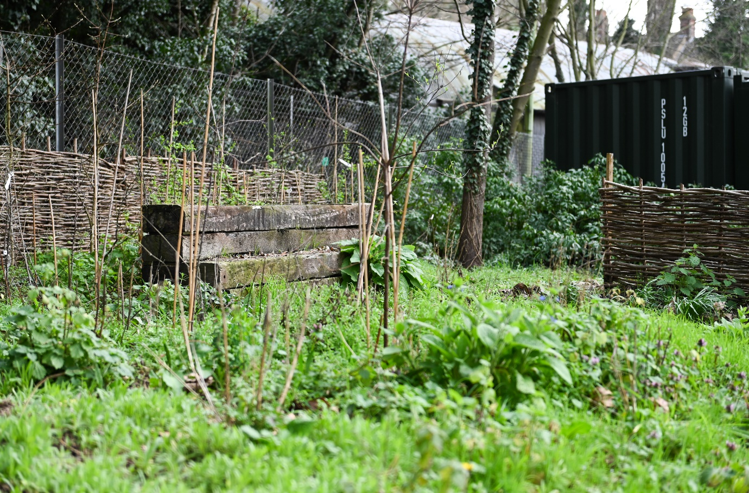
Wildlife Garden Report
Phase 1 habitat survey report
2022

Site name: University of Suffolk Wildlife Garden
Grid reference: TM17194420
Area: 179.4 meters²
Date and time of the survey: 3rd May 2022, 13:55 to 16:20 (terrestrial).
Weather conditions: overcast, no sun, 13°C.
Recorder: Thomas Heathwaite
Location, description, and geology of site:
The site is located on the University of Suffolk campus which is in the centre of Ipswich. Bordering the wildlife garden, to the east, is Alexander Park. Suffolk new college boarders just to the north of the University of Suffolk campus and the marina and Ipswich wet docks are to the south of the University of Suffolk campus. The centre of Ipswich is about 1km from the site campus.
The geology of the site consists of clay, silt, and sand and this type of geology is known as Thames Group geology
Statutory and Non-statutory designations:
There are no statutory designations within a radius of 1km of the survey site.
Two non-statutory designations are present within a radius of 1km of the survey site including zone III – total catchment source protection zone and drinking water protected area (surface water) (DEFRA, 2022)
Habitats and species:
The sample site is classified as broadleaved, mixed, and yew woodland under the Living England Habitat Map (DEFRA, 2022). Within the 1km radius of the survey site, there are many areas of Priority Habitat Inventory Deciduous woodland; these areas are present at the border between the survey site and Alexander Park; Bishops Hill, and Holywells Park (DEFRA, 2022). The above areas are also classified as Broadleaf woodland under the National Forest Inventory (DEFRA, 2022).
A Biodiversity Action Plan Priority Habitat is located within 1km of the survey site: namely Holywells park (it is approximately 513 meters from the survey site) (DEFRA, 2022).
Habitats, classified as Open mosaic habitats, are also present within 1km of the survey site (DEFRA, 2022).
For species, a granted European Protected Species Application exists for bats (DEFRA, 2022).
Methodology (terrestrial):
Before the site visit, a desktop survey consisting of 1) the geology of the site; 2) statutory and non-statutory designations and 3) a search using the NBN Atlas (2022) of all protected species recorded within a 1km radius of the survey site listed on the UK Wildlife and Countryside Act (1981), section 41 of the Natural Environment and Rural Communities Act (2006), and The Conservation of Habitats and Species Regulations 2017 was conducted.
A visit to the site was made on the 3rd of May to survey the terrestrial part of the site, with weather conditions, overcast, no sun and 13°C. The site was surveyed regarding the plant species present. 1-meter squared quadrants were used to sample the site, using standardised sampling (see figure 1). Plants species present in these quadrats were recorded, along with their local frequency in each quadrat. From this, dominant species were noted, and the habitats were mapped as per JNCC Phase 1 Habitat Survey methodology (JNCC, 2010). Where habitats were too small to map, target notes were used, as per JNCC’s recommendations (JNCC, 2010). Any species observed on the day were also noted.
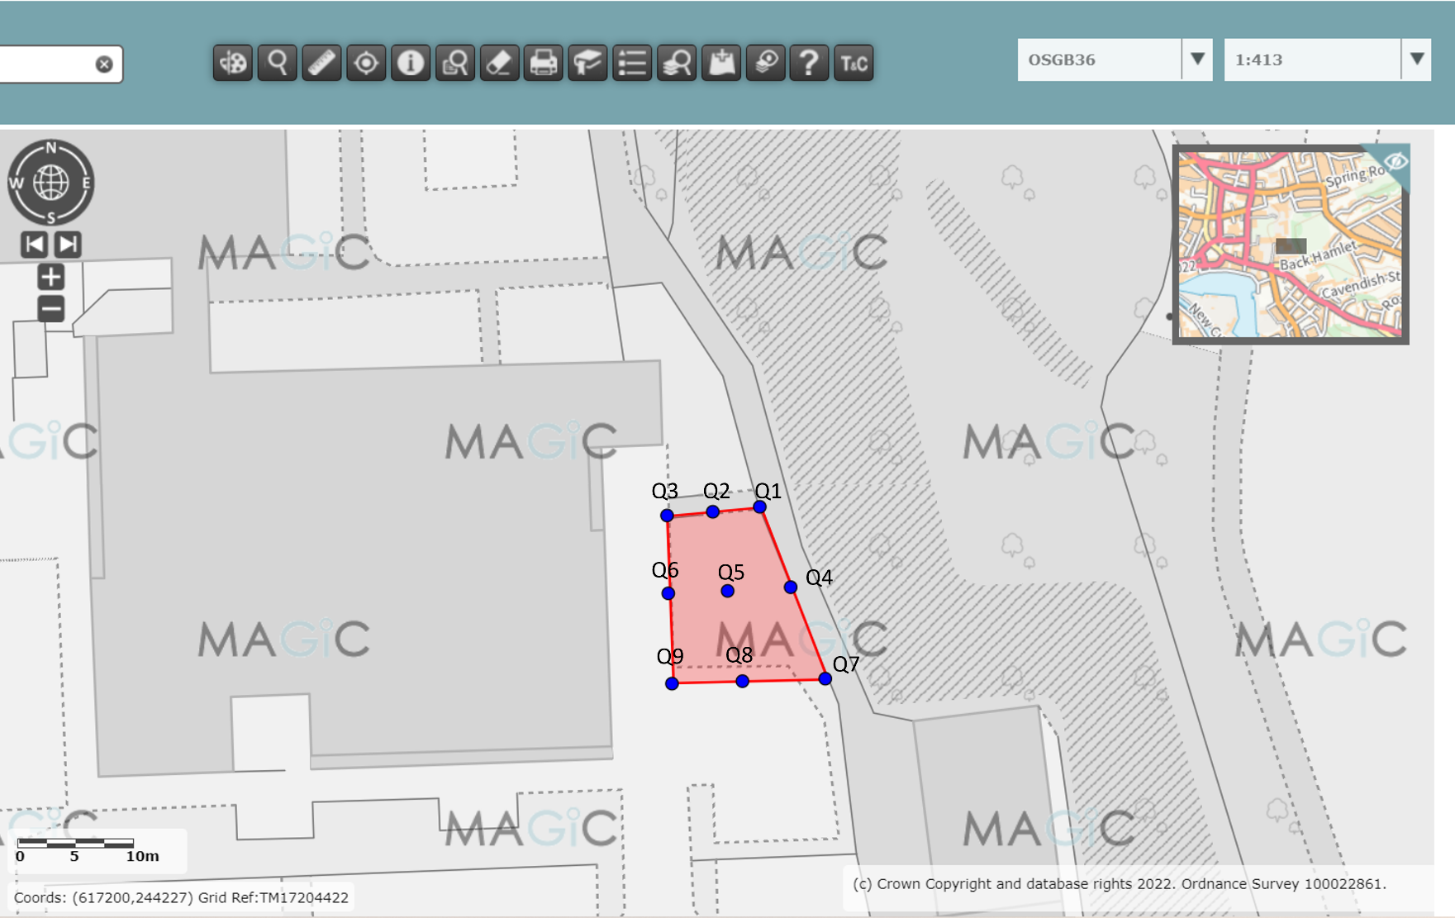
Figure 1, a diagram showing where each quadrat was placed, using systematic sampling. Red indicates the whole sampling site (terrestrial) boundary, and the blue dots indicate where the quadrats were laid. Image produced using the Magic Map application (DEFRA, 2022).

Results:
The habitats are described below. Figure 2 is a phase 1 map showing the habitats and boundaries present at the survey site, their codes, and the location of target notes. Table 1 describes each target note. Table 2 shows what species were present within the quadrats, their local frequencies, and a photo where relevant (figures 3 to 26).
Total species richness (plants and animals, combined) is estimated at 26 species for this site.
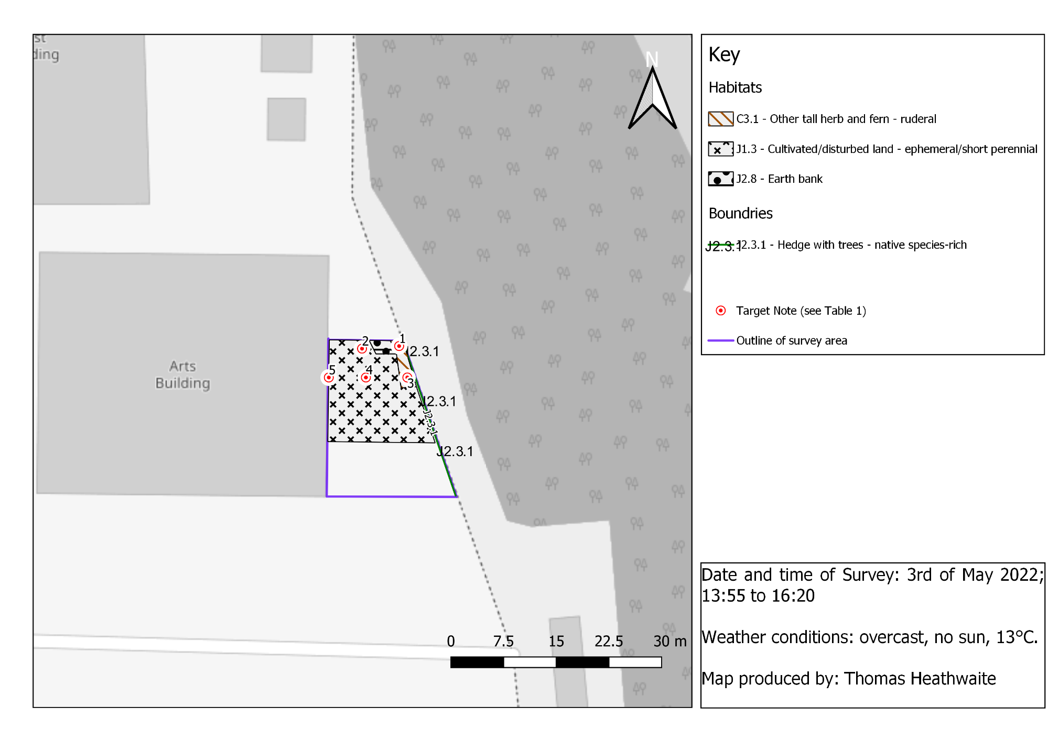

Figure 2, a phase 1 habitat survey map for the University of Suffolk Wildlife Garden, Ipswich, IP3 8AH. The blue outline shows where the survey boundary is, with each habitat and boundary categised within the site’s boundary according to the standardised phase 1 survey symbols and methodology (JNCC, 2010). Base map and data from OpenStreetMap and OpenStreetMap Foundation (2021).
Table 1, a table showing the target note number and a description of each target note.
Target note number | Target note description
T1 | Stinging nettle (Urtica dioica) is present in high quantities – 10 out of 25 squares in quadrat 1 (figure 3) are dominated by this. Signals nutrient-rich area of the wildlife garden.
T2 | In quadrat 2, stinging nettle (U. dioica) was present again, but in lower quantity at 4 out of 25 possible squares. Evidence exists of ephemeral/short perennial plants emerging such as common mallow (M. neglecta) (1 square), garlic mustard (Alliaria petiolate) (5 squares), and creeping buttercup (Ranunculus repens) (1 square). As seen in figure 4, the ground is also quite bare. Ensuring this area does not become dominated by stinging nettles (U. dioica) is a key priority.
T3 | In quadrat 4, there was still a large presence of stinging nettle (U. dioica) with 7 out of the 25 squares available in the quadrat occupied by this species. A reduction of the amount of stinging nettle (U. dioica) would be preferable in this area.
T4 | Green Alkanet (Pentaglottis sempervirens) present. Is non-native to the UK, and is invasive so it is recommended that this is removed from the wildlife garden. Present in small quantities in quadrat 5, with 5 out of 25 squares occupied by it.
T5 | Ribwort plantain (Plantago lanceolata) is present, indicative of distributed land which this land is. present in 1 of 25 squares available, in quadrat 6.

Results – plants:
Table 2, a table showing the plants found in each quadrat, their local frequency, and a photo where relevant
Quadrat number | Species present and local frequency. | Photos and captions
Q1 | $$\frac{10}{25}=stinging nettle$$ | 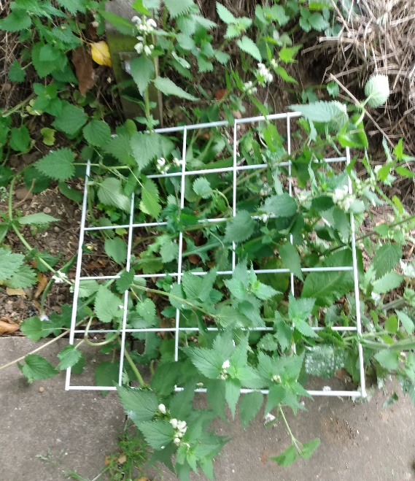  Figure 3, overall image of quadrat
Q2 | $$\frac{4}{25} =stinging nettle$$  $$\frac{5}{25}= garlic mustard$$  $$\frac{1}{25}=common mallow$$  $$\frac{1}{25}=creeping buttercup$$  $$\frac{1}{25 }=species of atriplex, (fat hen-23\% lilihoood)$$  $$\frac{1}{25}= species from ballota genus$$ | 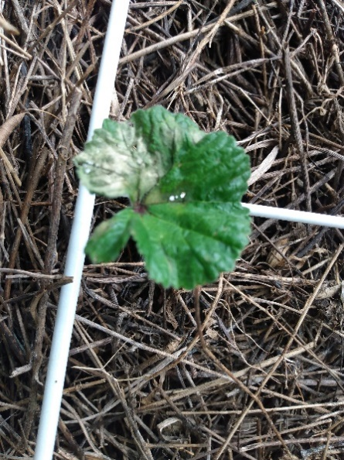  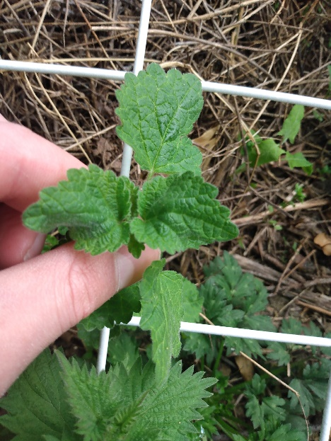  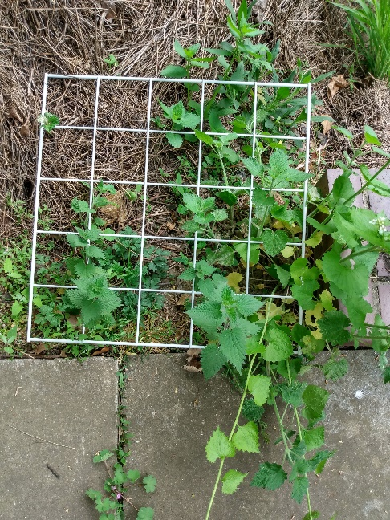  Figure 6, common mallow (Malva neglecta)  Figure 5, Species from ballota genus  Figure 4, overall image of quadrat  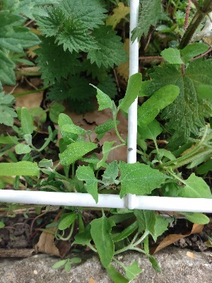  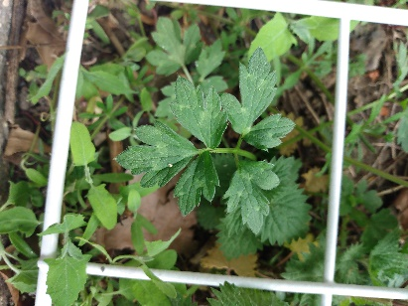  Figure 9, species of atriplex  Figure 8, creeping buttercup (R. repens)  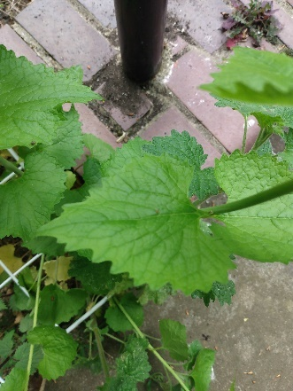  Figure 7, garlic mustard (Alliaria petiolata)
Q3 | Species were unknown during the site visit, so local frequencies were not measured for these species. | 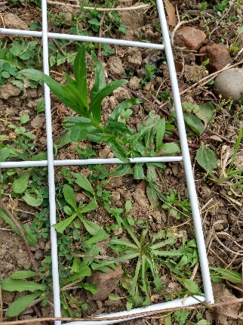  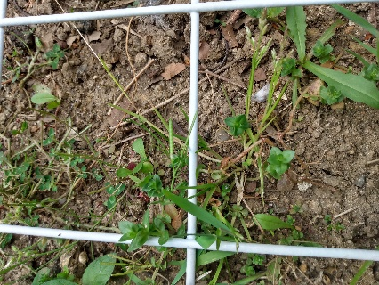  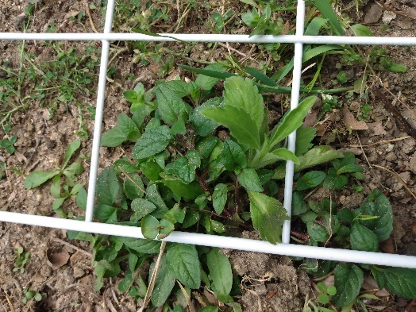  Figure 11, unknown species  Figure 10, Species of prunella genus  Figure 12, Unknown – possibly a plant species from either the dandoline (genus) or hawsbread (genus).
Q4 | $$\frac{7}{25}=stinging nettle$$  $$\frac{1}{25 }=dock species \left(dicot class?\right)$$  $$\frac{1}{25}=ground ivy$$
Q5 | $$\frac{5}{25}=Greek alkanet (25\% lilihood)$$  $$\frac{3}{25}=stinging neetle$$ | 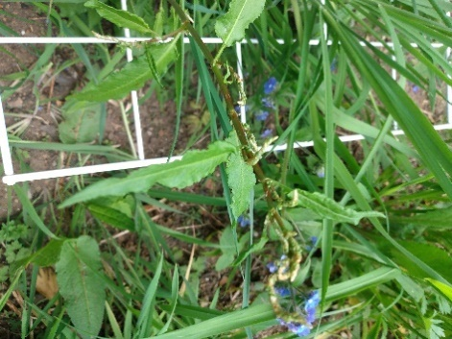  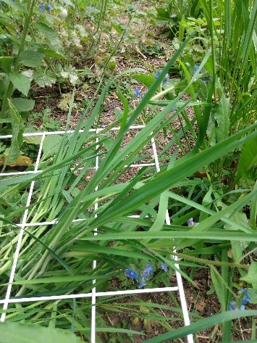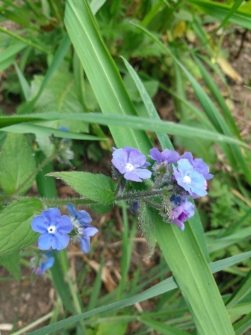  Figure 14, species of dock (rumex genus)  Figure 13, Two photos – Green alkanet (P. sempervirens).  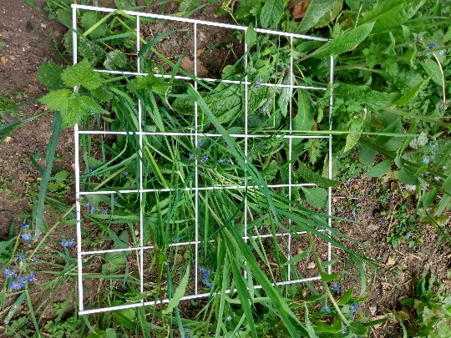  Figure 15, overall image of quadrat
Q6 | $$\frac{3}{25}=forgot me knot$$  $$\frac{1}{25}=Ribwort plantain$$  $$\frac{1}{25}=small flower crane bill$$ | 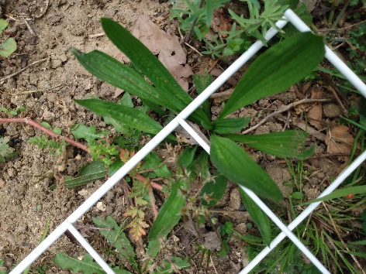  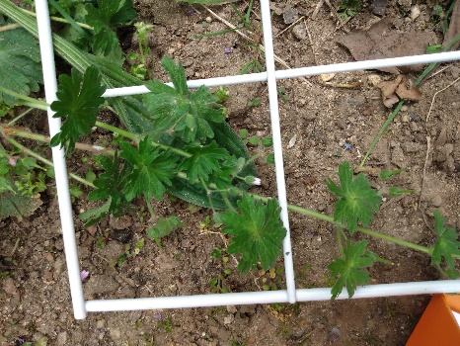  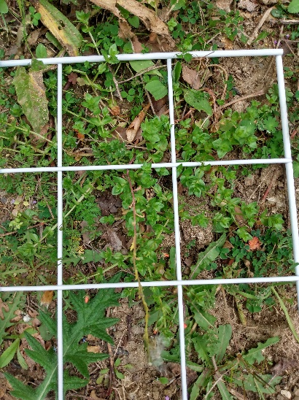  Figure 18, unknown species  Figure 17, small flower crane bill (Geranium pusillum)  Figure 16, unknown species
Q7 | $$\frac{1}{25}=spear thisle$$ | 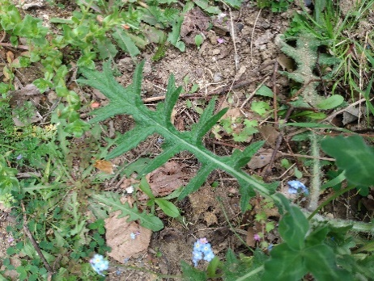  Figure 19, spear thistle (Cirsium vulgare)
Q8 | $$\frac{1}{25}=mug wort$$  $$\frac{11}{25}=spear thisle$$  Bristly ox-tongue (85%) – local freq. unknown. | 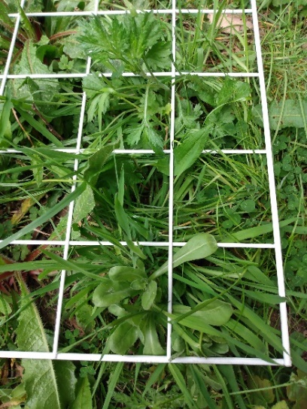  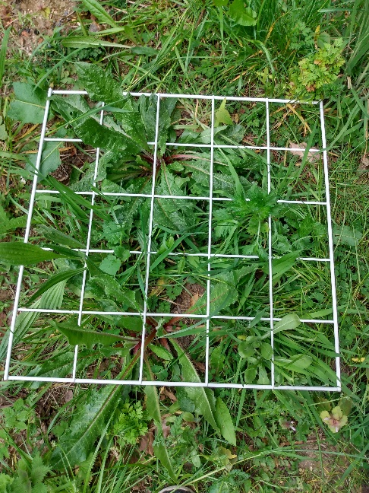  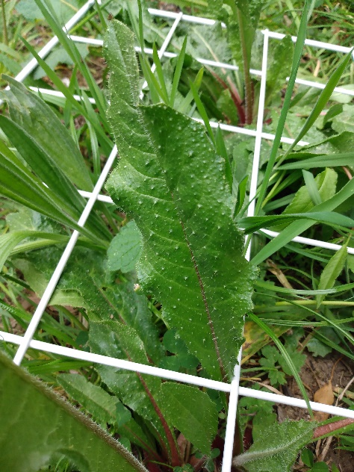  Figure 21, unknown species  Figure 22, overall image of quadrate  Figure 20, bristle ox-tongue (Helminthotheca echioides)  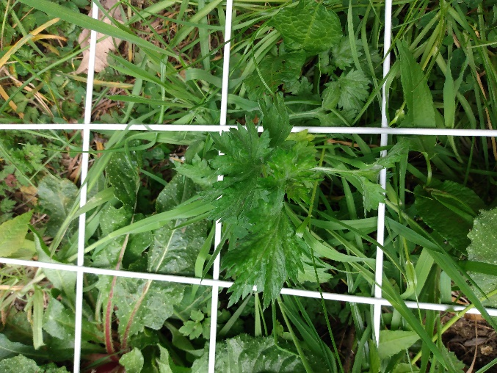  Figure 23, unknown although the image shows evidence of spear thistle present (C. vulgare)
Q9 | $$\frac{6}{25}=sheaperd purse \left(67\% likely\right)$$  $$\frac{1}{25}=garden dill$$ | 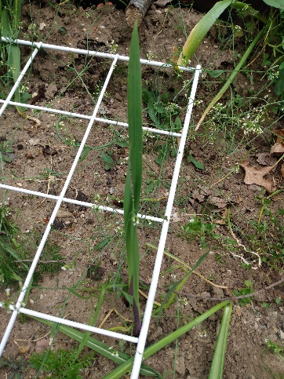  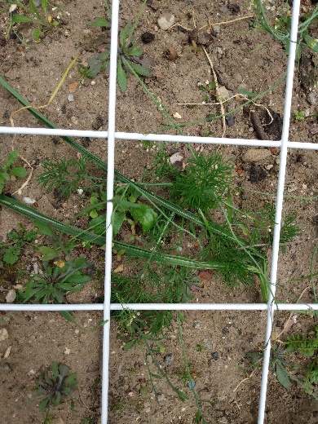  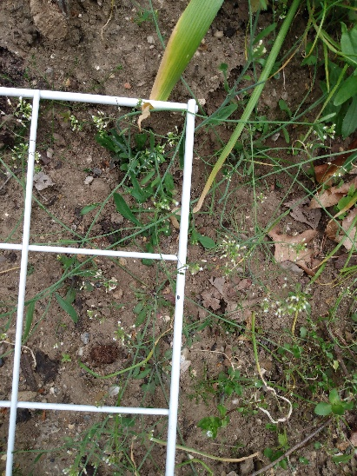  Figure 25, unknown species  Figure 26, unknown species  Figure 24, shepherd’s purse (Capsella bursa-pastoris)  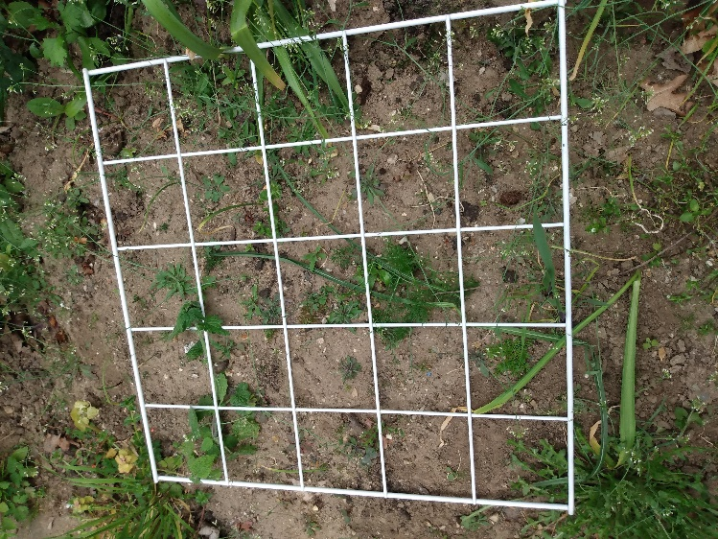  Figure 26, overall image of the quadrat.

The hedgerow, mapped as J2.3.1 (hedge with trees, native -species-rich), consisted of a multitude of species including Hawthorne (Crataegus monogyna), common dogwood (Cornus sanguinea), European hornbeam (Carpinus betulus), blackthorn (Prunus spinosa), and Siberian dogwood (Cornus alba). It is highly likely that there are more species than this present in this hedgerow, however, given the time of the year, some were un-identifiable.
Based upon the above results, the total species richness of plants on site was estimated at 20 species of which 16 were present in the garden itself.
The most dominant species were stinging nettles (U. dioica), and spear thistle (C. vulgare) was dominant in quadrat 8.
Results – animals:
On the day, wood pigeons (Columba palumbus), robin (Erithacus rubecula), blackbird (Turdus merula), goldfinch (Carduelis carduelis), and tree bumblebee (Bombus hypnorum), were all recorded. Evidence of foxes (Vulpes vulpes) was also identified during the survey.
Results – desktop survey:
Within the last 4 to 5 years, the following species which are listed on one or more of the following pieces of legislation: 1) Wildlife and Countryside Act 1981, 2) section 41 of the Natural Environment and Rural Communities Act 2006, and 3) Suffolk Biodiversity Action Plan Priority Species (Suffolk Biodiversity Information Service, 2022) have been observed within 1km radius of the survey site:
- Reptiles:
  - Common lizard (Viviparous lizard)
- Birds:
  - Dunnock (Prunella modularis)
  - Common starling (Sturnus vulgaris)
  - Song thrush (Turdus philomelos)
  - Lesser redpoll (Acanthis cabaret)
  - Lapwing (Vanellus vanellus)
  - Linnet (Linaria cannabina)
  - Herring gull (Larus argentatus)
  - Mandarin duck (Aix galericulata)
  - Canada goose (Branta canadensis)
- Mammals:
  - European otter (Lutra lutra)
  - Hedgehog (Erinaceus europaeus)
  - Grey Squirrel (Sciurus carolinensis)
- Beatles:
  - Stag beetle (Lucanus cervus)
- Plants:
  - Bluebell (Hyacinthoides non-scripta)

Recommendations:
This section is mainly targeted towards increasing the diversity of both solitary bees and bumblebees and looks first at what species are currently present that are good for these organisms and then discussed 1) a management plan based upon the above information and 2) what species rarer species that have been observed within the last 4 years within 2km radius of the survey site would need to be attracted back to this site (see appendix 1).
Species currently present:
- Common mallow (M. neglecta) is excellent for insects generally and flowers from June to October (London Wildlife Trust, n.da).
- Creeping buttercup (R. repens) is excellent for short-tongued bumblebees such as Bombus terrestris/ Bombus lucorum.(London Wildlife Trust, n.db).
- Although dock species (genus rumex) are difficult to eradicate, they are native and support a wide range of insects including moths, beetles, and butterflies (Royal Horticultural Society, 2022a).
- Ground ivy (Glechoma hederacea) is excellent for insects emerging in early spring and flowers from March to June (Sussex Wildlife Trust, 2020).
- Whilst Ribwort plantain (P. lanceolata) does not attract bees specifically, it attracts moths, butterflies, and hoverflies, and provides food for birds through its seed during the winter (Plantlife, 2022).
- Spear thistle (C. vulgare), has a ‘weed’ status in the UK, but it flowers from July to October and attracts butterflies such as the small copper (Lycaena phlaeas), and its seeds are attractive to birds such as goldfinches (C. carduelis), during the winter (The Wildlife Trust, n.da).
- The wildlife trusts (n.db) has complied a list of plants that attract 1) lacewings, 2) hoverflies and 3) parasitic wasps and dill species (genus), which feature in all three lists.
Species of concern and management of these species:
- Shepherd’s purse (C. bursa-pastoris), due to the number of seeds it produces (between 2,000 to 3,000) and because it may harbour the disease foliar disease white blister, which affects members of the Brassicaceae, Asteraceae, and Aizoaceae, and its seed may be a source of the disease even if susceptible plants are not being grown (Royal Horticultural Society, 2022b). No literature exists to suggest that this plant benefits either solitary bees or bumblebees.
- Stinging nettles (U. dioica), are highly dominant and an indicator of nutrient-rich ground (Puustinen, Koskela and Mutikainen, 2004). Removal of these, and conversion of the soil to nutrient-poor, should enable a greater diversity of wildflowers to thrive.
- Grass – although this survey did not show any evidence of this, from personal observations it is clear that grass still exists on this site. Grass should be removed as a matter of priority so that species that benefit wildlife, and possibly species that benefit solitary bees and bumblebees can be planted in that space instead. This would increase the species richness of the site and allow more species to colonise the site.
Species recommended to plant to enable solitary bees and bumblebees, particularly the rarer species to colonise:
White clover (Trifolium repens) is widely known to attract bumblebees (Beye et al., 2022).
There are a multitude species that feed more than one of the following 12 ‘rarer’ solitary or bumblebees listed below, these include: bramble (R. fruticosus), dandolin (T. officinale), buttercups (Ranunculus sp.), cinquefoil (P. arenaria), knapweed (C. rhenana) primrose (P. vulgaris) and willowherb (Epilobium sp.), daisy (B. perennis), gorse (ulex sp.) and ragwort (S. jacobaea), and Hawthorne (C. monogyna). However, gorse (genus ulex), may overtake a garden of this size if not controlled carefully.
- For B. lucorum, cornflower (Centaurea cyanus), Holewort (Corydalis cava), and heather (Calluna vulgaris) are known food plants for this species (Bossert et al., 2016; Carreck and Williams, 2002; Myczko et al., 2015). C. cava is also a beneficial food plant for B. terrestris and B. hortorum (Myczko et al., 2015)
- For Lasioglossum sexnotatum the recommended food plants according to the Bees, Wasps and Ants Recording Society (2017), are: dandelion (Taraxacum officinale), Common Figwort (Scrophularia nodosa), Buckthorn (Rhamnus cathartica), Foxglove (Digitalis purpurea), poppies (Papaver sp.) and ragwort (Senecio jacobaea), and bramble Rubus fruticosus agg.) (Bees, Wasps and Ants Recording Society 2017). Clearly dandelion (T. officinale), may pose a problem if they dominate the garden. Foxgloves (D. purpurea), are already present so would not need adding.
- For Nomada goodeniana, spring blooms are essential for this species including species such as cow parsley (Anthriscus sylvestris), dandelions (T. officinale), buttercups (Ranunculus sp.), forget me knots (Myostotis arvensis), and greater stitchwort (Stellaria holostea) are all recommended (Bumblebee Conservation Trust, 2021).
- For Anthophora bimaculate, knapweed (Centaurea rhenana), cinquefoil (Potentilla arenaria) Viper's-bugloss (Echium vulgare) and rosebay willowherb (Epilobium angustifolium) are known floral resources (Pawlikowski & Kruszynski 1997). Moreover, bramble (R. fruticosus agg.), dead nettle (Lamium purpureum), hawk’s-bread (genus: Crepis), ragwort (S. jacobaea), spear thistle (C. vulgare), thyme (genus: Thymus), and willowherb (genus: Epilobium and Chamaenerion) are also floral rescourse for this species (Bees, Wasps and Ants Recording Society, 2013). Spear thistle (C. vulgare) is already present in the site, as is dead nettles (L. purpureum) which, whilst not seen in the quadrats, are known to be on site from personal observation.
- For Anthophora plumipes, this species like plants in the forget me knot (boraginaceae) genus (Alves-dos-Santos and Wittmann, 1999), as well as, cabbage (Brassica oleracea), daffodil (Narcissus sp.), ground-ivy (G. hederacea), herb-robert (Geranium robertianum), lungwort (Pulmonaria spp.), primrose (Primula vulgaris) Rosemary (Rosmarinus officinalis), violet (Viola sp.) and wallflower (Erysimum sp.) are all good species for this species (Bees, Wasps and Ants Recording Society, 2021).
- Although the species Melecta albifrons does not collect pollen, like A. plumipes, nectar sources include ground-ivy (G. hederacea), rosemary (R. officinalis), wallflower (Erysimum sp.) cabbage (B. oleracea) (Bees, Wasps and Ants Recording Society, 2011a). Other known nectar sources include apples (Malus) and cherries (Prunus sp.) (Bees, Wasps and Ants Recording Society, 2011a). Ground ivy (G. hederacea), as seen in the quadrat results (Table 2), is already present on site.
- The species Andrena bicolor is known to feed on the following plants: bramble (R. fruticosus) (Wood and Goulson, 2016), dandelion (T. officinale) (Milet-Pinheiro et al., 2016), buttercups (Ranunculus sp.), cinquefoil (P. arenaria), knapweed (C. rhenana) primrose (P. vulgaris) and willowherb (Epilobium sp.) (Bees, Wasps and Ants Recording Society, 2006). Other known nectar sources include: nettle-leaved bellflower (Campanula trachelium), daisy (Bellis perennis), Hawthorne (C. monogyna), mustard (Brassica sp.), willow (Salix sp.), thistle (Cirsium sp.), rose (Rosa sp.) (Bees, Wasps and Ants Recording Society, 2006). Hawthorne is already present on site, as mentioned above.
- The species Andrena fulva, feeds from beech (Fagus sylvatica), blackthorn (P. spinosa), buttercup (Ranunculus sp.), garlic mustard (A. petiolata), gooseberry (Ribes uva-crispa), hawthorn (C. monogyna), holly (Ilex aquifolium), maple (Acer sp.), oak (Quercus sp.), plum (Prunus domestica) and sallow (Salix sp.) (Bees, Wasps and Ants Recording Society, 2011b). Hawthrone (C. monogyna), blackthorn (P. spinosa), and garlic mustard (A. petiolata) are all already on site.
- For the species, Andrena haemorrhoa, Hawthorne (C. monogyna) is a key food source (Bees, Wasps and Ants Recording Society, 2016). Hawthorne (C. monogyna) is already present on site.
- The species Andrena scotica food plants are presently unknown.
- For the Panurgus banksianus, yellow-flowered plants of the genus Asteraceae are a known food source (Bees, Wasps and Ants Recording Society, 2012b).
- The species Dasypoda hirtipes, food plants include Cat ear’s (Hypochoeris radicata), autumn hawsbread (Leontodon autumnalis), smooth hawsbread (Crepis capillaris) are known floral resources (Levermann, Bischoff and Wagner, 2000), as are creeping thistle (Cirsium arvense), fleabane (Pulicaria dysenterica) (Bees, Wasps and Ants Recording Society, 2011c). As mentioned previously, ragwort (S. jacobaea) is a floral resource (Bees, Wasps and Ants Recording Society, 2011c).

Appendix 1: solitary bees and bumblebees defined as ‘rarer’ for the purpose of this report.
This appendix lists the solitary and bumblebees defined as ‘rarer’ for the purpose of this report, when they were last seen and where they were seen. To be defined as ‘rarer’, species had to be seen within 2km of the survey site within the last six years, and within Ipswich, or very close to the boundary of Ipswich, within the last two years. All information compiled from the NBN Atlas (2022).
  - B. lucorum – last seen within 2km in 2019. Has also been seen in close proximity in 2020 too.
  - L. sexnotatum – last seen within 2km in 2020 and once within the Ipswich area every year since 2017.
  - N. goodeniana – last seen in 2020 and within Ipswich as a whole.
  - A. plumipes – last seen within 2km = 2021; species restricted to southern England. Regularly seen in Ipswich in 2020 and 2021.
  - M. albifrons – last seen within 2km of survey site in 2016 but seen in Woodbridge in 2020 and 2019 too.
  - A. bicolor – last seen within 2km of survey site in 2020 and within Ipswich.
  - A. bimaculate – last seen within 2km in 2017 and within Ipswich in 2020.
  - A. fulva – last seen within Ipswich area and within 2km of survey site in 2021.
  - A. haemorrhoa – last seen within Ipswich area and within 2km of survey site in 2020.
  - A. scotica, last seen within 2km of survey area in 2017 and within Ipswich in 2020.
  - P. banksianus – last seen within 2km of survey site in 2016 and in Shottisham in 2020 and in Woodbridge in 2018
  - D. hirtipes – last seen within 2km of survey site in 2019 and within Ipswich in 2020.

References:
Alves-dos-Santos, I. and Wittmann, D. (1999) The proboscis of the long-tongued Ancyloscelis bees (Anthophoridae/Apoidea), with remarks on flower visits and pollen collecting with the mouthparts. Journal of the Kansas Entomological Society, pp.277-288.
Bees, Wasps and Ants Recording Society (2006) Andrena bicolor Fabricius, 1775. Available at: https://www.bwars.com/bee/andrenidae/andrena-bicolor [accessed: 21/06/2022].
Bees, Wasps and Ants Recording Society (2011a) Melecta albifrons (Forster,1771). Available at: https://www.bwars.com/bee/apidae/melecta-albifrons [accessed: 21/06/2022].
Bees, Wasps and Ants Recording Society (2011b) Andrena fulva (Müller, 1766). Available at: https://www.bwars.com/bee/andrenidae/andrena-fulva [accessed: 21/06/2022].
Bees, Wasps and Ants Recording Society (2011c) Dasypoda hirtipes (Fabricius,1793). Available at: https://www.bwars.com/bee/melittidae/dasypoda-hirtipes [accessed 21/06/2022].
Bees, Wasps and Ants Recording Society (2012a) Andrena bimaculata (Kirby, 1802). Available at: https://www.bwars.com/bee/andrenidae/andrena-bimaculata [accessed: 21/06/2022].
Bees, Wasps and Ants Recording Society (2012b) Panurgus banksianus (Kirby,1802). Available at: https://www.bwars.com/bee/andrenidae/panurgus-banksianus [accessed 21/06/2022].
Bees, Wasps and Ants Recording Society (2013) Anthophora bimaculata (Panzer,1798). Available at: https://www.bwars.com/bee/apidae/anthophora-bimaculata [accessed: 21/06/2022].
Bees, Wasps and Ants Recording Society (2016) Andrena haemorrhoa (Fabricius, 1781). Available at: https://www.bwars.com/bee/andrenidae/andrena-haemorrhoa [accessed: 21/06/2022].
Bees, Wasps and Ants Recording Society (2017) Lasioglossum sexnotatum (Kirby,1802). Available at: https://www.bwars.com/bee/halictidae/lasioglossum-sexnotatum [accessed: 21/06/2022].
Bees, Wasps and Ants Recording Society (2021) Anthophora plumipes (Pallas,1772). Available at: https://www.bwars.com/bee/apidae/anthophora-plumipes [accessed: 21/06/2022].
Beye, H., Taube, F., Lange, K., Hasler, M., Kluß, C., Loges, R. and Diekötter, T. (2022) Species-Enriched Grass-Clover Mixtures Can Promote Bumblebee Abundance Compared with Intensively Managed Conventional Pastures. Agronomy, 12(5), p.1080.
Bossert, S., Gereben-Krenn, B.A., Neumayer, J., Schneller, B. and Krenn, H.W. (2016) The cryptic Bombus lucorum complex (Hymenoptera: Apidae) in Austria: Phylogeny, distribution, habitat usage and a climatic characterization based on COI sequence data. Zoological studies, 55.
Bumblebee Conservation Trust (2021) Gooden’s Nomad bee (Nomada goodeniana). Available at: Gooden’s Nomad bee - Bumblebee Conservation Trust [accessed: 21/06/2022].
Carreck, N.L. and Williams, I.H. (2002) Food for insect pollinators on farmland: insect visits to flowers of annual seed mixtures. Journal of Insect Conservation, 6(1), pp.13-23.
DEFRA (2022) MAGIC. Available at: https://magic.defra.gov.uk/MagicMap.aspx [accessed 29/04/2022].
JNCC (2010) Handbook for Phase 1 habitat survey – a technique for environmental audit. Peterborough: JNCC.
Levermann, E.M., Bischoff, I. and Wagner, T. (2000) Species-specific foraging strategies of the syntopical and synchronous bees Panurgus calcaratus (Scopoli, 1763) and Dasypoda hirtipes (Fabricius, 1793)(Hymenoptera: Apidae). Beiträge zur Entomologie= Contributions to Entomology, 50(1), pp.179-191.
London Wildlife Trust (n.da) Common mallow. Available at: https://www.wildlondon.org.uk/wildlife-explorer/wildflowers/common-mallow [accessed: 21/06/2022].
London Wildlife Trust (n.db) Creeping buttercup. Available at: https://www.wildlondon.org.uk/wildlife-explorer/wildflowers/creeping-buttercup [accessed 21/06/2022].
Milet-Pinheiro, P., Herz, K., Dötterl, S. and Ayasse, M. (2016) Host choice in a bivoltine bee: how sensory constraints shape innate foraging behaviors. BMC ecology, 16(1), pp.1-12.
Myczko, Ł., Banaszak-Cibicka, W., Sparks, T.H. and Tryjanowski, P. (2015) Do queens of bumblebee species differ in their choice of flower colour morphs of Corydalis cava (Fumariaceae)?. Apidologie, 46(3), pp.337-345.
Natural Environment and Rural Communities Act 2006, c. 16. Available at: https://www.legislation.gov.uk/ukpga/2006/16/contents [accessed 30/04/2022].
NBN Atlas (2022) Explore your area. Available at: https://records.nbnatlas.org/explore/your-area#52.10412650000001|1.3288216|13|ALL_SPECIES [accessed 29/04/2022].
Plantlife (2022) Ribwort plantain Plantago lanceolata. Available at: https://www.plantlife.org.uk/uk/discover-wild-plants-nature/plant-fungi-species/ribwort-plantain [accessed: 21/06/2022].
Puustinen, S., Koskela, T. and Mutikainen, P. (2004) Direct and ecological costs of resistance and tolerance in the stinging nettle. Oecologia, 139(1), pp.76-82.
Royal Horticultural Society (2022a) Docks. Available at: https://www.rhs.org.uk/weeds/docks [accessed: 21/06/2022].
Royal Horticultural Society (2022b) Shepherd’s purse. Available at: https://www.rhs.org.uk/weeds/shepherds-purse [accessed: 21/06/2022].
Suffolk Biodiversity Information Service (2022) Suffolk's Priority Species. Available at: https://www.suffolkbis.org.uk/species [accessed: 21/06/2022].
Sussex Wildlife Trust (2020) Species of the day: Ground-Ivy. Available at: https://sussexwildlifetrust.org.uk/news/species-of-the-day-ground-ivy [accessed: 21/06/2022].
The conservation of habitats and species regulations 2017 (SI 2017/1012). Available at: https://www.legislation.gov.uk/uksi/2017/1012/contents/made [accessed: 30/04/2022].
The Wildlife Trust (n.da) Spear thistle. Available at: https://www.wildlifetrusts.org/wildlife-explorer/wildflowers/spear-thistle [accessed: 21/06/2022].
The Wildlife Trust (n.db) Insect-friendly gardening. Available at: https://www.wildlifetrusts.org/features/garden-insects [accessed: 21/06/2022].
Wildlife and Countryside Act 1981, c. 69. Available at: https://www.legislation.gov.uk/ukpga/1981/69/contents [accessed 30/04/2022].
Wood, T. and Goulson, D. (2016) Aculeate bee and wasp survey report 2015/16 for the Knepp Wildland Project. Available at: https://static1.squarespace.com/static/595ca91bebbd1a1d0aaab285/t/5aa29e699140b7e46e21910b/1520606830898/Knepp+bee+and+wasp+survey+report+2015+%26+2016+-+Dave+Goulson+and+Tom+Woods.pdf [accessed 19/06/2022].

