
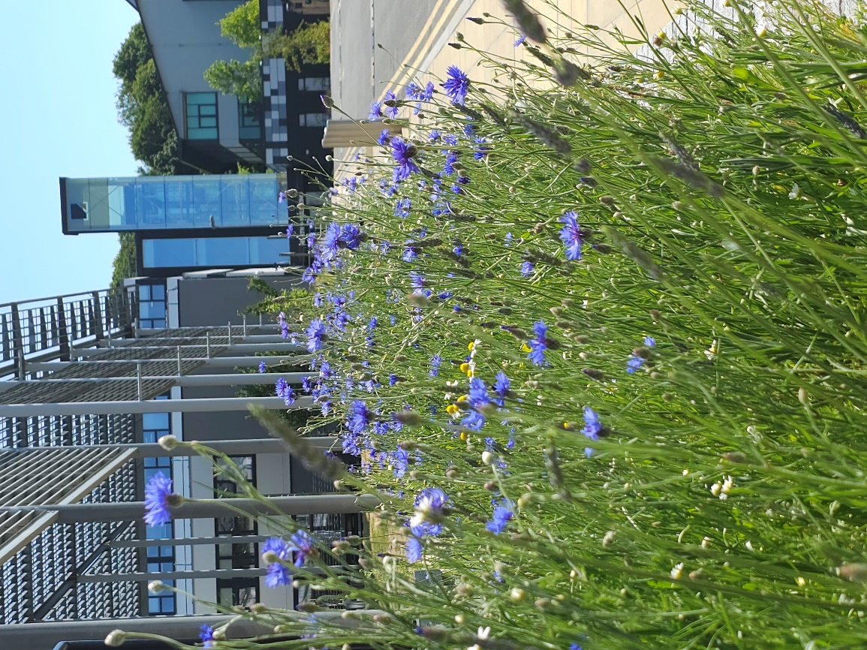
Bumblebee Buffet Area
Phase 1 habitat survey report
2024

Site name: University of Suffolk Bumblebee Buffet Area
Grid reference: TM17194420
Area: 110.3 meters²
Date and time of the survey: 30th April, 12:00 to 13:30
Weather conditions: sunny, slight wind, 15ºC
Recorders: Thomas Heathwaite, and 6 foundation year BS(C) Wildlife, Ecology and Conservation Science Students.
Location, description, and geology of site:
The site is located on the University of Suffolk campus which is in the centre of Ipswich. Bordering the Bumblebee Buffet Area, to the east, is Alexander Park. Suffolk new college boarders just to the north of the University of Suffolk campus and the marina and Ipswich wet docks are to the south of the University of Suffolk campus. The centre of Ipswich is about 1km from the site campus.
The bedrock geology of the site consists of clay, silt, and sand (the Tharnet Fomation and Lambeth Group) and the superficial deposits consist of sand and gravel (the Lowestoft formation).
Statuary and Non-statutory designations:
There are no statutory designations within a radius of 1km of the survey site.
Two non-statutory designations are present within a radius of 1km of the survey site including zone III – total catchment source protection zone and drinking water protected area (surface water) (DEFRA, 2022)
Habitats and species:
Given the Wildlife Garden is only 184 meters away, the finding presented within the 2022 Wildlife Garden Phase 1 Habitat Survey report is likely to be valid here too.
Methodology (terrestrial):
Before the site visit, a desktop survey consisting of 1) the geology of the site; 2) statutory and non-statutory designations and 3) a search using the NBN Atlas (2023) of all protected species recorded within a 1km radius of the survey site listed on the UK Wildlife and Countryside Act (1981), section 41 of the Natural Environment and Rural Communities Act (2006), and The Conservation of Habitats and Species Regulations 2017 was conducted.
A visit to site was made on the 30th of April 2024 to survey the site.
Plants were surveyed using 1 meter squared quadrats, using standardised sampling (see figure 1). Plant species present in these quadrats were recorded , along with their local frequency in each quadrat. From this, dominant species were noted and the habitats were mapped as per JNCC Phase 1 Habitat Survey methodology (JNCC, 2010). Where habitats were too small to map, target notes were used as per JNCC recommendations (JNCC, 2010).
Any species observed throughout the survey period were also noted.
Results:
A map showing the habitats and target notes locations is below (Figure 2). Table 1 describes each target note and Table 2 shows that species were present within the quadrats and their local frequencies.
The total species richness of plants is estimated at 17 which is an increase 6 from the 2023 survey.

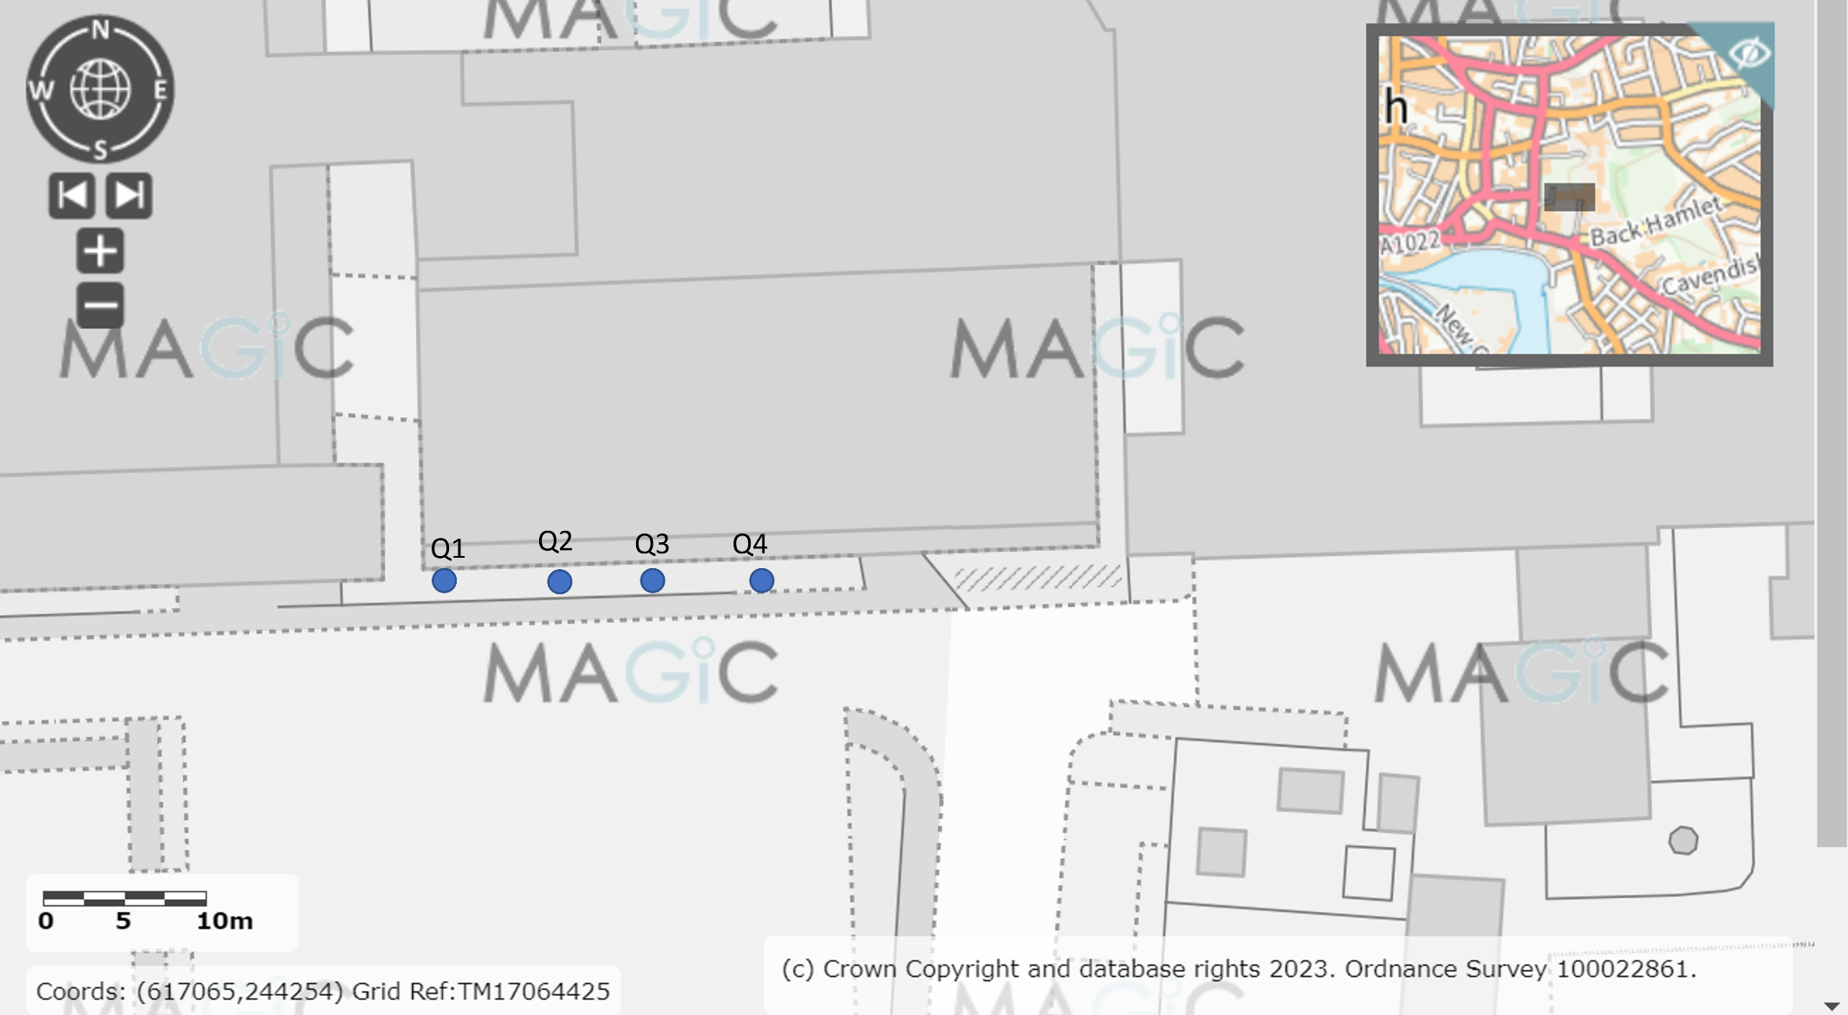Figure 1, a diagram showing where each quadrat was placed, using systematic sampling. The blue dots indicate where the quadrats were laid. Image produced using the Magic Map application (DEFRA, 2023).
Target notes:
Table 1, a table showing the target note number and a description of each target note.
Target note number | Description
T1 | Pink sorrel (Oxalis articulata) was seen between quadrat 2 and 3.
T2 | Birdseye speedwell (Veronica persica) was seen between quadrat 2 and 3.
T3 | Small amount of Bur Chervil (Anthriscus caucalis) located here. They have nutritional properties, however can be invasive. Their small white flowers are attractive to pollinators such as bees and butterflies
T4 | Isolated flower of Star of Bethlehem (Ornithogalum umbellatum) located here, close to quadrat 4.
T5 | Abundant amount of cow parsley (Anthriscus sylvestris) here.

Table 2, a table showing the plants found in each quadrat and their local frequency.
Quadrat number | Local frequency of plants | Photos
Q1 | $\frac{5}{25}$ = Spotted Medick (Medicago arabica)  $\frac{1}{25}$ = Common Dandelion (Taraxacum officinale)  $\frac{20}{25}$ = grass (species unknown) | 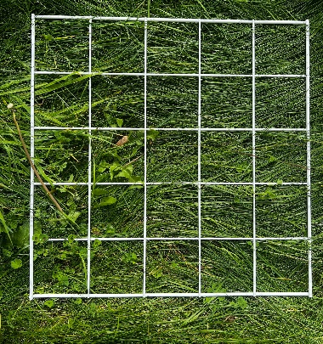
Q2 | $\frac{17}{25}$ = common dandelion (T. officinale)  $\frac{2}{25}$ = small flowered cranesbill (Geranium pusillum)  $\frac{1}{25}$ = groundsel (Senecio vulgaris)  $\frac{5}{25}$ = barren brome (Anisantha sterilis)  $\frac{25}{25}$ = winter grass (Lolium perenne)  $\frac{1}{25}$ = plantain
Q3 | $\frac{8}{25}$ = common dandelion (T. officinale)  $\frac{21}{25}$ = grass (species unknown)  $\frac{6}{25}$ = cow parsley (A. sylvestris)  $\frac{4}{25}$ = ribwort plantain (Plantago lanceolata)
Q4 | $\frac{7}{25}$ = Common dandelion (T. officinale)  $\frac{5}{25}$ = black medick (Medicago lupulina)  $\frac{6}{25}$ = creeping cinqual (Potentilla reptans)  $\frac{20}{25}$ = grass (species unknown)

Results – Animals:
Bluebottle and ladybug (3 lots) (species not recorded) were noted in Q4. A red tailed bumblebee was also noted during the survey time
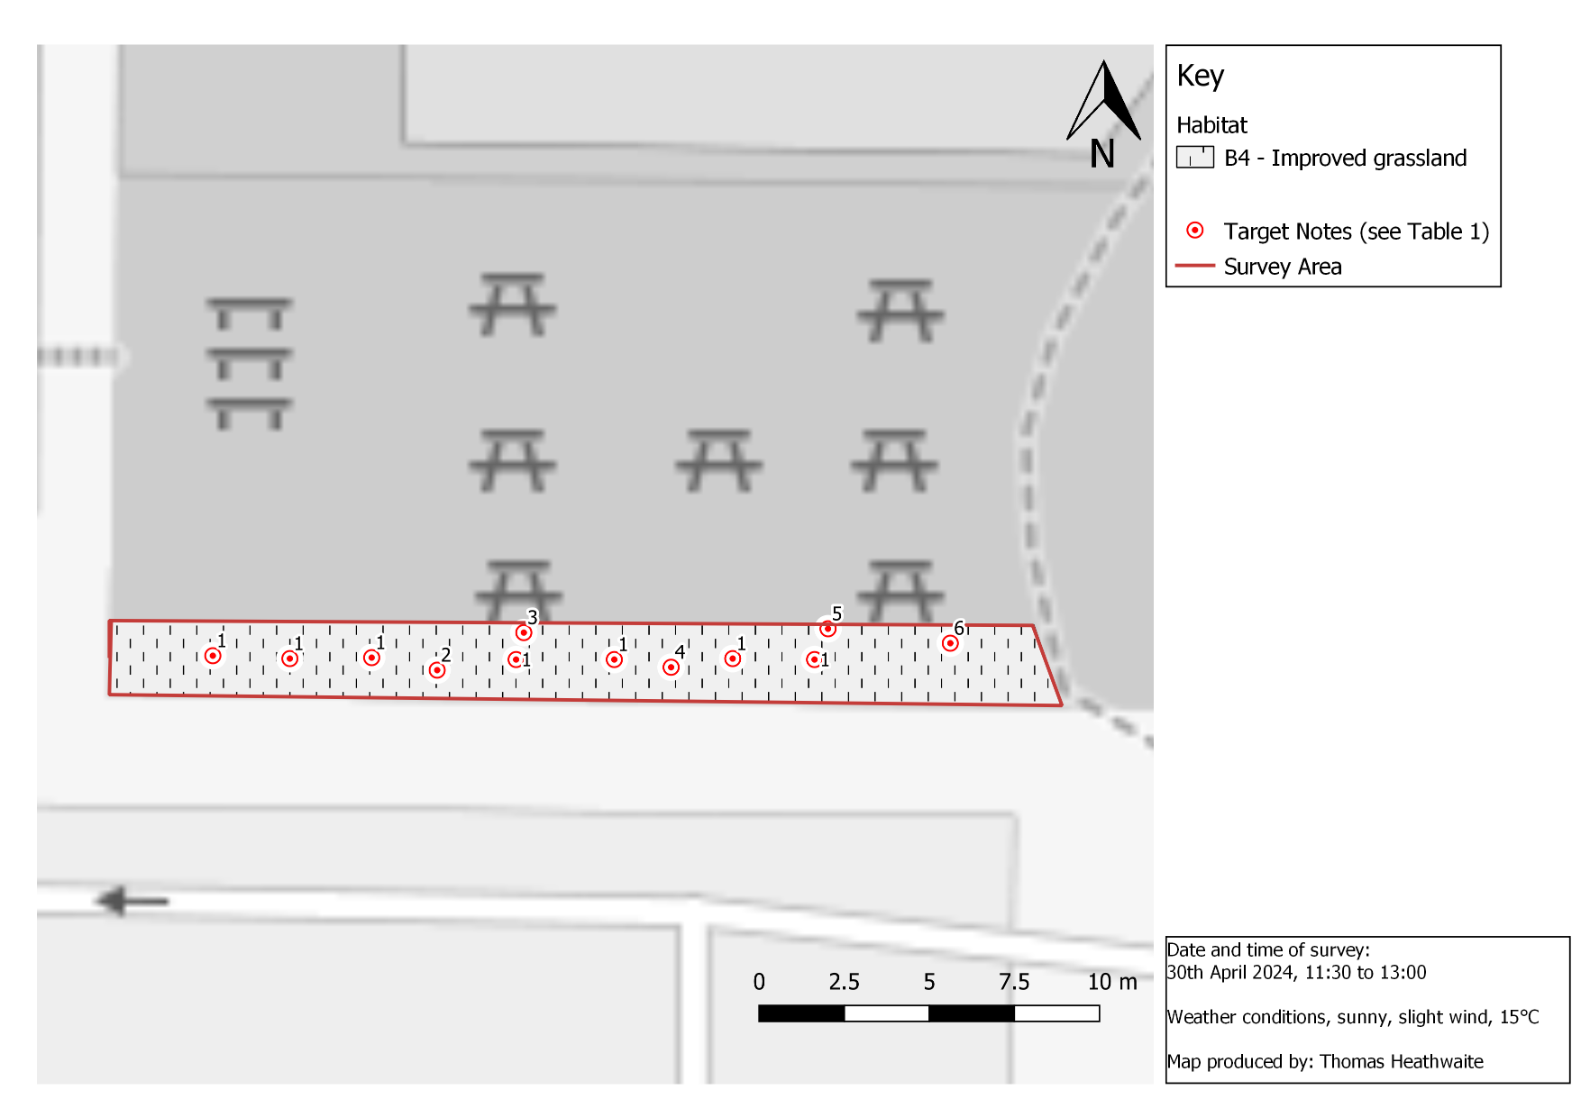

Figure 2, a phase 1 habitat survey map for the Bumblebee Buffet Area. The blue outline shows where the survey boundary is, with each habitat and boundary categories within the site’s boundary according to the standardised phase 1 survey symbols and methodology (JNCC, 2010). Base map and data from OpenStreetMap and OpenStreetMap Foundation (2021).
Results: Desktop survey:
Please see the 2022 Phase 1 report covering the Wildlife Garden (the sites are so close to each other that the results will differ insignificantly between sites).
Recommendations:
Summary and beneficial species already found:
Whilst it is good to see an increase in species richness this year, (17) compared to 11 in 2023, there is still more that can be done to continue to improve this site for bumblebees.
Cow parsley (A. sylvestris) is known to be beneficial to pollinators (Lysenkov S.& Galinskaya T. 2017), as well as common dandelion (T. officinale) and groundsel (S. vulgaris) whose benefits were described extensively in the 2023 phase 1 report for this site (Marshall et al., 2003). However, common dandelion (T. officinale) can be invasive if not managed properly.
Actions taken since the survey:
To further improve the species richness of the site, and attract some of the rarer bee species, Table 3 shows the plug plants and quantity planted of each species.
Table 3, a table showing species name, quantity, and benefits for different species of the plug plants sowed since undertaking the 2024 Bumblebee Buffet Phase 1 Habitat Survey.
Species name | Quantity planted | Benefits for Biodiversity
Yellow rattle (Rhinanthus minor) | 150 | Is semi-parasitic suppressing grass helping other wildflower to thrive. Flowers beneficial to bees and butterflies (Burian et al., 2023).
Bulbous buttercup (Ranunculus bulbosus) | 25 | Pollinated by many flies, beetles and weevils, and bees (Matter et al., 2012)
Betony (Betonica officinalis) | 25 | Excellent for a range of bumblebees and solitary bees (Corbet et al., 2001).
Birdseye speedwell (V. persica) | 25 | Excellent for bees (Brühl and Zaller, 2021)
Bladder campion (Silene vulgaris) | 25 | Foodplant of red and black froghopper (Wildlfie Trust, n.d)
Burnet saxifrage (Pimpinella major) | 25
Common sorrel (Rumex acetosa) | 25
Common Vetch (Vicia sativa) | 25
Hedge cranesbill (Geranium pyrenaicum) | 25

Recommended species to increase the species diversity of this site:
The recommendations from the 2023 report are still valid, and seeds for all of the recommendations have been bought and will be shown in the 2024/ 2025 session.

Bibliography:
Brühl, C.A. and Zaller, J.G. (2021). Indirect herbicide effects on biodiversity, ecosystem functions, and interactions with global changes. Herbicides (pp. 231-272). Available at: Indirect herbicide effects on biodiversity, ecosystem functions, and interactions with global changes - ScienceDirect [accessed 20/06/24]
Burian, A., Norton, B.A., Alston, D., Willmot, A., Reynolds, S., Meynell, G., Lynch, P. and Bulling, M., 2023. Low‐cost management interventions and their impact on multilevel trade‐offs in agricultural grasslands. Journal of Applied Ecology, 60(10), pp.2079-2090. Low‐cost management interventions and their impact on multilevel trade‐offs in agricultural grasslands (wiley.com) [accessed 20/06/24]
Corbet, S.A., Bee, J., Dasmahapatra, K., Gale, S., Gorringe, E., La Ferla, B., Moorhouse, T., Trevail, A., Van Bergen, Y. and Vorontsova, M. (2001) Native or exotic? Double or single? Evaluating plants for pollinator-friendly gardens. Annals of Botany, 87(2), pp.219-232. Available at: Native or Exotic? Double or Single? Evaluating Plants for Pollinator-friendly Gardens | Annals of Botany | Oxford Academic (oup.com) [accessed 20/06/24]
DEFRA (2023) MAGIC. Available at: https://magic.defra.gov.uk/MagicMap.aspx [accessed 10/08/23].
JNCC (2010) Handbook for Phase 1 habitat survey – a technique for environmental audit. Peterborough: JNCC.
Lin, S.Y. and Forrest, J.R. (2019) The function of floral orientation in bluebells: interactions with pollinators and rain in two species of Mertensia (Boraginaceae). Journal of Plant Ecology, 12(1), pp.113-123.
Lysenkov S.& Galinskaya T. 2017. Comparison of the Pollen Content on the Body and in the Gut of Hoverflies (Diptera, Syrphidae). Entomological Review. 97:10-16 Comparison of the pollen content on the body and in the gut of hoverflies (Diptera, Syrphidae) | Entomological Review (springer.com) [accessed 20/06/24]
Marshall, E.J.P., Brown, V.K., Boatman, N.D., Lutman, P.J.W., Squire, G.R. and Ward, L.K. (2003) The role of weeds in supporting biological diversity within crop fields. Weed research, 43(2), pp.77-89.
Matter, P., Pluess, A.R., Ghazoul, J. and Kettle, C.J. (2012). Eight microsatellite markers for the bulbous buttercup ranunculus bulbosus (ranunculaceae). American Journal of Botany.
Natural Environment and Rural Communities Act 2006, c. 16. Available at: https://www.legislation.gov.uk/ukpga/2006/16/contents [accessed 10/08/23].
NBN Atlas (2023) Explore your area. Available at: https://records.nbnatlas.org/explore/your-area#52.10412650000001|1.3288216|13|ALL_SPECIES [accessed 10/08/23].
The conservation of habitats and species regulations 2017 (SI 2017/1012). Available at: https://www.legislation.gov.uk/uksi/2017/1012/contents/made [accessed: 10/08/23].
The Wildlife Trust, (n.d) Bladder Campion. Available at: Bladder campion | The Wildlife Trusts [accessed 20/06/24]

