
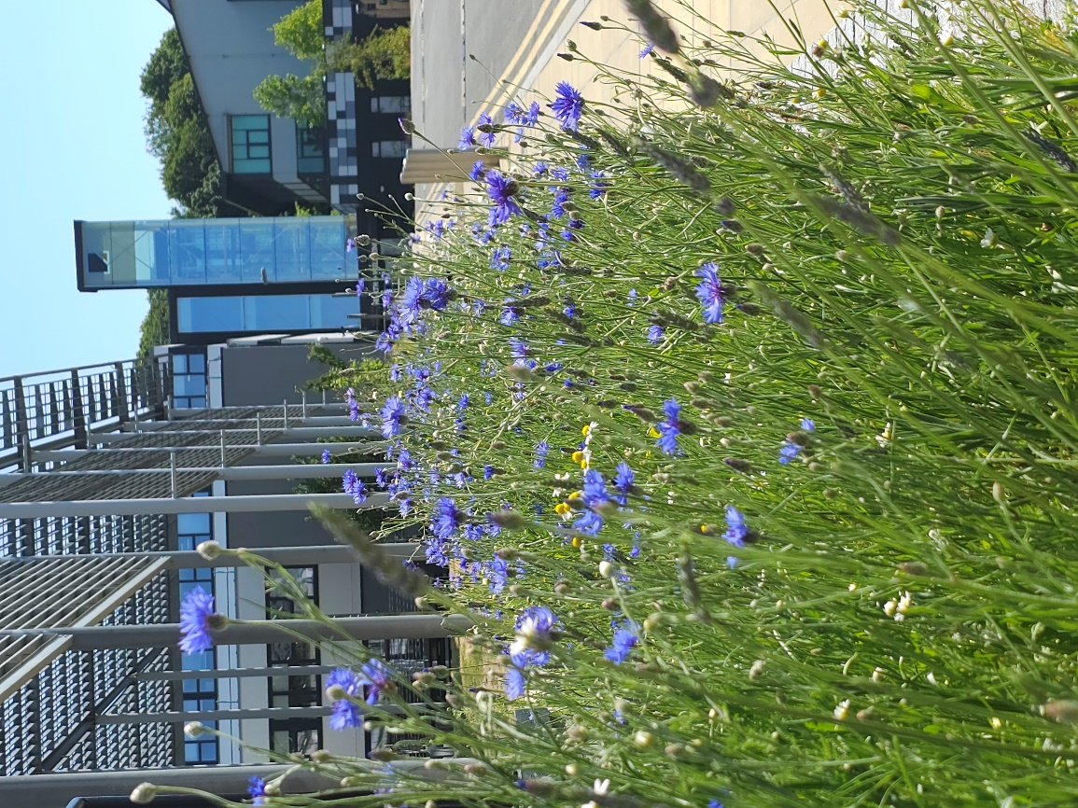
Bumblebee Buffet Area
Phase 1 habitat survey report
2023

Site name: University of Suffolk Bumblebee Buffet Area
Grid reference: TM17194420
Area: 110.3 meters²
Date and time of the survey: 20th April, 13:30 to 14:30
Weather conditions: sunny, slight wind, 13ºC
Recorders: Thomas Heathwaite, and 8 third-year BS(C) Wildlife, Ecology and Conservation Science Students.
Location, description, and geology of site:
The site is located on the University of Suffolk campus which is in the centre of Ipswich. Bordering the Bumblebee Buffet Area, to the east, is Alexander Park. Suffolk new college boarders just to the north of the University of Suffolk campus and the marina and Ipswich wet docks are to the south of the University of Suffolk campus. The centre of Ipswich is about 1km from the site campus.
The bedrock geology of the site consists of clay, silt, and sand (the Tharnet Fomation and Lambeth Group) and the superficial deposits consist of sand and gravel (the Lowestoft formation).
Statutory and Non-statutory designations:
There are no statutory designations within a radius of 1km of the survey site.
Two non-statutory designations are present within a radius of 1km of the survey site including zone III – total catchment source protection zone and drinking water protected area (surface water) (DEFRA, 2022)
Habitats and species:
Given the Wildlife Garden is only 184 meters away, the finding presented within the 2022 Wildlife Garden Phase 1 Habitat Survey report is likely to be valid here too.
Methodology (terrestrial):
Before the site visit, a desktop survey consisting of 1) the geology of the site; 2) statutory and non-statutory designations and 3) a search using the NBN Atlas (2023) of all protected species recorded within a 1km radius of the survey site listed on the UK Wildlife and Countryside Act (1981), section 41 of the Natural Environment and Rural Communities Act (2006), and The Conservation of Habitats and Species Regulations 2017 was conducted.
A visit to site was made on the 20th of April 2023 to survey the site.
Plants were surveyed using 1 meter squared quadrats, using standardised sampling (see figure 1). Plant species present in these quadrats were recorded , along with their local frequency in each quadrat. From this, dominant species were noted and the habitats were mapped as per JNCC Phase 1 Habitat Survey methodology (JNCC, 2010). Where habitats were too small to map, target notes were used as per JNCC recommendations (JNCC, 2010).
Any species observed throughout the survey period were also noted.
Results:
A map showing the habitats and target notes locations is below (Figure 2). Table 1 describes each target note and Table 2 shows that species were present within the quadrats and their local frequencies.
The total species richness of plants is estimated at 11 for this site.

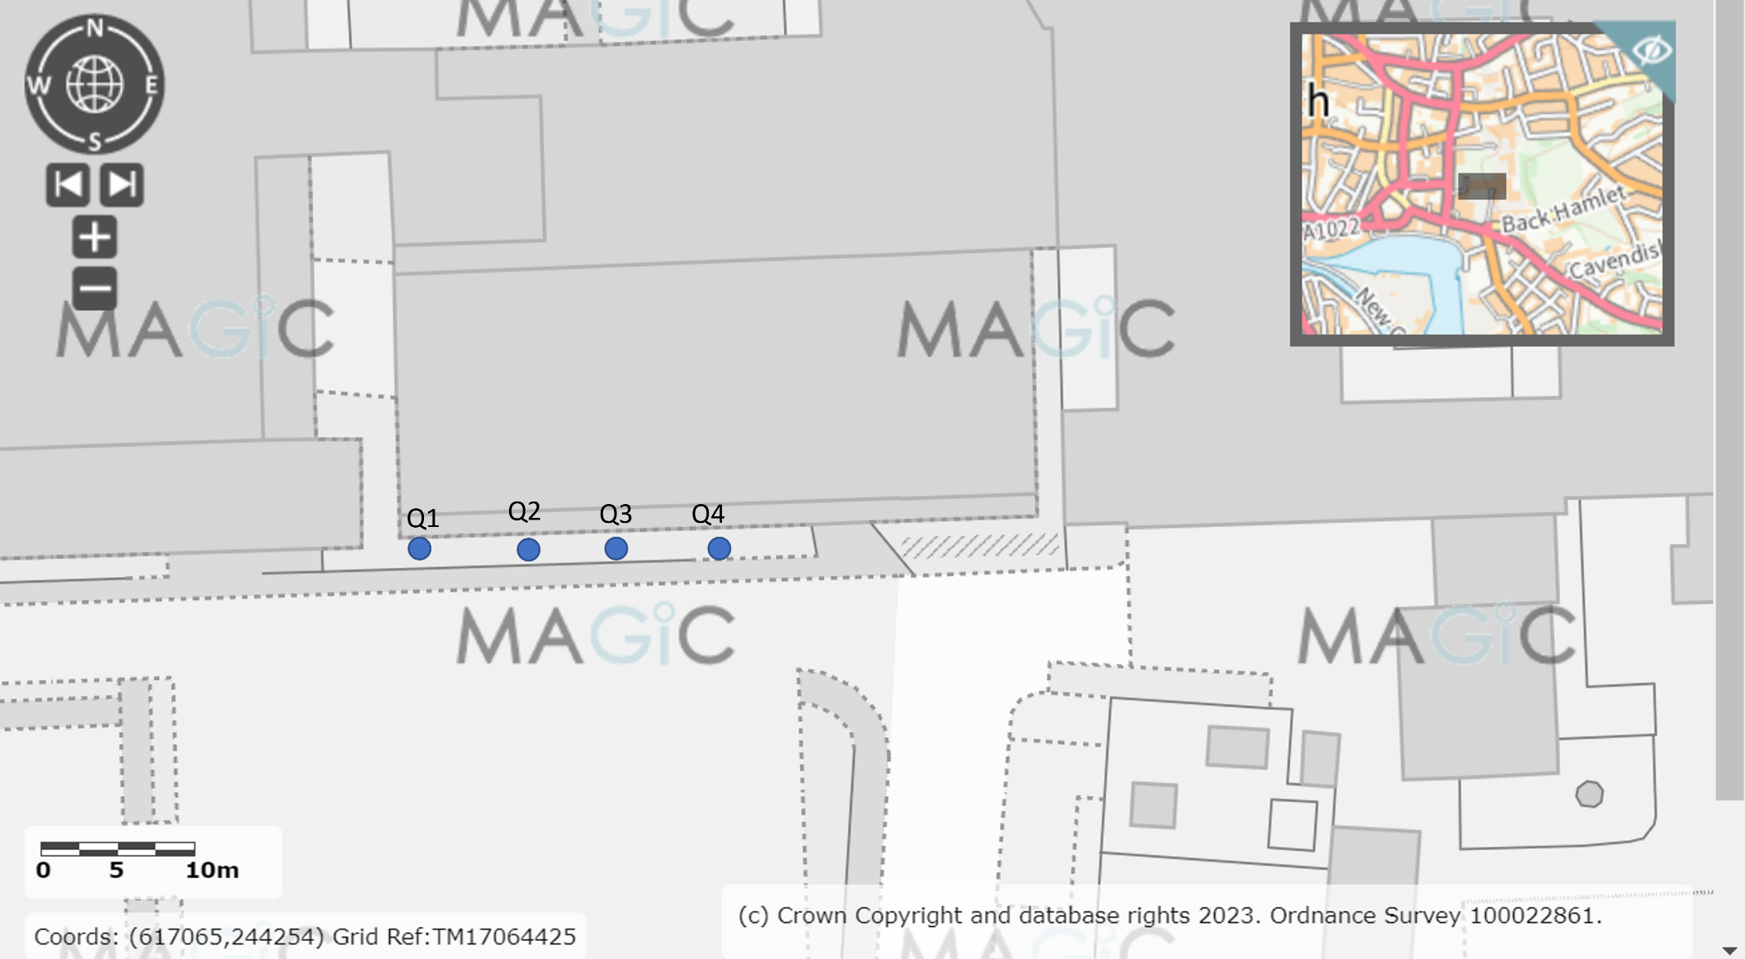
Figure 1, a diagram showing where each quadrat was placed, using systematic sampling. The blue dots indicate where the quadrats were laid. Image produced using the Magic Map application (DEFRA, 2023).

Target notes:
Table 1, a table showing the target note number and a description of each target note.
Target note number | Description
T1 | Jubilees Trees are located here, X7. The species are:
T2 | A large patch of cranesbill, which is the wild geranium. Good for pollinators.

Results – plants:
Table 2, a table showing the plants found in each quadrat and their local frequency.
Quadrat number | Local frequency of plants
Q1 | $$\frac{1}{25}=common dandelion$$  $$\frac{21}{25}=creeping cinquebill$$  $$\frac{22}{25}=spotted medick$$  $$\frac{1}{25}=common groundsel$$  $$\frac{25}{25}=grass (species unknown)$$
Q2 | $$\frac{4}{25}=dandolion$$  $$\frac{2}{25}=crosswort$$  $$\frac{6}{25 }=common groundsel$$  $$\frac{2}{25}=wood sorrel$$  Spotted medick (local frequency not recorded)
Q3 | $$\frac{13}{25}=giraniumss cranesbill$$  $$\frac{25}{25}=grass$$  $$\frac{13}{25}=dandolion$$  $$\frac{11}{25}=corn speedwell$$
Q4 | $$\frac{3}{25}=dandolion$$  $$\frac{9}{25}=chickweed$$  $$\frac{5}{25}=cowparsely$$  $$\frac{25}{25}=grass \left(species unknown\right)$$  $$\frac{1}{25}=meadow grass (species unknown)$$

Results – Animals:
Record of species seen during the survey were not made.

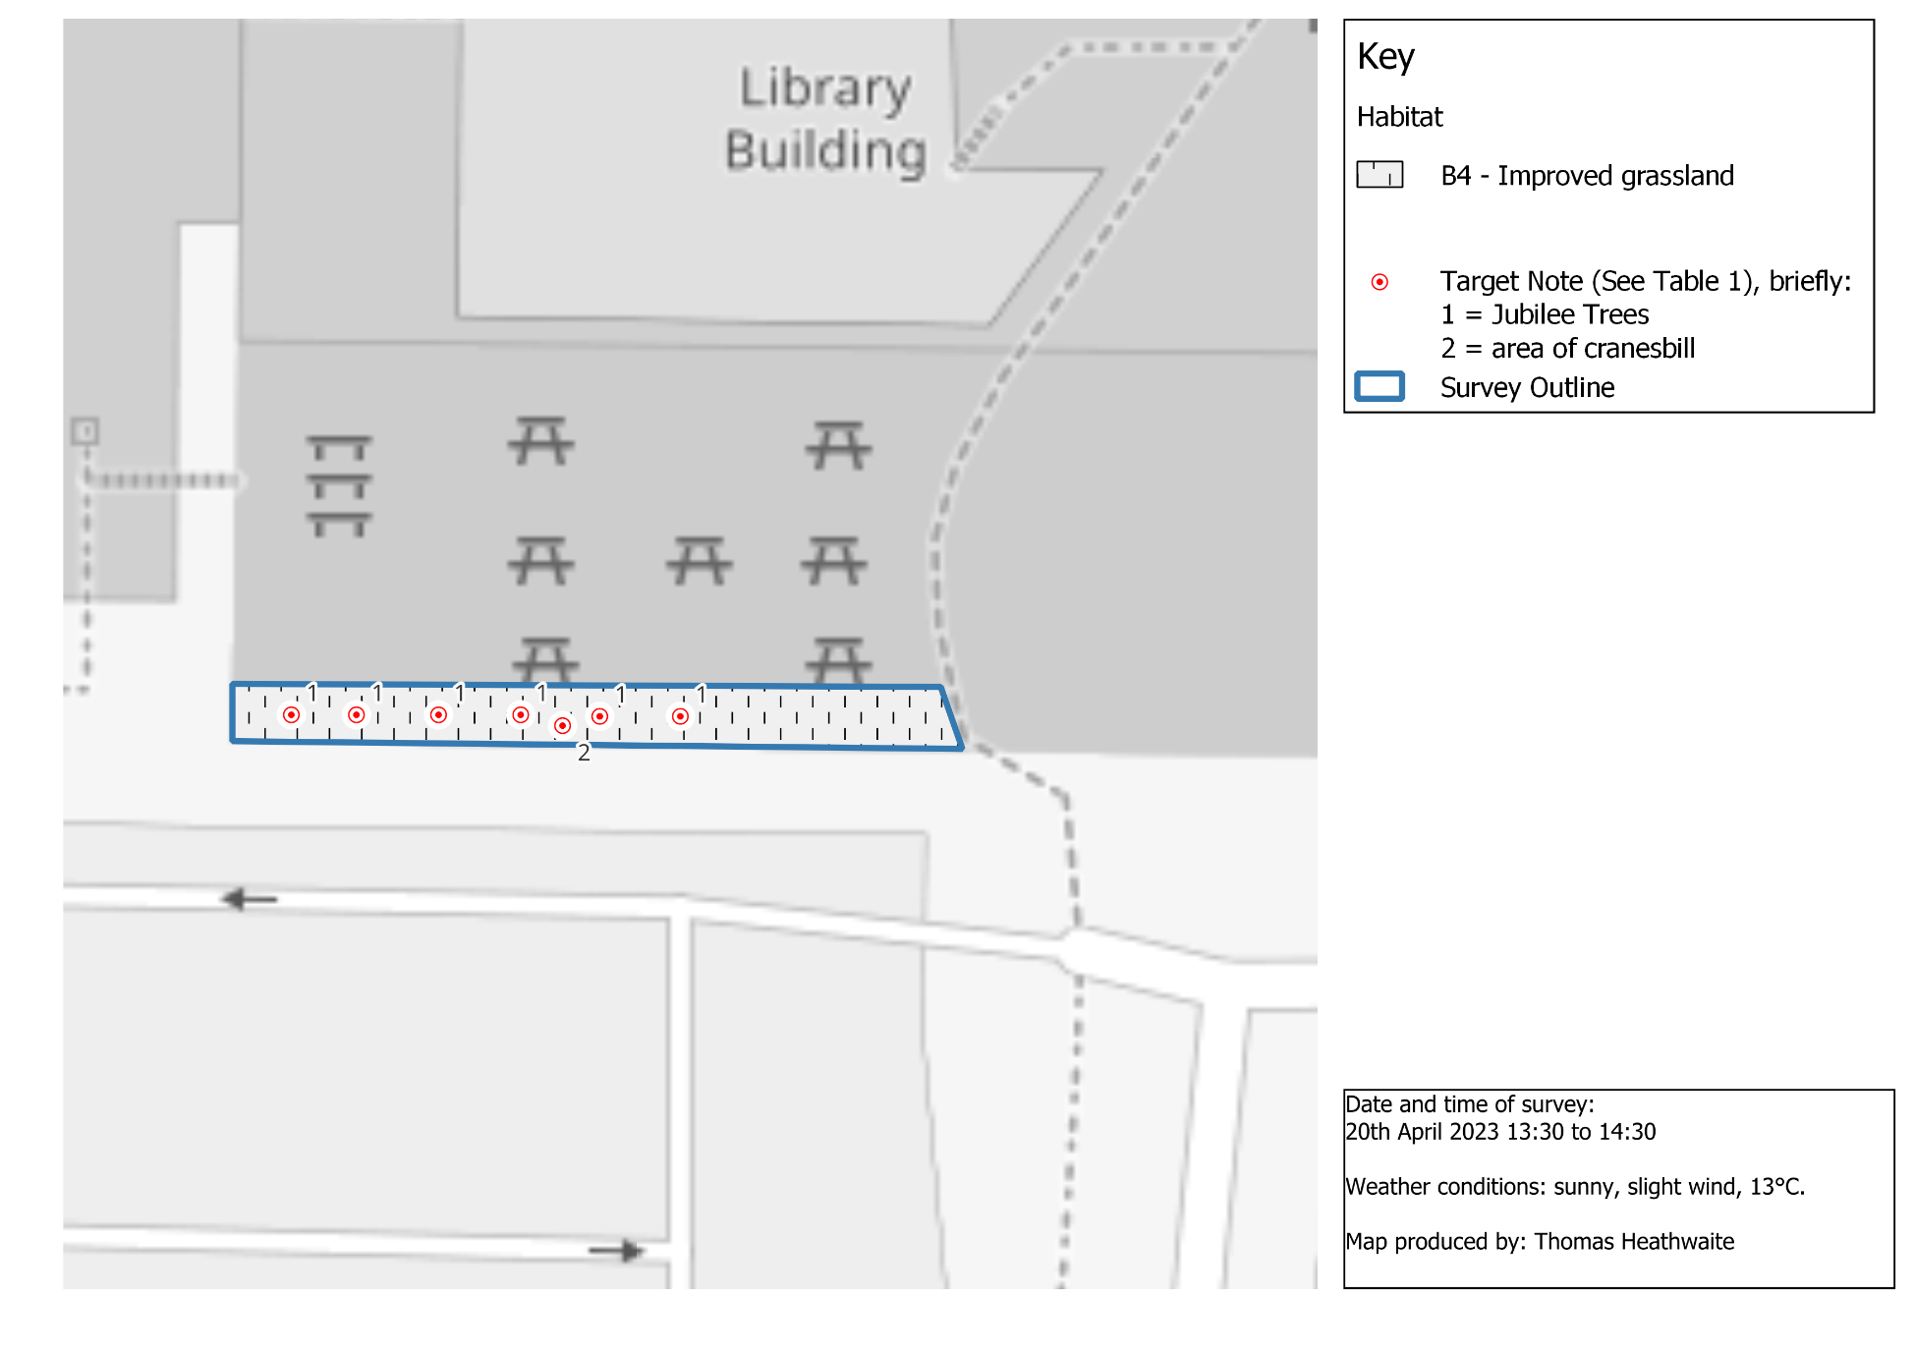

Figure 2, a phase 1 habitat survey map for the Bumblebee Buffet Area. The blue outline shows where the survey boundary is, with each habitat and boundary categories within the site’s boundary according to the standardised phase 1 survey symbols and methodology (JNCC, 2010). Base map and data from OpenStreetMap and OpenStreetMap Foundation (2021).
Results: Desktop survey:
Please see the 2022 Phase 1 report covering the Wildlife Garden (the sites are so close to each other that the results will differ insignificantly between sites).
Recommendations:
Summary and beneficial species already found:
It is pleasing that as a consequence of planting 7 Jubilee Trees and watering them that the species richness has increased to 11 from an area that was mowed regularly and kept in a manicured state.
Whilst common dandelion (Taraxacum officinale) can be invasive if not properly managed, it is beneficial to a wide range of pollinators including 97 bee species, 94 fly species and 25 species of butterflies in the UK (Wignall et al., 2023). Of particular note, T. officinale is also beneficial to three of the ‘rarer’ bee species as defined in the 2022 Wildlife Garden report, including: Lasioglossum sexnotatum, Nomada goodeniana and Andrena bicolor. Additionally, T. officinale provides nectar from March to October (Wignall et al., 2023).
Groundsel (Senecio vulgaris) is also known to be good for invertebrates and seed eating birds. A study within a crop filed, in the UK, showed that S. vulgaris is beneficial for over 26 invertebrates, and between 3 to 8 seed eating birds, (Marshall et al., 2003).
The recommended species to increase the species diversity of this site include:
- Red clover (Trifolium pratense) and White clover (Trifolium repens) which are both known to be particularly attractive to bumblebees (Carvell et al., 2006; Roger et al., 2017; Timberlake, Vaughan and Memmott 2019). Primrose (Primula vulgaris) is also excellent for all of these species, as well as bee flies and butterflies (Brys et al., 2004).
- Bluebells (genus Hyacinthoides) is attractive to bumblebees, megachilid bees (Megachilidae), halictid bees (Halictidae) and syrphids flies (Syrphidae) (Lin and Forrest 2019)
- Wood anemone (Anemone nemorosa) is attractive to hoverflies as is wood forget me knots (Myosotis sylvatica) (Woodland Trust n.da).
- Selfheal (Prunella vulgaris) are know to be particularly good for wasps and bees (Wildlife Trust, n.da).
- Common chamomile (Chamaemelum nobile) which is excellent for bees, butterflies, hoverflies, and other pollinators as well as having a medicinal value for humans (Wildlife Trust, n.db).
- Oxeye daisies (Leucanthemum vulgare) which are attractive to pollinators such as bumblebees as well as hoverflies (Woodland Trust, n.db).
- Comfrey (Symphytum officinale) which is attractive to many bumblebees such as Bombus pratourm, Bombus pascuorum and Bombus terrestris (Goulson et al., 1998) as well as butterflies, however it can take over quickly so careful management is needed to ensure it doesn’t engulf the whole site.
- Green flowered hellebores, Helleborus foetidus is great for bumblebees and solitary bees during the summer (Canto et al., 2008).
- Grape hyacinth, Muscari armeniacum, which flowers mainly from March to April is known to be attractive to the violet carpenter bee (Xylocopa violacea) and painted lady (Vanessa cardui) (Bretzel et al., 2020).
When planting the above species, it is vital to ensure that the holes are large (particularly for the taller plants) as this will allow the best possible drainage.

Bibliography:
Bretzel, F., Gaetani, M., Vannucchi, F., Caudai, C., Grossi, N., Magni, S., Caturegli, L. and Volterrani, M. (2020) A multifunctional alternative lawn where warm-season grass and cold-season flowers coexist. Landscape and Ecological Engineering, 16, pp.307-317.
Brys, R., Jacquemyn, H., Endels, P., Van Rossum, F., Hermy, M., Triest, L., De Bruyn, L. and Blust, G.D. (2004) Reduced reproductive success in small populations of the self-incompatible Primula vulgaris. Journal of Ecology, pp.5-14.
Canto, A., Herrera, C.M., Medrano, M., Pérez, R. and García, I.M. (2008) Pollinator foraging modifies nectar sugar composition in Helleborus foetidus (Ranunculaceae): an experimental test. American Journal of Botany, 95(3), pp.315-320.
Carvell, C., Roy, D.B., Smart, S.M., Pywell, R.F., Preston, C.D. and Goulson, D. (2006) Declines in forage availability for bumblebees at a national scale. Biological conservation, 132(4), pp.481-489.
DEFRA (2023) MAGIC. Available at: https://magic.defra.gov.uk/MagicMap.aspx [accessed 10/08/23].
Goulson, D., Stout, J.C., Hawson, S.A. and Allen, J.A. (1998) Floral display size in comfrey, Symphytum officinale L.(Boraginaceae): relationships with visitation by three bumblebee species and subsequent seed set. Oecologia, 113, pp.502-508.
Hicks, D.M., Ouvrard, P., Baldock, K.C., Baude, M., Goddard, M.A., Kunin, W.E., Mitschunas, N., Memmott, J., Morse, H., Nikolitsi, M. and Osgathorpe, L.M. (2016) Food for pollinators: quantifying the nectar and pollen resources of urban flower meadows. PloS one, 11(6), p.e0158117.
JNCC (2010) Handbook for Phase 1 habitat survey – a technique for environmental audit. Peterborough: JNCC.
Lin, S.Y. and Forrest, J.R. (2019) The function of floral orientation in bluebells: interactions with pollinators and rain in two species of Mertensia (Boraginaceae). Journal of Plant Ecology, 12(1), pp.113-123.
Marshall, E.J.P., Brown, V.K., Boatman, N.D., Lutman, P.J.W., Squire, G.R. and Ward, L.K. (2003) The role of weeds in supporting biological diversity within crop fields. Weed research, 43(2), pp.77-89.
Natural Environment and Rural Communities Act 2006, c. 16. Available at: https://www.legislation.gov.uk/ukpga/2006/16/contents [accessed 10/08/23].
NBN Atlas (2023) Explore your area. Available at: https://records.nbnatlas.org/explore/your-area#52.10412650000001|1.3288216|13|ALL_SPECIES [accessed 10/08/23].
Roger, N., Moerman, R., Carvalheiro, L.G., Aguirre‐Guitiérrez, J., Jacquemart, A.L., Kleijn, D., Lognay, G., Moquet, L., Quinet, M., Rasmont, P. and Richel, A. (2017) Impact of pollen resources drift on common bumblebees in NW Europe. Global Change Biology, 23(1), pp.68-76.
The conservation of habitats and species regulations 2017 (SI 2017/1012). Available at: https://www.legislation.gov.uk/uksi/2017/1012/contents/made [accessed: 10/08/23].
Timberlake, T.P., Vaughan, I.P. and Memmott, J. (2019) Phenology of farmland floral resources reveals seasonal gaps in nectar availability for bumblebees. Journal of Applied Ecology, 56(7), pp.1585-1596.
Wignall, V.R., Balfour, N.J., Gandy, S. and Ratnieks, F.L. (2023) Food for flower‐visiting insects: Appreciating common native wild flowering plants. People and Nature.
Wildlife Trust (n.da). Selfheal. Available at: Selfheal | The Wildlife Trusts [accessed 10/08/23].
Wildlife Trust, (n.db) Chamomile. Available at: https://www.wildlifetrusts.org/wildlife-explorer/wildflowers/chamomile [accessed 10/08/23].
Woodland Trust, (n.da) Wood Anemone. Available at: Wood anemone (Anemone nemorosa) - Woodland Trust - Woodland Trust [accessed 10/08/23].
Woodland Trust, (n.db) Oxeye Daisy. Available at: Oxeye daisy (Leucanthemum vulgare) - Woodland Trust [accessed:10/08/23].

