
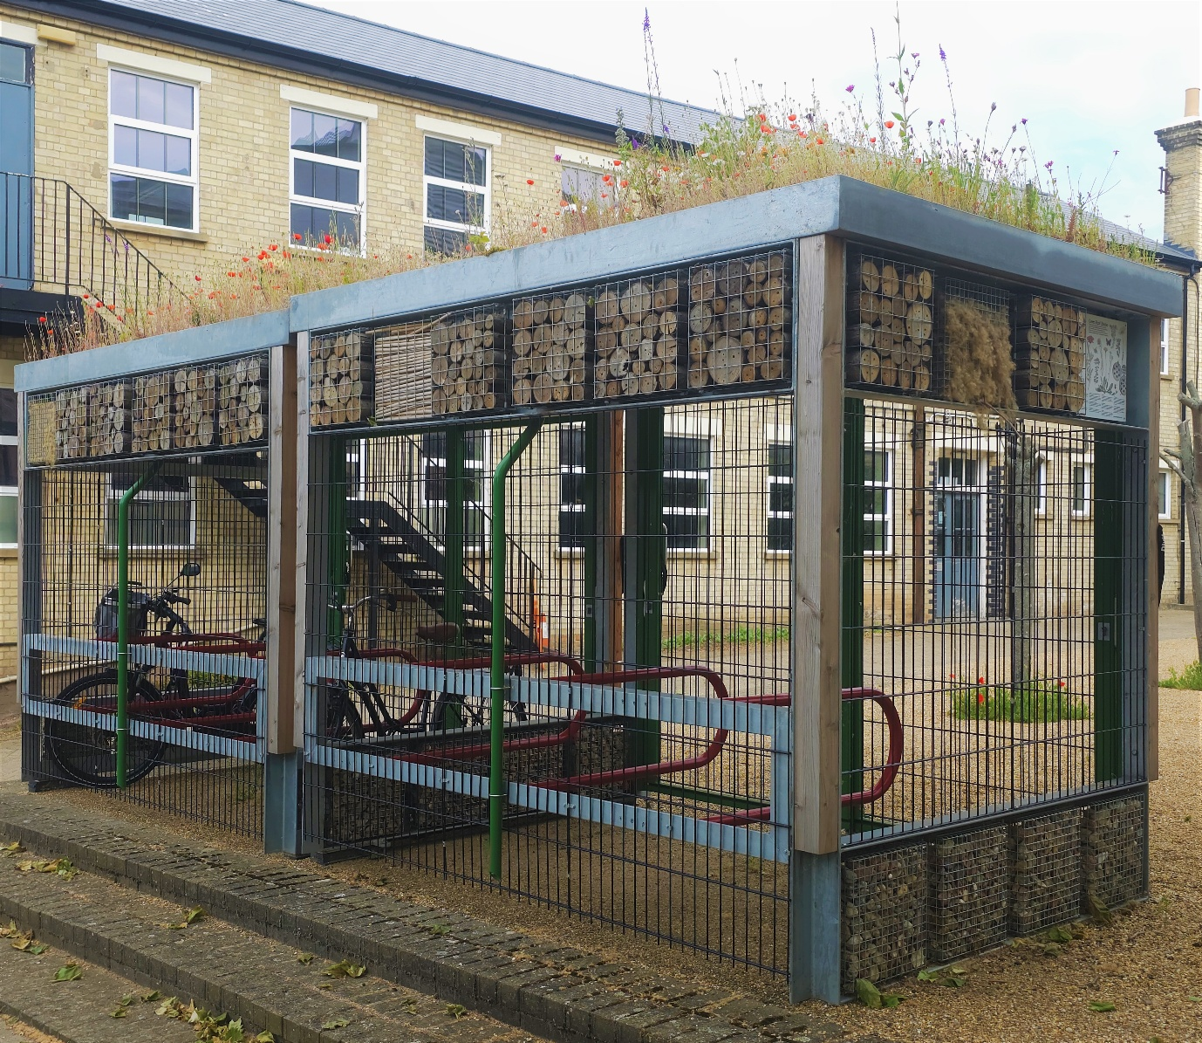
Physic Garden and Bike Shed
UK Habitat Classification Survey Report
2025
Site name: University of Suffolk Physic Grden and Bike Shed
Grid reference:
Area: the survey scope is made up of the following areas:
  - 3x Planters at front entrance of Health and Wellbeing Building (H&W): each planter = 195 by 75cm
  - 3x planters at back entrance of H&W: each planter = 195 by 75cm.
  - 2x boarder (the ‘Physic Garden’),
    - front boarder (front entrance to H&W) = 24.18m²
    - Back boarder (back entrance to H&W) = 4.37 m²
  - Bike Shed & Green roof: 15.53 m²
Date and time of the survey: 4th June 25, 13:25 till 15:00
Weather conditions: overcast, slight wind, 17ºC
Recorders: Thomas Heathwaite, and 2 BS(C) Wildlife, Ecology and Conservation Science Students, Cameron and Daniel.
Location, description, and geology of site:
The site is located on the University of Suffolk campus which is in the centre of Ipswich. Bordering the Bumblebee Buffet Area, to the east, is Alexander Park. Suffolk new college boarders just to the north of the University of Suffolk campus and the marina and Ipswich wet docks are to the south of the University of Suffolk campus. The centre of Ipswich is about 1km from the site campus.
The bedrock geology of the site consists of clay, silt, and sand (the Tharnet Fomation and Lambeth Group) and the superficial deposits consist of sand and gravel (the Lowestoft formation).
Statuary and Non-statutory designations:
There are no statutory designations within a radius of 1km of the survey site.
Three non-statutory designations are present within a radius of 1km of the survey site including Nitrate Vulnerable Zones 2017 Designations (England), total catchment source protection zone and drinking water protected area (surface water) (DEFRA, 2024)
Habitats and species:
Given the Wildlife Garden is only 230.35 meters away, the finding presented within the 2022 Wildlife Garden Phase 1 Habitat Survey report is likely to be valid here too.
Methodology (terrestrial):
Before the site visit, a desktop survey consisting of 1) the geology of the site; 2) statutory and non-statutory designations and 3) a search using the NBN Atlas (2025) of all protected species recorded within a 1km radius of the survey site listed on the UK Wildlife and Countryside Act (1981), section 41 of the Natural Environment and Rural Communities Act (2006), and The Conservation of Habitats and Species Regulations 2017 was conducted.
A visit to site was made on the 4th of June 25 to survey, with weather conditions overcast, slight wind, 17ºC
To survey the Physic Garden (see figure 1 for what areas in scope), sampling, without quadrats, was used and all plants that could be seen were noted. Local frequency was not recorded due to the size of the survey areas being too small for their use. The habitats were mapped as per the UKHab, UK Habitat Classification System, V2.0 methodology (UKHab Ltd, 2025).
For the bike shed (see figure 1 for where this area is located), photos of the green roof were taken from a ladder and plants identified from these photos. Quadrats were not used, and local frequency was not recorded. The habitat was mapped as per the UKHab, UK Habitat Classification System, V2.0 methodology (UKHab Ltd, 2025).
Any species observed throughout the survey period were also noted.
Any species recorded during observations made before the survey in the spring have also been noted; and are indicated as such.
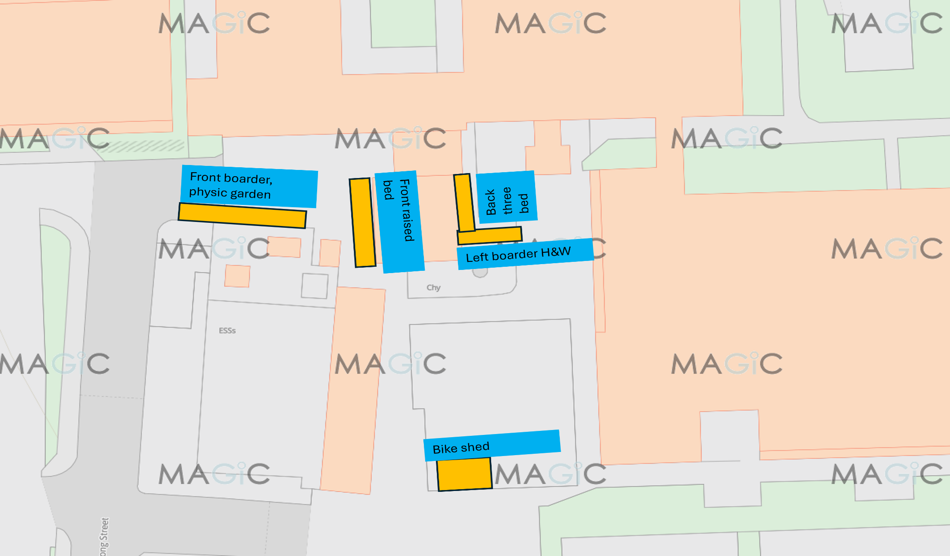
Figure 1, a diagram showing the survey sites and their locations. The orange indicated the survey sites, the blue labels describe each site’s name and are referred to in plant tables 1 to 4 Image produced using the Magic Map application (DEFRA, 2024)

Results – Physic Garden:
The habitats are described below. Figure 2 shows the habitats present at the survey site, their codes. Tables 1, 2, 3 and 4 shows that species were present within each area of the Physic Garden, the essential and additional secondary codes and photos, if taken (figures 3 and 4).
Total species richness (plants and animals combined) for Physic Garden is estimated at 32 species, including those seen in the spring.

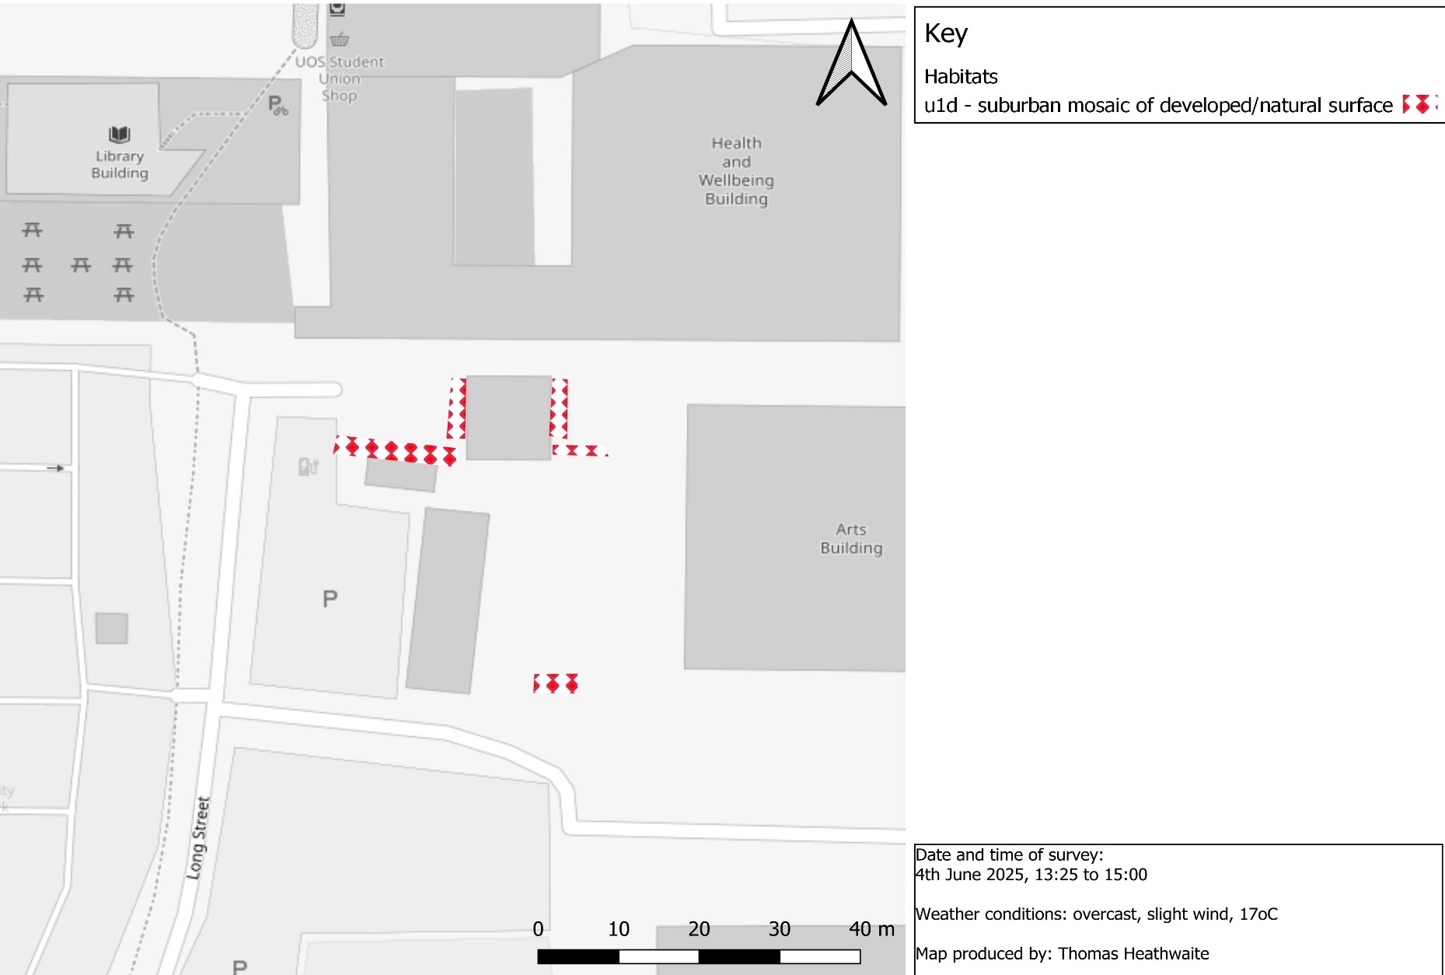
Figure 2 a habitat map of the University of Suffolk's Physic Garden and Bike Shed, Ipswich, OS Grid Reference:TM1711144224 using UK Habitat Classification methodology (UKHab Ltd, 2023)
Table 1, showing the plants species present in the boarder to the left of the front entrance of Health and Wellbeing Building (see maps, figures 1 and 2), the essential and additional secondary codes (UKHab Ltd, 2023) for each site and a photo if taken. The habitat classification is shown in figure 2 (UKHab Ltd, 2023).
Boarder to left of front entrance of H&W
Species name | Essential secondary codes | Additional Secondary codes | Photo?
Bloody crane’s bill (Geranium sanguineum) | 10 scatted scrub.  61 – re created habitat. | 828 – vegetated garden.  814 – education premises open space.  813 – educational building (as Health and Wellbeing is located next to survey site).  526 – accessible green space  516 – active management.  201 – young trees, planted.  117 – laid hedgerow? | 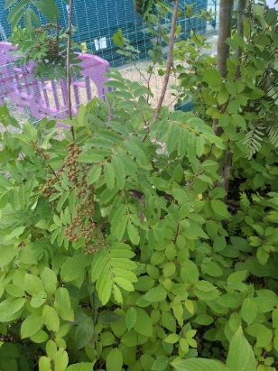  Figure 3, common dogwood
Common dogwood (Cornus sanguinea) | 10 scatted scrub.  61 – re created habitat.
Siberian dogwood (Cornus alba) | 10 scatted scrub.  61 – re created habitat.
European mountain ash (Sorbus aucuparia) | 10 scatted scrub.  61 – re created habitat.
Sweet violet (Viola odorata) | 10 scatted scrub.  61 – re created habitat.
Holm oak (Quercus ilex) | 10 scatted scrub.  61 – re created habitat.
English oak (Quercus robur) | 10 scatted scrub.  61 – re created habitat.

Table 2, showing the plants species present in the front three raised planter planters, Health and Wellbeing Building (see maps, figures 1 and 2), the essential and additional secondary codes (UK Hab Ltd, 2023) for each site and a photo if taken. The habitat classification is shown in figure 2 (UK Hab Ltd, 2023).
Front three raised beds, Health and Wellbeing Building.
Species name | Essential secondary codes | Additional secondary codes | Photo?
Ribwort plantain (Plantago lanceolata) | 10 scatted scrub.  61 – re created habitat. | 125 – flower forage abundant  516 – active management  813 – education building (as Health and Wellbeing is located next to survey site)  814 – education premises open space.  828 – vegetated garden.
Rosmary (Salvia rosmarinus) | 10 scatted scrub.  61 – re created habitat.
Lemon balm (Melissa officinalis) | 10 scatted scrub.  61 – re created habitat.
Cotton lavender (Santolina chamaecyparissus) | 10 scatted scrub.  61 – re created habitat.
English lavender (Lavandula angustifolia) | 10 scatted scrub.  61 – re created habitat.
Woodland sage (Salvia nemorosa) | 10 scatted scrub.  61 – re created habitat.
Bristly oxtongue (Helminthotheca echioides) | 10 scatted scrub.  61 – re created habitat.
Common thyme (Thymus vulgaris) | 10 scatted scrub.  61 – re created habitat.

Table 3, showing the plants species present in the left boarder of Health and Wellbeing Building (see maps, figures 1 and 2), the essential and additional secondary codes (UKHab Ltd, 2023) for each site and a photo if taken. The habitat classification is shown in figure 2 (UKHab Ltd, 2023).
Left boarder of Health and Wellbeing Building
Species name | Essential secondary codes | Additional secondary codes | Photo?
Green mullein (Verbascum thapsus) | 10 scatted scrub.  61 – re created habitat. | 125 – flower forage abundant  516 – active management  813 – education building (as Health and Wellbeing is located next to survey site)  814 – education premises open space.  828 – vegetated garden. | 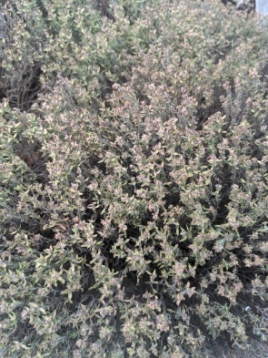  Figure 4, cotton lavender
Rosmary (S. rosmarinus) | 10 scatted scrub.  61 – re created habitat.
Cleaver (Galium aparine) | 10 scatted scrub.  61 – re created habitat.
English lavender (L. angustifolia) | 10 scatted scrub.  61 – re created habitat.
Cotton lavender (S. chamaecyparissus) | 10 scatted scrub.  61 – re created habitat.
Hyssop (Hyssopus officinalis) | 10 scatted scrub.  61 – re created habitat.
Sweet woodruff (Galium odoratum) | 10 scatted scrub.  61 – re created habitat.
Greater plantain (Plantago major) | 10 scatted scrub.  61 – re created habitat.
Sweet violet (V. odorata) | 10 scatted scrub.  61 – re created habitat.
Lemon Balm (M. officinalis) | 10 scatted scrub.  61 – re created habitat.
Corn poppy (Papaver rhoeas) | 10 scatted scrub.  61 – re created habitat.
Purple cornflower (Echinacea purpurea) | 10 scatted scrub.  61 – re created habitat.
Rose-of-Sharon (Hibiscus syriacus) | 10 scatted scrub.  61 – re created habitat.
Common thyme (T. vulgaris) | 10 scatted scrub.  61 – re created habitat.
Common sow-thistle (Sonchus oleraceus) | 10 scatted scrub.  61 – re created habitat.
Gorse (Ulex europaeus) | 10 scatted scrub.  61 – re created habitat.
Jacob’s ladder (Polemonium caeruleum) | 10 scatted scrub.  61 – re created habitat.
Yarrow (Achillea millefolium) | 10 scatted scrub.  61 – re created habitat.
Echinacea (genus echinacea) | 10 scatted scrub.  61 – re created habitat.

Table 4, showing the plants species present in the boarder to the left of the front entrance of Health and Wellbeing Building (see maps, figures 1 and 2), the essential and additional secondary codes (UKHab Ltd, 2023) for each site and a photo if taken. The habitat classification is shown in figure 2 (UKHab Ltd, 2023).
Back three raised bed, Health and Wellbeing Building.
Species name | Essential secondary codes | Additional secondary codes | Photos
English lavender (L. angustifolia) | 61 – re created habitat. | 828 – vegetated garden.  814 – education premises open space.  813 – educational building (as Health and Wellbeing is located next to survey site).  526 – accessible green space  516 – active management.
Common vervain (Verbena officinalis) | 61 – re created habitat.
Common sow thistle (S. oleraceus) | 61 – re created habitat.
Purple cornflower (E. purpurea) | 61 – re created habitat.
Lambsquarters (Chenopodium  Album) | 61 – re created habitat.
Lemon balm (M. officinalis) | 61 – re created habitat.

During the spring before the survey and during the survey, the following animal species were recorded:
- Wasp species (suborder Apocrita) found – back boarder entrance to H&W
- Black garden ant (Lasius niger) found at the back boarder entrance to H&W.
- Brimstone (Gonepteryx rhamni) flying around physic garden, during spring.
Results – Bike Shed:
The habitats are described below. Figure 2 shows the habitats present at the survey site, their codes. Table 5 shows the species which were present within this habitat, the essential and additional secondary codes and photos, if taken (figures 5 and 6).
Total species richness (plants and animal combined) for Bike Shed is estimated at 11 species, including those seen in the spring.

Table 5, showing the plants species present in the boarder to the left of the front entrance of Health and Wellbeing Building (see maps, figures 1 and 6), the essential and additional secondary codes (UKHab Ltd, 2023) for each site and a photo if taken. The habitat classification is shown in figure 6 (UKHab Ltd, 2023).
Bike shed
Species name | Essential Secondary codes | Additional secondary codes | Photo?
Red campion (Silene dioica) | 10 – scatted scrub.  87 – biodiverse green roof. | 521 – unmanaged  522 – native.  813 – educational building (as Arts building located close by). | 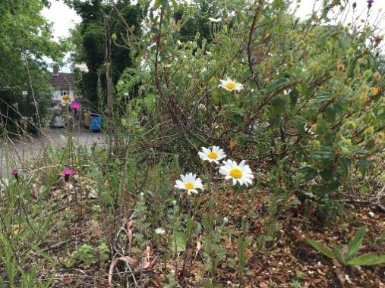  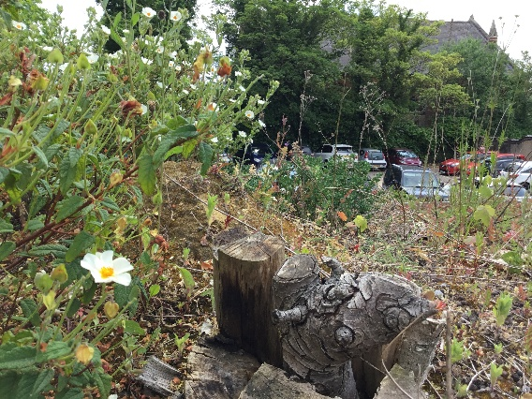  Figure 5, oxeye daisy  Figure 6, sage leaved rock rose
Thistle (species unknown) | 10 – scatted scrub.  87 – biodiverse green roof.
Feverfew (Tanacetum parthenium) | 10 – scatted scrub.  87 – biodiverse green roof.
English lavender (L. angustifolia) | 10 – scatted scrub.  87 – biodiverse green roof.
Crested Dog’s tail (Cynosurus cristatus) | 10 – scatted scrub.  87 – biodiverse green roof.
Common sorrel (Rumex acetosa) | 10 – scatted scrub.  87 – biodiverse green roof.
Common thyme (T. vulgaris) | 10 – scatted scrub.  87 – biodiverse green roof.
Sage leavd rock-rose (Cistus salviifolius) | 10 – scatted scrub.  87 – biodiverse green roof.
Oxeye Daisy (Leucanthemum vulgare) | 10 – scatted scrub.  87 – biodiverse green roof.

During the spring, before the survey, the following animals species were spotted:
- Great tit (Cyanistes caeruleus) nesting in Bike Shed, during spring.
- Speckled wood (Parus major) – flying around bike shed, during spring.

Discussion and Recommendations:
Physic Garden:
This is the first year that a survey of the physic garden has been undertaken, and it is pleasing to see a species richness of 32 species in the three areas.
The planting scheme of the Physic Garden is to simultaneously showcase and explore the medicinal plants which also have biodiversity benefits which have been used throughout the centuries. The recommendations, therefore, for this area will be tailored to this concept.
Cleavers, (G. aparine) are known to be invasive and out-compete other plants. Therefore, removal of these is a top priority over the next year, potentially through the use of yellow rattle (Rhinanthus minor), which is parasitic to grasses (Rowntree and Craig., 2018).
Recommendations for this site that will complement the existing planting scheme include planting common evening primrose (Oenothera biennis) whose oil has been shown to treat skin disorders e.g diabetes, mastalgia,, hydration and barrier function of the skin, amongst others (Sharifi et al., 2024) and is beneficial to moths, bees and butterflies (Sumara et al., 2023; The Wildlife Trust, n.d).
Additionally, chamomile (Matricaria chamomilla), is known to have many medicinal properties including calming effects, digestive issues, relieving stress, and skin irritation amongst others and also is beneficial to bees and flies (Polcaro et al., 2025) would also be beneficial for this site, particularly in the back entrance to Health and Wellbeing.
Bike Shed:
The bike shed acts a living example of how the competing needs of traveling and biodiversity can mingle and coexist together, with a number of benefits. Not only does the Bike Shed provide secure storage for your bike, it also is home to a relatively large species richness of plants and insects thriving on the green roof, as part of our “Bigger, Better, More Joined Up” (Lawton, 2010) nature corridor.
A variety of wildflower species which have been shown to have a multitude of biodiversity benefits have been recorded in this survey, including Common sorrel (R. acetosa) is the food plant of the small copper (Lycaena phlaeas), a widespread butterfly; Oxeye daisy (L. vulgare) and red campion (S. dioica) are both beneficial to a wide range of bees, hoverflies and butterflies (Plantlife, 2025a, Plantlife, 2025b). Finally, thistles are the foodplant of painted lady (Vanessa cardui), a migrant to the UK from North Africia, Southern Europe and Middle East during the summer (UK Butterflies, 2025 and Butterfly Conservation, n.d).
Moreover, the bike shed provides nesting material and bird boxes for nesting birds to use, as well as nesting cavities for solitary and bumblebees to occupy. Great tits (P. major), for the first time this year, nested in one of the nest boxes. Solitary bees have also been seen nesting, though identification of the species have not been identified.
Recommendations for this site are to continue to not irrigate the green roof as this helps biodiversity beneficial plants to thrive, and also to continuing surveying the site and not withstanding a decrease in species richness, active management of the site is not recommended.
The species recorded here are, like with any site, a snapshot in time, but also a snapshot of what could be seen form the ladder and, due to a lot of the flowers turning to seed by the survey date, a product of what could be identified. These limitations notwithstanding, the results show a positive sign and trend of how both how travel and biodiversity can live in harmony.

Bibliography:
Butterfly Conservation (n.d) Painted Lady. Available at: Painted Lady | Butterfly Conservation [accessed 13/08/25].
DEFRA (2024) MAGIC. Available at: Magic Map Application [accessed 07/08/25].
Lawton, J. (2010) Making space for nature: A review of England's wildlife sites and ecological networks. Defra.
Natural Environment and Rural Communities Act 2006, c. 16. Available at: https://www.legislation.gov.uk/ukpga/2006/16/contents [accessed 13/08/25].
NBN Atlas (2025) Explore your area. Available at: https://records.nbnatlas.org/explore/your-area#52.10412650000001|1.3288216|13|ALL_SPECIES [accessed 13/08/25].
Plantlife (2025a). Oxeye Daisy. Available at: Oxeye Daisy - Plantlife [accessed 13/08/25].
Plantlife (2025b) Red Campion. Available at: Red Campion - Plantlife [accessed 13/08/25].
Polcaro, L.M., Cerulli, A., Masullo, M. and Piacente, S. (2025) Phytochemical Investigation of Chamaemelum nobile L. and Evaluation of Acetylcholinesterase and Tyrosinase Inhibitory Activity. Plants, 14(4), p.595.
Rowntree JK and Craig H. (2018) The contrasting roles of host species diversity and parasite population genetic diversity in the infection dynamics of a keystone parasitic plant. Journal of Ecol. 2019;107:23–33. https://doi.org/10.1111/1365‐2745.13050
Sharifi, M., Nourani, N., Sanaie, S. and Hamedeyazdan, S. (2024) The effect of Oenothera biennis (Evening primrose) oil on inflammatory diseases: a systematic review of clinical trials. BMC Complementary Medicine and Therapies, 24(1), p.89.
Sumara, A., Stachniuk, A., Montowska, M., Kotecka-Majchrzak, K., Grywalska, E., Mitura, P., Saftić Martinović, L., Kraljević Pavelić, S. and Fornal, E. (2023) Comprehensive review of seven plant seed oils: chemical composition, nutritional properties, and biomedical functions. Food reviews international, 39(8), pp.5402-5422.
The conservation of habitats and species regulations 2017 (SI 2017/1012). Available at: https://www.legislation.gov.uk/uksi/2017/1012/contents/made [accessed: 13/08/25].
The Wildlife Trust (n.d). Common Evening Primrose. Available at: Common evening-primrose | The Wildlife Trusts [accessed 13/08/25].
UK Butterflies (2025) Larval Foodplants. Available at: UK Butterflies - Larval Foodplants [accessed 13/08/25].
UKHab Ltd (2023). UK Habitat Classification Version 2.0. Available at: ukhab – UK Habitat Classification [accessed 07/08/25].
Wildlife and Countryside Act 1981, c. 69. Available at: https://www.legislation.gov.uk/ukpga/1981/69/contents [accessed 13/08/25].

