How to access OASIS for Partner students

Step 1: Accessing OASIS to complete the graduation registration form
Access OASIS https://intranet.uos.ac.uk/oasis

You will be taken to the Microsoft Single Sign-On Page. You will need your UoS student email address in order to log in (for example: s123456@uos.ac.uk). You will then be asked to provide your password.

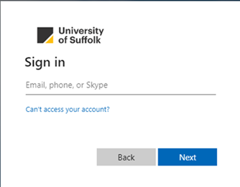

If you cannot find your University of Suffolk email and password, search your emails for "University of Suffolk" from the time your course started as you will have been sent this. Your partner institution can also help you find your University of Suffolk student email.

Step 2: Using Incognito Mode
You will need to ensure that you are logged out of your partner institution account and use your University of Suffolk login details. If you are logged into another account, use incognito mode to log in to your University of Suffolk account. This clears saved usernames and passwords.

Step 3: Complete the Registration Form

Once in O.A.S.I.S, scroll down and click on the ‘Graduation Registration’ tile to access the graduation registration form. You can also access graduation related emails via the Correspondence History tab at the top of the page.

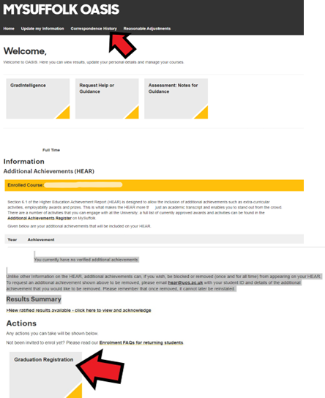

Whether you plan to attend the graduation ceremony or not, you must complete the registration form. This is the final opportunity for you to check your details and correct any misspelling of your name before your award is conferred and your certificate issued. If you do not complete the form, we cannot make any amendments to your name or send your certificate.

